Swine Disease Classification Using Deep Learning

A Project Report

Presented to

The Faculty The Faculty of the Department of Applied Data Science

San Jose State University

In Partial Fulfillment

Of the Requirements for the Degree

Master of Science in Data Analytics

By

Hruthik Vinnakota

Jugal Kishore Ruvva

Rajeev Yenugula

Ramya Sudireddy

May 13, 2024

Copyright © 2024

*Hruthik Vinnakota, Jugal Kishore Ruvva, Rajeev Yenugula, Ramya Sudireddy*

ALL RIGHTS RESERVED

**APPROVED FOR DEPARTMENT OF APPLIED DATA SCIENCE**

Dr. Jerry Gao, Project Advisor

Dr. Lee C. Chang, Department Chair

**ABSTRACT**

Swine Disease Classification Using Deep Learning

By

Hruthik Vinnakota, Jugal Kishore Ruvva, Rajeev Yenugula, Ramya Sudireddy

**Purpose**

The swine industry plays a significant role in the global livestock industry, providing a vital source of meat consumption to meet the need for protein-rich food. As of April 2022, there are 784 million pigs worldwide. However, the pork industry faces constant challenges regarding timely disease detection. The outbreak of diseases in pig herds can lead to considerable economic loss, compromise animal welfare, raise food safety concerns, and burden farmers with increased maintenance costs. This project deals with pig disease classification and is motivated by identifying the importance and significance of these challenges and needs in the swine farming industry. It aims to classify the diseases in pigs by working on acoustic and visual data. By analyzing the pig farming industry data, early disease detection can be achieved, reducing medical costs and enhancing food safety. The present disease detection techniques in swine are invasive, time-consuming, and expensive. Traditional disease detection and classification methods generally involve rude and harassing procedures that cause stress and discomfort to pigs. Conventional methods usually identify the conditions at advanced stages, which can substantially increase economic loss. The importance of this project cannot be overstated as it addresses an important issue within the swine industry, which is very relevant and impactful. Timely discovery of diseases in pigs is the key to preventing outbreaks. This project helps in early disease detection, which minimizes the disease spread and reduces the financial impacts. Taking care of the health and well-being of swine is not just an economic concern but also a moral ethical responsibility, and sustainable farming. Disease outbreaks in swine can significantly increase medical expenses along with losses due to reduced productivity and mortality rates. A good project can reduce these expenses and increase the profitability of swine farming. The project not only increases the profits for the farmers but also ensures food safety and public health by preventing diseased animals from entering the food supply chain. This project contributes to producing safe pork products, protecting consumers from potential health issues. Timely disease detection plays a vital role in preserving the reliability of the food supply chain to ensure the well-being of consumers and the reputation of the pig farming industry. The non-invasive audio and image analysis method will be a better approach to track swine health. This method reduces animals' physical and psychological stress and aligns with animal welfare considerations. Working on data science technologies for disease detection in swine and technological advancement. It explains the potential for innovation and modernization in the traditional livestock industry. The main challenge addressed by this project is the timely, non-invasive disease detection in pig farming. This results in economic losses and animal welfare concerns. The important objective of this project is to develop a machine learning model with a minimum accuracy rate of 90% in determining swine diseases using audio and image data. The objective is to ensure the model is reliable and practical for swine disease detection. The project also provides the development of a model adaptable to various swine breeds and various types of diseases found in the swine population. Generalization is the key factor in the tool's application. The time taken to detect and classify the disease can be significantly reduced using this project and can assess the impact on animal welfare. The project holds immense potential in addressing the challenges and transforming disease detection and classification in the swine farming industry.

**Tasks**

A well-structured strategy is required to develop models and solutions for swine disease detection through audio and image recordings using machine learning and deep learning techniques. The process can be divided into various important tasks following CRISP-DM, where each contributes to creating an accurate disease classification solution. Data collection is a significant step of this project. Considerable data of audio video recordings of swine and images must be collected. Parallelly, careful annotation of the dataset with labels that indicate the specific disease's features is essential, which may require domain experts. Data acquisition is followed by data preprocessing. Raw audio data generally consists of different forms of noise and are unpredictable in volume and format. Various types of noise indicate the necessity to enhance the dataset's quality whereas certain skin disease images of swine need to be collected for a particular disease classification. Feature extraction is crucial as these features act as the basis for model input. Spectrograms and Mel-frequency cepstral coefficients (MFCCs) are generally used in audio analysis and image data undergoes feature extraction utilizing a pre-trained model, from the preprocessed images. This process allows for extracting high-level features from the images to be used in further analysis and tasks. After the dataset is processed, the data is divided into training, validation, and test datasets to evaluate the training and evaluation of the model. Hyperparameter tuning is based on a validation set which involves selecting the optimal settings for model training. Choosing suitable machine learning and deep learning models is crucial based on the problem. Conventional neural networks are great for image and spectrogram analysis, which makes them the better choice for audio classification tasks. Hybrid models or combining CNN and RNN can also be experimented with to improve accuracy. The selected model should always maintain a balance between model complexity and interpretability. Hyperparameter tuning is essential to fine-tune model performance, such as learning rates, dropout rates, and batch sizes. Model evaluation is a crucial step of the project. Multiple metrics like accuracy, precision, recall, F-1 score, and confusion matrices are calculated to evaluate the model's performance.

**Outcomes**

The project deliverables are important in shaping every aspect of the project, from the initial data collection stage to the deployment and maintenance of the machine learning and deep learning models. The project requests a detailed annotated dataset of audio and image recordings of swine. The dataset serves as the base for the disease classification model. The labeled dataset should be diverse and accurate, with a broad spectrum of health conditions and diseases in swine. The dataset's quality is crucial, as it impacts the accuracy and success of the model. Making sure that the dataset is clean, and uniform is an essential milestone. The preprocessing pipeline comprises noise reduction, and format conversion should be applied systematically and documented to maintain transparency and repeatability in the preprocessing pipeline. Extracting relevant audio features is a crucial step in the project. These features, like spectrograms, Mel-frequency cepstral coefficients (MFCCs), and descriptors, act as the input for machine learning and deep learning models. So extracting features is also considered an important deliverable consisting of a pipeline, provided with code and the steps for extracting and processing these features from both audio and image data. The project's core lies in the trained machine learning and deep learning models, which identify and classify diseases in pigs based on audio and image recordings. The models should be well documented with detailed descriptions of the features, hyperparameters, and issues in the training process. It's crucial to jot down the development and evaluation of multiple models required to identify the most efficient model. The success of the model is measured through rigorous evaluation metrics. The deliverables include results of model evaluations like accuracy, precision, recall, F-1 score, and confusion matrices. These metrics help understand the model's capability and the accuracy of disease classification. A deployment package is an essential deliverable for real-time swine disease classification. The package should include trained models, code, and additional instructions to reduce the friction between model development and real-time utilization. In the end, a final report summarizing the project's objectives, procedures, findings, and outcomes is presented. The final report displays a high-level perspective to stakeholders and the impact on swine disease classification. As discussed above in the deliverables, the project's success in classifying swine disease can be measured by the accuracy of the trained models. An interactive GUI will be developed to ease the classifier access for the farmers.

High accuracy indicates the model's capability to identify healthy and diseased swine using the audio and image recordings. Precision and recall are the additional measures of accuracy. Precision measures the mode's ability to correctly identify diseased pigs, whereas recall computes its capacity to identify all actual disease cases. The f-1 score is the harmonic mean of precision and recall, which indicates the balanced measure of model performance. A high F-1 score represents a well-rounded solution. Robustness and generalization are the quality indicators of a model. Considering their flexibility, high-quality models should perform steadily across multiple swine populations and environmental conditions. Interpretability also adds to the quality of the project. High-quality solutions should show why specific decisions were made, displaying trust and understandability. The project's scalability is one more quality that indicates the project's performance. A good project should be able to handle larger volumes of data and high workloads without degradation in performance.

**Applications**

The Swine disease classification project, utilizing both Machine Learning (ML) and Deep Learning techniques on both audio and image data consisting of pig cough sounds, offers a comprehensive solution with far-reaching implications across agriculture, veterinary care, and animal health surveillance. This application delineates the multifaceted advantages and positive impacts of this innovative approach. One of the most critical applications of this project is its capability for early disease detection in swine populations. This ability to identify diseases promptly has far-reaching implications for farmers. By enabling earlier intervention, the project aids in controlling the spread of infections within pig farms. This, in turn, leads to a significant reduction in the mortality rate among pigs, directly mitigating economic losses for farmers. The project's contribution to early disease detection is invaluable, as it empowers farmers to take timely measures to safeguard their livestock. The project's automated audio-based and image-based disease classification system introduces a groundbreaking method for continuous disease monitoring within swine populations. Traditional disease-tracking methods are often neither continuous nor spontaneous. However, with this system in place, regular supervision becomes a dynamic approach to ensuring the overall health of pig farms. The constant monitoring offered by this project enhances the ability to detect diseases at their earliest stages, facilitating timely interventions and minimizing the potential for disease outbreaks. A significant outcome of this project is the improvement in animal welfare standards. Rapid disease intervention substantially reduces both suffering and mortality rates among pigs, emphasizing the ethical treatment of animals. Ensuring the welfare of animals aligns with moral principles and enhances the reputation and trustworthiness of the swine farming industry. Healthy and well-treated pig farms are synonymous with improved animal welfare, ultimately translating into higher-quality meat and other swine-derived products. The positive effects of this project extend to the productivity and profitability of swine farms. Healthy swine farms are inherently more productive, producing higher-quality meat and other products. Reducing disease-related losses, achieved through early detection and intervention, contributes significantly to increased productivity. In turn, enhanced productivity bolsters the overall profitability of swine farming operations. This project aligns with the fundamental principle of efficient resource management, which is essential for the economic sustainability of the swine farming industry.

**ACKNOWLEDGMENTS**

We extend our heartfelt gratitude to all those who played a pivotal role in the successful completion of this project. Your unwavering support and invaluable guidance have been instrumental every step of the way.

A profound appreciation is owed to Dr. Jerry Gao, whose exceptional mentorship and profound expertise in data analytics illuminated our path to success. Dr. Gao's dedication and insights enriched our understanding, driving the project forward with purpose and precision.

Special acknowledgment is also extended to our esteemed department chairperson, Dr. Lee Chang. His steadfast support and diligent oversight ensured the project's smooth progress, reflecting his commitment to nurturing excellence within our academic community.

We express heartfelt gratitude to our peers, friends, and beloved family members for your generous financial assistance and unwavering encouragement. Your belief in our abilities served as a beacon of motivation, inspiring us to surmount challenges and strive for excellence.

Finally, we extend our sincerest appreciation to all contributors who lent their expertise, guidance, and resources to this endeavor. Your collective efforts have been integral to our success, and we are privileged to have collaborated with such outstanding individuals and organizations.

In reflection, this journey has been a testament to our collective determination and the power of collaboration and shared vision. As we celebrate this milestone, let us carry forward the lessons learned, and the bonds forged, continuing to strive for excellence in all our future endeavors.

**TABLE OF CONTENTS**

Swine Disease Classification Using Deep Learning 17

Project Background and Executive Summary 17

Outdated and Stressful Procedures 18

Late Detection 18

Time-consuming 18

Project Requirements 22

Project Deliverables 30

Technology and Solution Survey 33

Literature Survey of Existing Research 36

Data and Project Management Plan 41

Data Management Plan 41

Data Collection Approaches 41

Data Storage Methods 42

Data Management methods 44

Data Usage Mechanics 45

Project Development Methodology 46

Business Understanding 47

Data Understanding 48

Data Preparation 49

Modeling 50

Evaluation 50

Deployment 51

Project Organization Plan 52

Project Resource Requirements and Plan 55

Project Schedule 61

Gantt Chart 61

Pert Chart 65

Data Engineering 67

Data Process 67

Data Collection 68

Data Preprocessing 71

Data Cleaning and Validation 71

Data Augmentation and Synthesis 74

Exploratory Data Analysis (EDA) 76

Data Transformation 80

Feature Extraction 80

Data Preparation 87

Data Statistics 90

Data Analytics results 92

Model Development 97

Model Proposals 97

Convolutional Neural Network (CNN) 98

DenseNet 102

Residual Networks (ResNet) 105

Model Supports 111

Environment, Platform, Tools 111

Model Architecture and Data Flow 117

Model Comparison and Justification 119

Model Evaluation Methods 128

Confusion Matrix 128

Area Under Receiver Operating Characteristic Curve (AU - ROC) 128

Precision 129

Recall 129

F1 Score 129

Accuracy 130

Model Validation and Evaluation 131

DenseNet 131

CNN 132

ResNet 132

LSTM 133

MobileNet 134

Data Analytics Systems 135

System Requirement Analysis 135

System Design 138

System Architecture and Infrastructure 138

System Supporting Platforms and Cloud Environment 139

System Data Management Solution 141

Figure 13 142

Data flow chart from input to output 142

System User Interface 142

System Development and Implementation 143

AI and Machine Learning Models Development 143

Implement Designed System 145

Input and Output Requirements 146

System Support Environment 146

Supporting Systems and Solution APIs 147

System Evaluation and Visualization 150

Analysis of Model Execution and Evaluation Results 150

Achievements and Constraints 155

Achievements 155

Constraints Encountered 156

References 172

Appendice………………………………………………………………………………………187

Appendix A – System Testing 187

Appendix B - Project Data Source and Management Store 190

Appendix C - Project Program Source Library, Presentation and Demonstration 191

|  |
| --- |
| List Of Figures   * Figure 1. Flow diagram for the project * Figure 2. Work Breakdown Structure * Figure 3. Business Understanding Phase * Figure 4. Data Understand Phase * Figure 5. Data Preparation Phase * Figure 6. Modeling Phase * Figure 7. Evaluation Phase * Figure 8. Deployment Phase * Figure 9. Pert Chart illustrating project flow and critical path * Figure 10. Representation of workflow for Data Engineering * Figure 11. Representation of workflow for Data Engineering for image file * Figure 12. Data collection plan * Figure 13. Input samples of three diseases * Figure 14. Samples of synthesized data * Figure 15. Total number of data samples * Figure 16. Converting video to MP3 * Figure 17. Manually extracting useful parts of audio * Figure 18. Trimming the large input MP3 file * Figure 19. Status update and statistics * Figure 20. Different audio sequences before and after data augmentation and synthesis * Figure 21. Pie chart illustrating volume of input files for each type of disease * Figure 22. The input file successfully loaded and displayed * Figure 23. Visualizing the wave plot of input audio file using Librosa * Figure 24. Visualizing wave plot of a sample input audio file * Figure 25. Number of files available for each type of disease * Figure 26. Use of different visualization techniques on the available data * Figure 27. Features extracted from an input sample * Figure 28. Data frame with features and corresponding label * Figure 29. Visualizing the extracted features * Figure 30. Padded sequences * Figure 31. Spectrograms of input file and altered file * Figure 32. Number of data points for test, train, and validation after the split * Figure 33. Number of data points from each class in test, train, and validation * Figure 34. Visualization of dataset distribution * Figure 35. Visualizations of data distribution based on class ID * Figure 36. Duration comparison between original and augmented data * Figure 37. Visualization of spectrogram for sample of original data * Figure 38. Visualization of spectrogram for the same sample after augmentation * Figure 39. Visualization of MFCC of sample from the original data * Figure 40. Input samples of twelve diseases * Figure 41. Labeled each type of diseases * Figure 42. Statistics and status report * Figure 43. Description of features * Figure 44. Visual explanation of characteristics of image data * Figure 45. Index of image with min & max size * Figure 46. Feature extraction into pixels * Figure 47. Divide the data into test, validation, and train sets * Figure 48. Shape of test, validation, and train sets * Figure 49. The CNN architecture is used for extraction deep features * Figure 50. Schematic representation of DenseNet * Figure 51. A skip connection from ResNet is used in the Res-n block * Figure 52. Architecture of LSTM * Figure 53. Architecture of MobileNet * Figure 54. System Framework and data routing * Figure 55. Evaluation metrics for DenseNet model * Figure 56. Evaluation metrics for CNN * Figure 57. Evaluation metrics for ResNet * Figure 58. Structural System Boundaries, Use Cases, Users * Figure 59. System Architecture * Figure 60. Frameworks, Cloud Environments and Supporting Environments * Figure 61. Data flow chart from input to output * Figure 62. Sample graphical user interface * Figure 63. DenseNet predicts the class of a test case * Figure 64. AU Roc curve of the DenseNet * Figure 65. Confusion matrix * Figure 66. Accuracy curves indicating overfitting * Figure 67. Specific swine diseases categorized in Tableau * Figure 68. Bar plot of class distribution * Figure 69. Types of swine skin disease images * Figure 70. Distribution of the features of each category * Figure 71. The values and distribution of the retrieved characteristics of data * Figure 72. Examining the average value of the features * Figure 73. Distribution of classes in the training, validation, and test set * Figure 74. Dispersion of the features that were extracted * Figure 75. Min, Max, and Standard deviation of features * Figure 76. Histogram of pixel distribution * Figure 77. Different categories of diseases * Figure 78. Distribution of class ID * Figure 79. Distribution of feature lengths by their frequency * Figure 80. Big data statistics * Figure 81. Data analytics results in graphical format * Figure 82. Confusion matrix of machine learning outcomes * Figure 83. Web Dashboard – User Interface |

|  |
| --- |
| List Of Tables   * Table 1. Functional requirements * Table 2. AI requirements of this project * Table 3. Data requirements of project * Table 4. Listing of project deliverables with dates * Table 5. Technology survey of model comparison * Table 6. Literature survey of key findings of the models * Table 7. Data management plan * Table 8. Hardware requirements for this project * Table 9. Libraries used for this project * Table 10. Tools and License need for project * Table 11. Project resources cost and justification * Table 12. Data statistics * Table 13. Hardware requirements * Table 14. Software requirements * Table 15. List of libraries needed and used * Table 16. Comparison of functional and non-functional aspects of the models * Table 17. Characteristic comparison of MobileNet and LSTM * Table 18. Confusion matrix * Table 19. Comparison of evaluation metric scores * Table 20. Comparison of all the evaluation metrics for all the models * Table 21. Model performance |

# Swine Disease Classification Using Deep Learning

## Project Background and Executive Summary

The swine farming sector plays a vital role in the worldwide livestock industry, serving as a significant contributor to meat consumption by ensuring the well-being of swine populations is crucial for preserving a reliable and safe food supply chain. The global pork industry, which currently has 784 million pigs as of April 2022, continues to confront persistent challenges in effectively identifying diseases within pig populations. However, the sector encounters difficulties concerning the prompt identification of diseases. Different disorder outbreaks in pig herds can result in substantial economic losses, compromise animal welfare, raise food safety concerns, and burden farmers with elevated maintenance costs which may also negatively affect public perception of swine production.

Detecting swine diseases in a timely and accurate manner is essential for preventing and managing outbreaks effectively. Advanced diagnostic tools like PCR assays, ELISA tests, and next generation sequencing are witnessing increasing collaboration with artificial intelligence (AI) algorithms. The combination of the above technologies enables early indication of swine diseases. The amalgamation of AI and machine learning has turned out to be a significant trend which allows the analysis of large datasets. The motivations behind this project arise from the numerous challenges faced by the swine farming industry, including the financial impacts of diseases on smaller farms and the potential spread of infectious diseases. It is crucial to effectively monitor pig health and detect early symptoms to mitigate risks and protect livestock. The objective is to classify diseases in pigs using a combination of acoustic and visual data. This approach can have several benefits, including early detection of diseases, lower medical expenses, and improved food safety measures. This approach aligns with the expanding demand for better livestock production methods that prioritize animal welfare, environmental sustainability, and consumer safety first. Producers can optimize all facets of swine production, including nutrition, health, societal factors, and economic considerations, in addition to detecting the onset of diseases, by utilizing real-time monitoring of animal behavior and posture through precision livestock farming techniques. These developments are essential in addressing the major issues the swine industry is facing, such as the rising global demand for meat amid worries about long-term sustainability and consumer safety.

The traditional methods of swine disease detection are invasive, time-consuming, and expensive, often causing distress to the animals. Moreover, these methods frequently identify conditions at advanced stages, increasing economic losses.

### Outdated and Stressful Procedures

Traditional methods of disease detection in swine often involve invasive and stressful procedures for the animals. These methods can cause discomfort and distress to the pigs, affecting their well-being. It is crucial to explore alternative approaches that prioritize animal welfare.

### Late Detection

Conventional methods of disease detection often detect diseases in their advanced stages. This delayed detection can result in significant economic repercussions, causing increased financial losses for farmers.

### Time-consuming

One of the major challenges faced in pig farming is the prompt and non-invasive detection of diseases. It is crucial to identify diseases at an early stage to prevent outbreaks, as they can result in higher healthcare expenses, reduced productivity, and increased mortality rates among swine.

The main objective of this project is to create a machine learning algorithm that can accurately classify swine diseases using audio and video data, with a target accuracy rate of at least 90%. The aim is for the model to be versatile enough to work with different types of swine breeds and diseases, ensuring accurate detection and classification in a shorter timeframe. This project has the potential to make a significant impact by reducing economic losses, improving animal welfare standards, increasing productivity, and promoting sustainability in the swine farming industry. Additionally, it plays a crucial role in safeguarding public health by preventing diseased animals from entering the food supply chain ensuring the production of safe pork products by protecting consumers from potential health issues and preserving the reliability of the food supply chain.

The utilization of non-invasive audio and image analysis promotes ethical and sustainable farming practices and is in line with animal welfare considerations. It also represents a technological advance in the traditional livestock industry. This project has enormous potential for enhancing disease detection and classification in the swine farming sector. For this study, a substantial volume of audio and image recordings capturing swine behavior was amassed. This dataset will form the foundation for developing a model to classify diseases in swine. The audio data was collected in two methods. First and foremost, the initial strategy involved initiating contact with professionals in the field of swine health and acoustics, as well as relevant organizations and authors of research papers. Secondly, the project utilized a creative approach by retrieving pig cough sounds from readily accessible sources, mainly YouTube.

After the collection of data, the subsequent stage involves preprocessing the data. Typically, raw audio data consists of different types of noise and can have varying volumes and formats that are difficult to predict. As a result, it is crucial to engage in pre-processing steps such as noise reduction and format standardization. To ensure transparency and reproducibility, a well-documented and systematic approach is implemented for data pre-processing. The image data is collected from various sources, including the Iowa State University veterinary department, The Center for Food Security and Public Health, and Google Search.

Furthermore, the process of extracting features is an essential stage as audio analysis commonly utilizes spectrograms and Mel-frequency cepstral coefficients (MFCCs) as fundamental techniques to process data. Swine disease classification employs both machine learning and deep learning models. Conventional neural networks (CNN) are commonly employed for audio classification tasks due to their effectiveness in analyzing images and spectrograms their incredible ability to capture and analyze intricate patterns makes it an exceptional choice for a wide range of audio classification tasks. One possible avenue to explore to improve accuracy is experimenting with recurrent neural networks (RNN). Feature extraction for image data involves using a pre-trained Convolutional Neural Network such as inception-V3 to analyze the preprocessed images and extract relevant features. This process allows the capture of intricate details in images that can be used for various applications, including image classification, skin disease detection, and content-based image retrieval of swine. When selecting models, it is crucial to find a careful equilibrium between complexity and interpretability. To thoroughly evaluate the performance of the models, a wide range of metrics are employed. These include accuracy, precision, recall, F-1 score, and confusion matrices. Through these metrics, one can gain a comprehensive insight into the model's ability to accurately classify swine diseases. The Probabilistic Neural Network (PNN) is trained using a subset of the labeled audio data and image data. The training process involves adjusting the parameters of the Radial Basis Functions to minimize any classification errors encountered during training. Figure 1 shows the flow diagram.

To identifying pig cough sounds and skin images, the researchers used a convolutional neural network (CNN) called the refined Alex Net model. To convert sound signals into spectrogram images for recognition, they made use of CNNs' advantages in image recognition. The performance of the proposed algorithm was compared to that of other, already-in-use algorithms, such as the probabilistic neural network (PNN), in the study. The outcomes demonstrated appreciable advancements in the suggested algorithm, with higher accuracy ratings when compared to PNN.

The accuracy scores for overall, cough, non-cough, precision, and F1 were 95.6%, 96.8%, 93.8%, 95.9%, and 96.4%, respectively. The proposed algorithm achieved an overall accuracy of 95.4%, while the PNN achieved 91.7% overall accuracy from the research paper “Recognition of sick pig cough sounds based on convolutional neural network in field situations”.

**Figure 1**

*Flow diagram for the project*

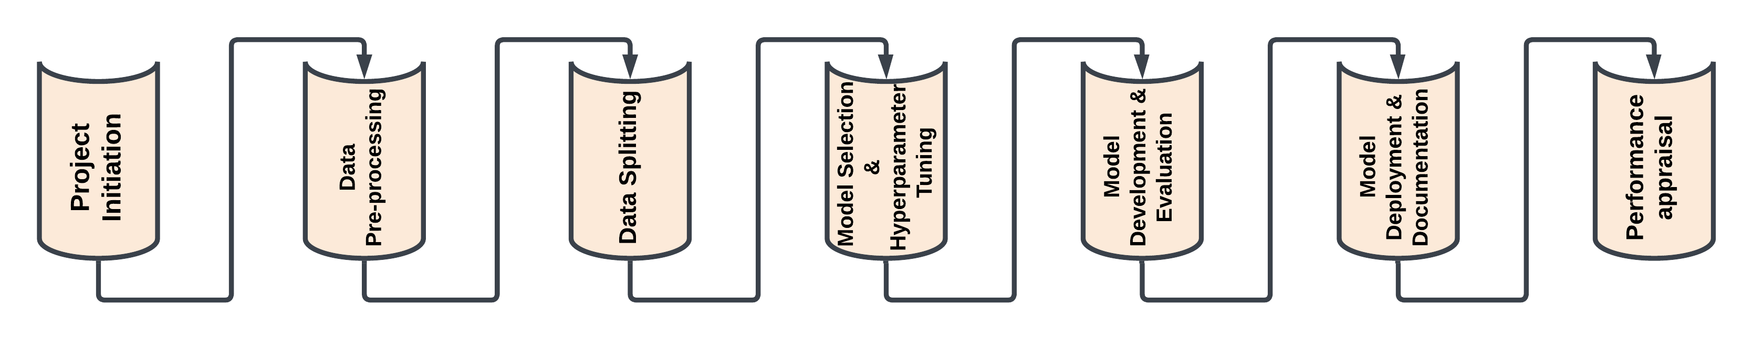

The following are the main contributions of this project:

**Early Disease Detection.** Using audio and video data, the project aims to build a deep learning model for categorizing swine diseases. Early disease detection aids in preventing the spread of infections within pig farms and lowering pig mortality rates.

**Continuous Disease Monitoring.** The project introduces an innovative technique for continuous disease monitoring in swine populations, an automated audio-based disease classification system. Through timely interventions and enhanced early disease detection made possible by ongoing monitoring, the risk of disease outbreak is reduced.

**Public Health and Food Safety.** Early disease detection is essential to maintaining the security of the food supply chain and ensuring the welfare of consumers. Enhancing food safety and public health, the project's contribution to the production of safe pork products helps shield consumers from potential health problems.

**Improved Animal Welfare Standards.** Early disease detection and rapid disease intervention significantly lower pig mortality and suffering rates, highlighting the moral treatment of animals. The project advances animal welfare standards, enhancing the swine farming sector's credibility and reputation.

**Continuous Disease Monitoring.** The project introduces an innovative technique for continuous disease monitoring in swine populations, an automated audio-based disease classification system. Through timely interventions and improved early disease detection made possible by ongoing monitoring, the risk of disease outbreaks is reduced.

Veterinarian care and animal health surveillance may be significantly affected by the model's ability to accurately categorize swine diseases. It provides a comprehensive solution with many uses in the agricultural and cattle sectors.

## 

## Project Requirements

The functional requirements of this project are carefully and thoroughly structured to ensure a smooth process for data collection, organization, and analysis. Firstly, the project places a strong emphasis on thoroughly collecting pig cough sounds from various sources, including academic research papers, YouTube videos, and veterinary organizations. This involves extensive efforts in gathering, cleaning, and regularly updating the data to ensure accuracy and consistency. It is important to comply with legal and regulatory requirements such as data protection laws like GDPR and potentially obtain approval from an Institutional Review Board to maintain ethical standards.

To ensure secure and reliable data storage, effective communication with research paper authors and organizations is encouraged to obtain the necessary permissions. Integration with AWS cloud storage provides a reliable platform for storing data. To improve dataset diversity and quality, various data augmentation techniques, including additive, subtractive, and frequency modulation methods are implemented.

Collaborative development is facilitated through GitHub for version control and collaboration purposes. Robust documentation covers important aspects such as data sources, preprocessing steps, augmentation methods, and architectural design to promote transparency and reproducibility of the research project. Thorough testing, error handling, and security measures have been put in place to guarantee the integrity and safety of sensitive data. These consist of encryption techniques used during both the transmission and storage phases. Table 1 depicts the functional requirements for this project.

**Table 1**

*Functional requirements*

| **Functionality** | **Requirements** |
| --- | --- |
| Collection and Organization of Data | Gathering information from various sources. Preparing and cleaning data to ensure its accuracy and consistency. A resilient and efficient system for managing data storage and organization. Ability to update data on a regular basis |
| Legal and Regulatory Requirements | Adherence to data protection laws and regulations, such as General Data Protection Regulation (GDPR). Potentially including approval from an Institutional Review Board (IRB). |
| External contact points | Communication with research paper authors and organizations to obtain necessary permissions and data access. Data storage and retrieval integration with cloud storage APIs (AWS S3). |
| Data usage permits and authorization | Obtaining proper licenses and permissions for using the cough sounds data. Ensuring that the synthesized data created through augmentation techniques complies with the licenses of the original data. |
| Data Augmentation | Implementation of various techniques |
| Version Control and Collaboration | Use of GitHub for source code management and collaborative development |
| Documentation | Detailed documentation of the data sources. Data preprocessing steps. Various methods of augmentation. An architectural design that promotes both transparency and reproducibility |
| Testing and Validation | Creation and formulation of test scenarios and cross-validation techniques |
| Data-driven modeling and analysis | Enable deep learning-based classification. Support multiple multiclass models. Hyperparameter tuning for model optimization. Comparison model. Resolution for enhanced accuracy |
| Error Handling and Recovery | Included various metrics and interactive tools utilized |
| Security | Ensuring the security of sensitive data. Encryption during storage and transmission. Regular security audits to identify and mitigate potential vulnerabilities. |

The goal of AI research is to discover effective techniques for gathering and storing data. This involves gathering recordings of pig coughs from reliable sources and creating new data using sound synthesis methods. In all phases of data processing, training, and evaluation, the emphasis is on resource optimization and efficiency improvement. Through efficient optimization techniques, to do this while minimizing training time and memory usage.

Four important AI models are used to address the specific challenges in the classification of swine diseases: ResNet, known for successfully handling very deep networks and capturing complex audio features important for swine cough pattern detection, DenseNet, which makes the best use of the information at hand, especially when data is scarce to ensure efficient feature extraction. Convolutional Neural Network, skilled at learning hierarchical representations from grid-structured data like audio, which is essential for accurate classification, and Deep Neural Network, adaptable to a variety of different environments. Table 2 shows all the necessary AI requirements for this project.

**Table 2**

*AI requirements of this project*

| **AI Requirement** | **Description** | **Suitability for Swine Disease Classification** |
| --- | --- | --- |
| Data Collection | Collect pig cough recordings from reliable sources, analyze YouTube cough videos, and create new data using sound synthesis methods. | The quantity of distinct cough sound samples gathered and labeled. The percentage rise in the size of the data set following data augmentation. |
| Data Storage | Utilized AWS services primarily to store the acoustic data in the cloud. | The quantity of data housed within the AWS cloud storage system, measured in (GB/TB), as well as the system's reliability and uninterrupted operation. |
| Resource Utilization | Maximize efficiency in data processing, training, and evaluation with computational resources. | Improvements in the duration of training and reduction in memory consumption following optimization |
| ResNet | A deep CNN architecture with a good track record for very deep network training. Skip connections are used to prevent vanishing gradient issues. | As it handles deep networks well, it is excellent for classifying swine diseases. Captures complex audio features that are aid better performance. |
| DenseNet | A CNN architecture that encourages feature reuse and gradient flow through dense connections between layers. | Effectively using the information that is available when there is little data. useful in situations where data, like swine cough sounds, may be scarce. |
| Convolutional Neural Network (CNN) | A subset of deep neural networks that learns hierarchical representations using convolutional and pooling layers. | User engagement metrics, such as time spent on the platform, clicks, zooms, and searches |
| Deep Neural Network (DNN) | Neural networks with many hidden layers that can recognize intricate patterns in data. | Adaptable and useful for many different deep-learning tasks. investigates intricate patterns and relationships in audio data for the classification. |

The project's data requirements encompass various facets in an academic manner. The Swine Cough Sound Dataset serves as the central data source, comprising audio files sourced from research papers, YouTube, and veterinary organizations. Metadata and Annotations are carefully curated by hand to include information such as the source, disease labels, and relevant details. To enhance dataset diversity, generated Synthetic Data internally. Furthermore, this research includes meticulous collection and organization of datasets to ensure robustness in subsequent deep learning-based classification processes. Acoustic parameters such as RMS, frequency, and duration of cough sounds are also extracted for thorough analysis. Stringent measures are implemented to maintain data integrity and accuracy, guaranteeing the reliability of this project's outcomes.

**Table 3**

*Data Requirements of Project*

| **Data Requirement** | **Description** | **Source** |
| --- | --- | --- |
| Swine Cough Sound Dataset | Sound recordings of swine coughs were sourced from various academic research papers, YouTube videos, and veterinary organizations. These recordings encompass a wide range of respiratory conditions exhibited by pigs. | Research Papers: Sought information from authors and organizations. Cough sounds from videos on YouTube were extracted and labeled based on the titles. |
| Metadata and Annotations | The research team manually created metadata and annotations during the labeling process. Contains information about the source, disease labels, and other pertinent details. | Used combined, subtractive, and variation-in-frequency methods of data augmentation. Contains source attribution, descriptions of the diseases, and related data. |
| Synthetic Data | Internally produced audio files that have been artificially generated. intended to increase the diversity of the dataset. | Livestock organizations and providers of farm data. Auditory confirmation and the spectrogram were used to categorize the sounds as artificial coughing. |
| Pig Cough Sounds | The data description includes various acoustic parameters of the cough sounds. These parameters include RMS (Root Mean Square), frequency, and duration of the cough sounds | The cough sounds were extracted from cough attack recordings, which consisted of multiple individual coughs. The data collection was done over a period of three days in early spring. Welch method and fast Fourier analysis were used to extract acoustic features like frequency and duration. |

## Project Deliverables

The project’s main goal is to develop a system for detecting and classifying pig diseases using audio recordings in farms, which will help farmers to detect and stop the spread of diseases early. The system will identify various types of diseases in swine like cough, African swine fever, Pneumonia. It commences with a clear project background, detailing the technical prerequisites, and conducting an extensive literature review of the research papers. A powerful data management strategy which consists of collecting audio, video data from the farms, and preprocessing of pig sounds from external noises. Models and algorithms for data processing are chosen calculatedly followed by an evaluation of the structured model. The safe storage of data, project’s code, model is maintained through GitHub repository. The final summary encapsulates the necessary elements of planning, execution, and documentation for the complete project. Table 4 shows the project deliverables that are planned for this project.

**Table 4**

*Listing of project deliverables with dates*

| **Phase** | **Deliverables** | **Description** | **Date** |
| --- | --- | --- | --- |
| Project Understanding | Literature Survey report | Summarizes the findings and conclusions from related research papers. | 11-August 2023 |
|  | Technology and data requirements report | Evaluates technology and data requirements for the project | 02-October 2023 |
| Project Proposal | Project Plan | Outlines development methodology, milestones, and data management | 16-October 2023 |
| Data Preparation | Data Collection, preprocessing. | Gathers data and conducts data exploration and preprocessing. | 23-October 2023 |
|  | EDA | Summarizes the key findings and insights from exploration of the dataset. | 01-November 2023 |
|  | Feature Engineering | Describes the transformation of features and the relevance in addressing the problem. | 07-November 2023 |
|  | Data Modelling Report | Finalizing the data and processing the data to feed into deep learning models | 13-November 2023 |
| Model building | Model Proposal and development. | Proposal for models to address the problem, including model architecture, data flow and technologies used for development. | 21-November 2023 |
|  | Model accuracy and evaluation | Report on model accuracy and evaluation using selected performance metrics. | 30-November 2023 |
| Data Documentation | Fall Semester report | Detailed report of the project progress until fall semester | 06-December 2023 |
|  | Project Presentation | Presentation of project progress for fall semester | 13-December 2023 |
| Evaluation | Comparison report | Reporting the results of the developed models and the evaluation metrics | 29-January 2024 |
|  | Summary report | Summarizing the performances and research conducted during the project. | 19-February 2024 |
| Hyperparameter tuning | Hyperparameter tuning report | Documents  the process and  outcomes of  tuning model  hyperparameters  for performance | 27-February 2024 |
| Deployment | Prototype of web application | Development of a web portal to host the model. | 04-March 2024 |
|  | Presentation | Presentation of the project using Microsoft PowerPoint. | 31-May 2024 |
|  | Final Report | Final documentation of the whole project. | 31-May 2024 |

## Technology and Solution Survey

The outlook of pig health monitoring system has undergone revolutionary changes because of the technology and solutions from all over the world that strengthen audio and video analysis. This research drives the industry for early disease detection and animal welfare. Various key studies and technologies are discussed in technology and solution review Table 5.

One notable analysis inspected by researchers is on pig health issues using sound data. In the paper “Recognition System for Pig Cough based on Probabilistic Neural Networks (PNN)”, A.Chedad, *et al.* (2021) combined probabilistic neural networks with Mel Frequency Cepstrum Coefficients (MFCC). This method allows us to classify different pig sounds based on sound patterns. This method also uses Convolutional neural networks (CNN) to pre-classify the pig sounds with normal sounds like cough and non-cough where the cough sounds are passed to PNN and classify the diseases in the pigs.

In another video-based research paper “Automatic monitoring and detection of tail-biting behavior in groups of pigs using video-based deep learning methods.” By Franziska Hakansson, *et al.* (2023) Employed convolutional neural networks (CNN) and Long Short-term Memory (LSTM). The research is a multi-step process for detecting the tail-biting events in the video data. It starts the feature extraction using pre-trained CNN which classifies the sequential images using LSTM and CNN networks. Best parameters are determined through cross validation and final models are tested for the evaluation of performance.

In the paper “Animal Vocal Recognition-Based Breeding Tracking and Disease Warning”, by Yinggang Xie, *et al.* (2023) research uses Deep Learning to identify pig vocalizations to enhance pig farming efficiency by quickly identifying the issues. The fusion of residual Networks (ResNet) and Long Short-Term Memory (LSTM) were customized, optimized and trained. Mel frequency Cepstral Coefficients (MFCC) are used for analysis. The model showed exceptional performance in identifying pig vocalizations, stating the capacity of deep learning in livestock management with efficient real-time health monitoring systems.

In the paper “Alarm Call Analysis of Farm Pigs Using Deep Learning and Noise Filtering Methods”. By Kaushik Dey (2024) used a pre-trained CNN, instead of using a custom CNN and data augmentation to counter the data shortage issue. As part of preprocessing data is normalized and Mel spectrograms were plotted. The processed data is fed into two DNN namely EfficientNet-Bo (3 layers) and ResNet-18(4 layers). Both the models are executed on two kinds of data, processed data, and data with added noise (augmented data.) The number of layers makes most of the difference between the two chosen models.

**Table 5**

*Technology survey of model comparison*

| **Paper** | **Model** | **Key Points** |
| --- | --- | --- |
| Recognition System for Pig Cough based on Probabilistic Neural Networks | PNN | The research utilizes novel neural network methods based on probabilistic neural networks for pig cough recognition |
| Automatic Monitoring and Detecting of Tail-Biting Behavior in Groups of Pigs Using Video-Based Deep Learning Methods | CNN-LSTM | The CNN-LSTM model explains the better performance in recognizing the tail-biting behavior compared to CNN-CNN models |
| Automatic Detection and recognition of Pig Wasting Diseases using Sound Data in Audio surveillance Systems | Mel Frequency cepstral coefficients (MFCC) | The technology offers an efficient and economical solution for detecting pig wasting diseases using cough sounds |
| An Improved Machine Learning Model for Pig Abnormal Voice Recognition | Hidden Markov Model (HMM) | This technology enhances sound recognition efficiency by introducing sound noise reduction and machine learning algorithms |
| Animal Vocal Recognition-Based Breeding tracking and Disease Warning | MFCC, LSTM, ResNet | MFCC parameters are extracted from the original frequency and advanced preprocessing techniques achieves a better accuracy with LSTM and ResNet |
| Alarm Call Analysis of Farm Pigs Using Deep Learning and Noise Filtering Methods  Practical Monitoring Pigs for IoT-Based Large-Scale Smart Farm | EfficientNet-Bo, and ResNet-18  GMM, Otsu, Image processing techniques. | The study utilizes pre trained models, data augmentation and noise filtering to analyze farm pig alarm calls effectively.  The study uses edge computing, hybrid approach uses tinyYOLO3 for pig detection |

The above-mentioned studies explain the ongoing capability of technology to transform disease detection, animal welfare and overall efficiency in the pig farming industry. These technologies consistently evolve and become valuable tools for farmers which help in early disease detection. The collaboration of multiple countries and departments enriches innovative solutions.

In the paper “Practical Monitoring Pigs for IoT-Based Large-Scale Smart Farm”. By Sungju Lee(2019) proposes an 0n-device computing method for real-time detection of undergrown pigs in smart farms, emphasizing cost reduction and efficiency. Using edge computing, the hybrid approach employs TinyYOLO3 for pig detection through deep learning and image processing techniques (GMM, Otsu, connected component) for size computation. This overcomes the challenges of overlapping pigs in group housing, providing an automatic alarm system based on relative size analysis rather than actual weight. The system, designed for resource-constrained IoT devices, balances accuracy and speed by leveraging multi-core CPUs and many-core GPUs through heterogeneous computing. It serves as an aid to farm workers, sending alarms for abnormal growth rates.

## Literature Survey of Existing Research

The purpose of this section is to structure the literature review on the ongoing demand for identifying various diseases in swine. While referring to several relevant previous studies, to establish a benchmark for evaluating the performance of the model. The approach is to comprehensively evaluate these methodologies to identify the strengths and weaknesses. The studies reviewed in this survey explain various techniques like acoustic and deep fusion to motion-based video monitoring and thermal data analysis. Table 6 below includes the key-finding of various methods based on the data source that are employed for this study.

One study that stands out in the review is “Fusion of acoustic and deep features for pig cough sound recognition.” by Weizheng Shen *et al.* (2022) has achieved an impressive 97.35% classification accuracy using Support Vector Mechanism. The data that was collected using microphone and sound cards is preprocessed using 2D Time-Frequency Representations (TRFs) using Convolutional Neural Networks (CNN). The major significance of this model is the combination of audio and deep features which is the reason for achieving high accuracy. The major drawback of this model is the amount of labeled data required for training the model.

Another noteworthy study is by Hong Hee Chang *et al.* (2013) in their paper “Automatic Detection and recognition of Pig Wasting Diseases Using Sound Data in Audio Surveillance System,” used sparse representation classifier. The data for this project is collected using a wireless sensor network and a camcorder. Support Vector Data Description (SVDD) process is used to differentiate pig sounds from general noise which results in 94% accuracy. The major advantage in this process is the robust and economical solution for disease monitoring in pig farming.

**Table 6**

*Literature survey of key findings of the models*

| **Title** | **Country** | **Method Employed** | **Data Source** | **Key Findings** | **Accuracy** |
| --- | --- | --- | --- | --- | --- |
| Fusion of Acoustics and Deep Features for Pig Cough sound Recognition | China | Support Vector Mechanism | Microphones and soundcards | Combining acoustics and deep features improves accuracy. Required substantial amount of labeled data | 97.35% |
| Automatic Detection and Recognition of Pig Wasting Diseases using Sound Data in Audio Surveillance System | South-Korea | Sparse Representation Classifier | Wireless Sensor Network, Camcorder | Eliminating the need for frequent system updates. It stands out for its cost effectiveness | 94.0% |
| Classification of Porcine Wasting Diseases Using Sound Analysis | South-Korea | SPSS | Crowd source from Pyo Joon farm | Uses sound analysis to classify porcine wasting diseases using cough sounds |  |
| Depth wise Separable Inception Subnetwork for Pig Treatment Classification Using Thermal Data | Korea | CNN, LeakyReLU, CNN-Inception | Thermal dataset captured using a FLIR camera | Explains that pitch intensity remains consistent for coughs of infected pigs |  |
| Automatic scoring of lateral and sternal lying posture in grouped pigs using image processing and Support Vector Machine | Netherlands | SVM | Top view images from cameras located on the ceiling in pig farms | Machine vision and machine learning techniques can be used to monitor the health and welfare of pigs in large-scale farms. |  |
| Investigation of acoustic and visual features for pig cough classification | China | SVM, KNN, Random Forest | Crowdsourcing from pig house in Harbin, Heilongjiang Province, China | Combined both visual and acoustic features and created a new feature vector by dimension reduction | 96.45% |
| Cough sound analysis to identify respiratory infection in pigs | Italy | FET, RMS | Crowd sourcing from lab and field | Used available data to synthesis new data and verified the accuracy. | 94.5% |
| Real-time Recognition of Sick Pig Cough Sounds | China | Fuzzy C-means Cluster | Crowdsourcing and induced coughs in a laboratory | Pig cough sounds and false sounds are classified using the power signal density method. It is useful in cases where immediate action is required | 85.5% |
| Research on Improved Dense Nets Pig Cough Sound Recognition Model Based on SENets | China | Dense Nets + SE-DenseNet-121 | Artificial pig sound generation using signal acquisition system | Improved the performance of Dense Net model using SENets by 0.9% with overall accuracy | 93.8% |
| Recognition of sick pig cough sounds based on convolutional neural network in field situations | China | Fine-tuned CNN | Big commercial piggery located in Harbin, Heilongjiang province, North China. | Features are extracted using FC layers which is fed into SoftMax for classification. |  |
| Cough localization for the detection of respiratory diseases  in pig houses | Belgium | Coordinates of the triangle sound | Estimated positions of a reference sound were compared with real. positions in various microphone configurations. | It's not about classifying the coughs but using them to figure out where they're happening |  |

The above overall study explains the diversification of how technologies are used in the classification of diseases using audio in swine all over the world. The review studies emphasis on interdisciplinary nature of the field which include methods and techniques including from machine learning and data analysis to audio and image processing. Such integrative collaborations expand the range of the research. With constant effort, pig disease detection using audio data technology can become a valuable fool for farmers, veterinarians, animal welfare and overall farming efficiency.

# Data and Project Management Plan

## Data Management Plan

### Data Collection Approaches

In the project context, data collection is a crucial step that influences the success and accuracy of the model. The data collected for this project is in the form of acoustic recordings, specifically pig cough sounds. A combination of two distinct data collection approaches was utilized to obtain a diverse and representative dataset for training the deep learning model.

The first data collection approach involved reaching out to research paper authors and relevant organizations in swine health and acoustics. This method allowed the project to tap into the expertise of those actively involved in swine disease research. By establishing contact and requesting data access from these professionals, the project gained access to high-quality, well-documented acoustic recordings of pig cough sounds. These recordings are invaluable for training a deep learning model, as they will likely be accurately labeled and represent real-world scenarios.

The second data collection approach was more resourceful and involved extracting pig cough sounds from publicly available sources, primarily YouTube. This approach enabled the project to expand the dataset significantly. The process involved searching for videos with relevant titles or descriptions that suggested the presence of pig cough sounds. Once identified, these videos were used as sources for audio data extraction. The video titles or descriptions were initial labels for the extracted audio samples.

A data augmentation process was employed to enhance the dataset's diversity and size. This process involved manipulating the existing data in various ways. Additive, subtractive, and frequency modulation techniques were used to create new audio samples from the initial dataset. Additive methods added background noise to simulate different environments, subtractive methods removed portions of the sound to simulate various recording conditions, and frequency modulation introduced variations in the pitch and tone. These augmentation techniques allowed for the creation of additional training data, making the deep learning model more robust and adaptable to different real-world scenarios.

File sizes for acoustic data can vary depending on the recording duration, audio quality, and sample rate. Typically, audio files in the project's dataset are stored in formats like WAV or MP3. These file formats offer a balance between audio quality and file size. WAV files tend to be larger, especially for longer recordings, as they store audio data in a lossless format. MP3 files, on the other hand, are compressed and result in smaller file sizes, making them more suitable for storage and processing. For example, a one-minute WAV file of pig cough sounds might be several megabytes, whereas the audio recorded in an MP3 format may be significantly smaller, often in the hundreds of kilobytes. When choosing file formats for the dataset, it is essential to consider the trade-off between audio quality and storage requirements. The project likely has a combination of both file types to balance the need for high-quality data and efficient storage in the cloud, mainly if AWS is used for data storage.

### Data Storage Methods

The choice of data storage methods impacts not only the accessibility and availability of data but also the overall performance of the deep learning model. The project primarily utilizes cloud-based storage solutions, focusing on AWS (Amazon Web Services) for data management.

As implemented in AWS, cloud storage offers several advantages for this project. It provides scalability, flexibility, and accessibility, making it an ideal choice for handling large datasets. AWS allows the project to store and manage data in a distributed manner, ensuring data availability and reliability. Moreover, it eliminates the need for extensive on-site hardware infrastructure, which can be costly and less flexible.

AWS provides various storage services, and the selection depends on specific requirements. For instance, Amazon S3 (Simple Storage Service) is commonly used for object storage, making it suitable for storing audio files and metadata. This service offers high durability, low-latency access, and seamless integration with other AWS tools and services. S3 allows the project to organize data into buckets and apply access control policies, ensuring data security and integrity.

To efficiently manage the dataset, the project can implement lifecycle policies in AWS. These policies automate data transition between storage classes, such as moving less frequently accessed data to cheaper storage options like Amazon Glacier. This approach optimizes costs while retaining the ability to retrieve data when needed. Additionally, the project can facilitate quick and efficient data transfers between storage and processing resources, which is particularly important when training and using deep learning models that require significant computational power. Data durability is critical for any project, especially when dealing with valuable and extensive datasets. AWS services like AWS Backup and AWS Disaster Recovery ensure that data remains protected and recoverable in case of unexpected events.

Data security is a paramount concern, and AWS provides robust security measures. Access control policies, encryption, and monitoring services help safeguard the dataset against unauthorized access or data breaches. AWS Identity and Access Management (IAM) allows the project to define and manage access permissions for different team members and applications, enhancing security while promoting collaboration. AWS offers compliance certifications and audit trails, which facilitate adherence to data protection regulations and allow the project to maintain comprehensive data access and usage records.

### Data Management methods

Ensuring the extensive acoustic dataset is organized, accessible, and ready for analysis. The project relies on a combination of methods to manage the data effectively.

Firstly, data organization is essential. Metadata is used to label and categorize each audio sample. This metadata includes information about the source, recording conditions, and any data augmentation techniques applied. Such an organization aids in selecting relevant training data and contributes to the model's accuracy. Tags and labels are vital in classifying the audio samples, enabling the deep-learning model to understand and differentiate between cough sounds.

Version control is another crucial aspect of data management, especially when the project is developed on GitHub. Version control systems, such as Git, track changes and updates in the project's codebase, including any modifications to the dataset or data processing scripts. This approach helps maintain data consistency and traceability, ensuring that team members can collaborate effectively without the risk of overwriting or losing important data.

Regular backups and data snapshots are taken to ensure data integrity and recoverability. AWS, the chosen cloud storage solution, provides mechanisms for automated data backup. This ensures that data remains secure and accessible, even during unexpected data loss or corruption. Backups are scheduled at appropriate intervals to minimize data loss. Data quality checks and validation procedures are implemented to maintain the dataset's quality and integrity. This involves identifying and addressing any anomalies or inconsistencies within the data, such as mislabeled or corrupted audio samples. Data cleaning techniques may be applied to rectify such issues and maintain the dataset's reliability.

Furthermore, data access control is enforced to protect the sensitive and valuable dataset. AWS Identity and Access Management (IAM) defines and manages permissions, ensuring that only authorized personnel can access and modify the data. This enhances data security and prevents unauthorized alterations or data breaches.

### Data Usage Mechanics

Data Usage Mechanisms are critical in ensuring that the extensive acoustic dataset for the project is used responsibly, ethically, and efficiently. These mechanisms encompass documentation, metadata, and a precise distribution of responsibilities among team members involved in various Data Management Plan (DMP) phases.

Documentation for data usage, distribution, and acquisition is essential for future users, ensuring that the dataset is employed in accordance with ethical and legal guidelines. The documentation outlines the terms of usage, data sources, and any licensing agreements associated with the acquired data. It provides a clear roadmap for accessing and distributing the data, setting the stage for responsible data handling.

Metadata, detailed information about each audio sample, is a crucial component in data management. It includes data on the source of the recording, any applied data augmentation techniques, and relevant contextual information. Metadata aids in understanding the dataset's composition and assists users in selecting suitable data for their specific tasks. It facilitates data discovery and selection by providing essential details that enhance data usability.

A clear distribution of responsibilities among team members is essential to manage the data and maintain accountability efficiently. The following Table 7 delineates the roles and responsibilities of teammates in different phases of the Data Management Plan.

**Table 7**

*Data Management Plan*

|  |  |  |
| --- | --- | --- |
| **Activity** | **Assigned to** | **Participation** |
| Data Collection | Hruthik, Kishore, Rajeev, Ramya | To gather different types of cough sounds from different sources |
| Documentation and Metadata | Rajeev, Ramya | Documentation and overseas comprehensive metadata creation |
| Data storage and recovery | Hruthik, Kishore | Oversee data storage on AWS including regular backups and recovery through implementation of storage lifecycle. |
| Data sharing | Kishore | Manages access control using AWS IAM and controls the access to authorized users. |
| Ethics and legal compliance | Ramya | Ensures that all data acquisition and usage comply with ethical and legal guidelines |
| Data preservation | Rajeev | Ensures that the dataset remains accessible and usable. |

## Project Development Methodology

The System Development Life Cycle (SDLC) is a structured approach to guide the development of systems or projects from inception to deployment. The CRISP-DM (Cross-Industry Standard Process for Data Mining) model is the chosen SDLC framework in the project context. CRISP-DM is a comprehensive and widely accepted methodology for data mining and machine learning projects.

CRISP-DM is a flexible and iterative model that consists of several key stages, including Business Understanding, Data Understanding, Data Preparation, Modeling, Evaluation, and Deployment.

In the initial "Business Understanding" phase, the project team defines objectives, requirements, and success criteria. This phase is essential in understanding the problem domain, in this case, swine disease classification, and the desired outcomes. The subsequent stages, "Data Understanding" and "Data Preparation," involve data collection, exploration, and preprocessing. Given the project's emphasis on acoustic data from pig cough sounds, this involves acquiring, cleaning, and organizing the dataset for analysis. The "Modeling" stage, where the deep learning model is developed, aligns with the core objective of classifying swine diseases using acoustic data. The model is trained and refined to achieve optimal accuracy. The "Evaluation" phase assesses the model's performance, ensuring it meets the predefined success criteria. Based on the evaluation results, iterative adjustments may be made to enhance model performance. Finally, the "Deployment" stage involves implementing the model for real-world usage, which might involve integrating it into a system for disease diagnosis or other applications in this project's context.

### Business Understanding

The initial "Business Understanding" phase is pivotal in framing the project's objectives and contextualizing its importance. This phase involves several vital components. The project's primary domain revolves around the impact of livestock on swine respiratory diseases. The team needs to comprehend the intricacies of swine health and the potential consequences of respiratory issues within the livestock industry. It is essential to be aware of the increasing prevalence of swine respiratory diseases, as this background knowledge highlights the urgency and significance of the project. Understanding the current challenges faced in the industry is crucial.

Acoustic analysis emerges as a prominent technology in this context. The team should evaluate the feasibility and effectiveness of acoustic analysis in diagnosing swine diseases through audio recordings. Gathering insights from existing literature on swine audio, video, and image data is invaluable. This survey provides a foundation for understanding the available resources, potential techniques, and challenges in this field. Understanding what has been previously explored in swine health and acoustic data analysis provides a foundation for the project's approach. It helps identify gaps in current knowledge and informs the project's direction. Acquiring a comprehensive understanding of the terminology and technology stack relevant to acoustic analysis and deep learning is essential. This ensures effective communication and decision-making throughout the project.

### Data Understanding

In the "Data Understanding" phase of the project, several crucial steps are undertaken to gain a comprehensive understanding of the data that will be used for training and testing the deep learning models.

The initial step involves gathering diverse data related to swine respiratory diseases. This includes audio recordings of cough sounds, which serve as the primary dataset for the project. The data collected should encompass various disease states, environmental conditions, and other relevant factors to ensure the model's robustness. The team conducts a thorough assessment of data quality. Parameters like POLQA (Perceptual Objective Listening Quality Assessment) and Audio Delay are used to evaluate the audio data's integrity and accuracy. Data with poor quality may be filtered out or subjected to data preprocessing.

Data exploration is vital to uncover patterns and characteristics within the dataset. Visualization techniques, such as plotting waveforms and spectrograms, provide insights into the structure and features of the audio data. This step helps identify any anomalies or trends within the dataset. Further exploratory data analysis involves a deeper dive into the dataset using various visualization techniques. Waveforms reveal the temporal patterns in cough sounds, while spectrograms offer a frequency-domain view, aiding in identifying distinguishing features of different respiratory diseases. To ensure data accessibility and security, the project team stores the data on the cloud, specifically AWS. Cloud storage offers scalability, backup, and easy access to the dataset, facilitating collaboration and efficient data management throughout the project's lifecycle.

### Data Preparation

The project's "Data Preparation" phase ensures that the acoustic data is appropriately conditioned and ready for model training and evaluation. The first step is to choose the most essential acoustic features for analysis. This could include pitch, duration, spectral characteristics, and other audio-specific characteristics indicative of various swine respiratory diseases. Then, the dataset is cleaned to remove any noise or anomalies. Data labeling ensures that each audio sample is assigned to the correct category of swine respiratory disease. Normalizing audio characteristics to make them consistent and comparable may be part of data transformation.

Data augmentation techniques are used to increase the dataset's diversity. Additive and subtractive methods introduce variations into acoustic data, simulating various environmental conditions and recording scenarios. This increases the dataset's robustness and representativeness in real-world situations. Principal Component Analysis (PCA) and dimensionality reduction techniques may be used to reduce the dataset's complexity. This improves the deep learning model's efficiency by focusing on the most relevant features while reducing noise and computational demands. The dataset is then divided into training, validation, and testing subsets in the final step. This distinction ensures that the model can generalize to previously unseen data.

### Modeling

The project's "Modeling" phase is critical for developing and training deep learning models. The project begins with a thorough examination of various multiclass classification models. This includes reviewing existing models, analyzing their strengths and weaknesses, and determining their suitability for swine disease classification.

The team chose several models for evaluation after careful consideration. ResNet, DenseNet, Convolutional Neural Networks (CNN), and Deep Neural Networks (DNN). Each model has its own set of features and capabilities, and the choice is dictated by the project's specific requirements as well as the complexity of the classification task.The selected deep-learning models are designed and implemented by the team. This includes specifying hyperparameters, defining the architecture, and preparing the models for training. Each model is specifically designed to handle acoustic data, with the appropriate layers and configurations for feature extraction and classification. The models that were chosen are integrated into the project's infrastructure. The preprocessed and augmented dataset is then used to train them. During training, the models learn to recognize patterns and characteristics in the acoustic data indicative of various swine respiratory diseases. During validation, model parameters are optimized to achieve high accuracy and robust performance.

### Evaluation

The project's "Evaluation" phase is critical in determining the performance and effectiveness of the developed deep learning models. The first step is to use validation data to evaluate the model’s performance. Accuracy, precision, recall, and F1 score are all calculated metrics. The model's parameters are also optimized by hyperparameter tuning, ensuring the best possible performance. The models are then evaluated using a separate test dataset that was not used during the training or validation phases. This step simulates real-world scenarios and evaluates the model’s generalization capabilities objectively.

The performance of the model is evaluated using predefined evaluation metrics. These metrics aid in quantifying the accuracy of the models in classifying swine diseases from acoustic data. The project team compares the performance of the deep learning models developed with benchmark models or existing solutions. This comparison aids in comprehending the effectiveness of custom models in the context of swine disease classification. Any issues or discrepancies discovered during the evaluation phase are addressed, and any changes required to improve model performance are implemented. This could include improving model architecture, adjusting hyperparameters, or improving data preprocessing techniques.

### Deployment

The project's "Deployment" phase entails making the developed deep learning model accessible and usable in real-world applications. The AWS cloud platform hosts the deep learning model and the associated data and infrastructure. This ensures model scalability, dependability, and easy access from anywhere. A web-based user interface is created using ReactJS to make the model accessible to users.

The web interface includes a dashboard allowing users to input audio data for classification intuitively. It should be easy to use and should guide users through the process. The implemented model can be integrated to stream real-time audio data, allowing users to classify swine diseases instantly. The model is constantly monitored and maintained to ensure that it is accurate and current. A thorough report and a presentation summarizing the project's objectives, methods, findings, and deployed solutions will be created.

## Project Organization Plan

The Project Organization Plan includes a Work Breakdown Structure (WBS) that uses CRISP-DM methodology to decompose the project into key phases hierarchically. As shown in Figure 2, the WBS structure is divided into the following phases: Business Understanding, Data Understanding, Data Preparation, Modeling, Evaluation, and Deployment.The foundational phase of the project is Business Understanding. During this phase, the project team focuses on learning about the domain and history of swine respiratory diseases. During this phase, liaison with domain experts and stakeholders is required to clarify project objectives, requirements, and success criteria. It lays the groundwork for the subsequent phases, ensuring the project aligns with the livestock industry's real-world needs. Hruthik coordinates expert meetings and compiles disease history, while Jugal Kishore conducts industry research and assists in expert interactions. Rajeev's responsibilities include documentation and data structuring, while Ramya aids in presentation creation and organizing information for stakeholder interactions.

The second phase is Data Understanding, which extends the project's understanding of the dataset. This phase includes data collection, quality assessment, and exploratory data analysis to uncover insights into the dataset's characteristics. The team investigates additional data sources and reviews the literature to understand relevant terminology and technologies better. This phase connects the initial domain understanding to the tangible data driving the project. Hruthik oversees data collection and initiates quality checks, Ramya leads exploratory data analysis and reviews relevant literature, Rajeev collaborates with domain experts and documents insights, and Jugal Kishore supports data cleaning, labeling, and initial transformation while assisting in organizing datasets.

Following that is data preparation, which includes data cleaning, labeling, transformation, and synthesis via augmentation techniques. Data preprocessing techniques such as Principal Component Analysis (PCA) and dimensionality reduction are used to reduce the complexity of the dataset. The data is divided into training, validation, and testing subsets to prepare for the modeling phase. This phase ensures that the dataset is well-structured, labeled, and ready for use. Ramya coordinates data preprocessing and implements reduction techniques, Hruthik collaborates in structuring data subsets, Rajeev verifies data integrity and documents the preparation techniques, and Jugal Kishore contributes to augmentation techniques and dataset structuring.

The project's core is modeling, which analyzes, selects, designs, and implements various multiclass classification models. Models such as ResNet, DenseNet, CNN, and DNN are evaluated, and custom models are built to classify swine diseases based on acoustic data effectively. The modeling phase encompasses implementing these models laying the groundwork for their use in the classification process. Ramya leads model analysis and implementation, Hruthik assists in model evaluation and provides insights, Rajeev aids in performance and documents the process, while Jugal Kishore collaborates in model implementation and custom model creation.

Following the modeling phase, the model's performance is evaluated using validation and test data. Various evaluation metrics are used to assess the model’s accuracy and effectiveness. To determine their relative performance, benchmark models are compared to custom models. This phase is critical for ensuring that the models meet the project's objectives, that any issues discovered are addressed, and that necessary improvements are made. Rajeev leads the performance evaluation, Jugal Kishore supports evaluating models and comparing their performance, Hruthik documents the evaluation process, and Ramya aids in evaluation and model optimizations.

**Figure 2**

*Work Breakdown Structure*

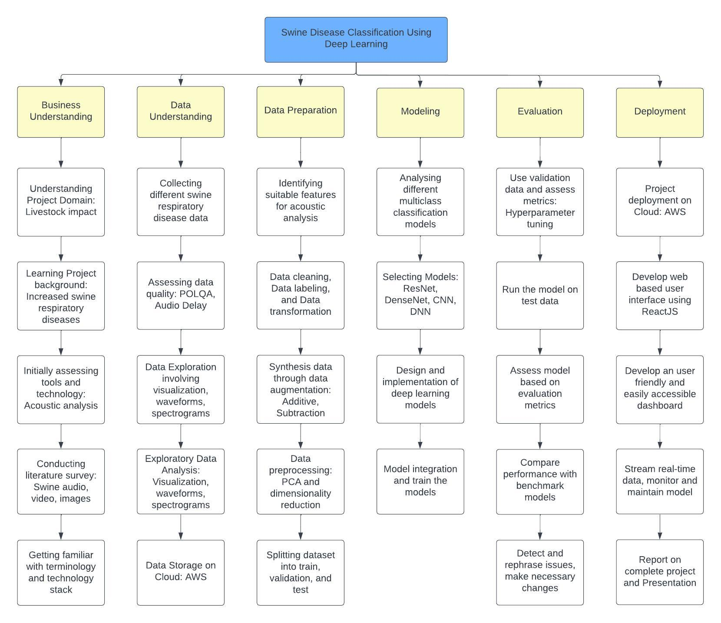

Deployment is the final stage of the project, in which the use of AWS for project deployment ensures accessibility and scalability. A web-based user interface is created for users to interact with the models, including a user-friendly dashboard for inputting audio data. Real-time data streaming and continuous monitoring and maintenance are integrated to ensure the model's reliability and accuracy. The phase concludes with a detailed project report and presentation summarizing the findings and outcomes. Hruthik oversees AWS deployment, Jugal Kishore assists in UI development and real-time data integration, Ramya documents the deployment process, and Rajeev supports UI development and continuous monitoring integration.

## Project Resource Requirements and Plan

The complete project runs on a local machine providing a convenient and controlled environment for development and testing. This local setup allows for efficient debugging and prototyping before potential scalability to work on AWS and GitHub. To ensure the PC runs efficiently, it's essential to have a 64-bit architecture, along with a substantial 8GB or more of RAM. In addition to improving system performance, this configuration makes it possible to use contemporary software and applications. When weighing your options, it's important to keep in mind that the MacBook with Apple's potent M2 chip offers exceptional performance and represents a significant advancement in computing. With a 128-bit architecture, the M2 chip is at the cutting edge of technology and offers a fluid and quick computing experience. Additionally, the use of MacBooks by most teammates has the benefit of enabling the processing of large datasets at a remarkable rate, enhancing collaborative effectiveness and productivity.

To facilitate effective development and testing, the project's initial stage involves running the code and processing the data on a local machine. The project seamlessly switches to storing the pertinent data and trained models in an Amazon S3 bucket after the training and testing phases are finished. S3, a scalable and long-lasting cloud-based storage solution, will now be used for data storage, guaranteeing data preservation and accessibility while facilitating additional analysis, deployment, and sharing within the AWS ecosystem. Utilizing Amazon S3 (Simple Storage Service) in an AWS environment to store audio data presents a scalable and economical solution. When securely stored in S3 buckets, audio files can be used for machine learning applications or just for general storage, offering redundancy and durability across multiple AWS regions. Access to these S3 buckets is controlled and secure thanks to IAM (Identity and Access Management) roles. Additionally, since pricing can differ between regions based on data transfer and storage costs, by carefully choosing the AWS region for your S3 storage, you can optimize latency and compliance while efficiently managing storage costs. The benefits of scalability, security, and cost-effectiveness are all combined in this comprehensive approach to audio data storage in AWS.

The project leverages a set of machine learning libraries such as scikit-learn (sklearn), Hidden Markov Models (hmmlearn), and pyAudioAnalysis for audio-related tasks. Additionally, the inclusion of libROSA and pyAudioProcessing provides tools for Mel Frequency Cepstral Coefficients (MFCC) and Gammatone Frequency Cepstral Coefficients (GFCC) analysis, enhancing the project's capabilities for audio feature extraction.

A flexible environment for software development, data analysis, and documentation is provided by Visual Studio Code (VS Code) with integrated Jupyter Notebook support. This can easily create, edit, and run Jupyter notebooks as part of their development workflow thanks to the Jupyter extension for Visual Studio Code. The ability to use markdown cells to record findings and insights while writing and running code is made easier by this integration and efficiently commit changes, manage versions, and collaborate with team members by directly linking the project to GitHub from VS Code. The team can now work on the projects holistically, from coding and data analysis to thorough documentation and version control, all within a single, integrated environment, because of this integrated approach.

Utilizing Jira as the project management platform has proven to be highly advantageous. This tool streamlines task planning, tracking, and prioritization, ensuring project alignment with its objectives and adherence to deadlines. Real-time progress visibility and task assignment and monitoring capabilities within Jira contribute to efficient project management, facilitating successful project completion. The integration of Gantt chart tools in Jira further enhances the team’s ability to manage project schedules effectively by offering clear visual timelines, displaying all tasks and their dependencies. Microsoft Word for documentation allows us to collaboratively create and format textual content, making it a versatile choice for the text-based documentation needs. It enables the team to compose and edit documents while incorporating various elements, to present information clearly and professionally. On the other hand, PowerPoint, a dynamic presentation tool, facilitates the creation of engaging slideshows that combine text, images, and multimedia elements. This is particularly valuable when there is a need to deliver captivating presentations that effectively communicate information to audience.

To effectively execute the machine learning and deep learning tasks within the project, the hardware setup encompasses two key components. A robust 8-core CPU equipped with 8GB of unified memory and a 256GB SSD acts as the primary computation engine, facilitating the seamless execution of machine learning and deep learning models directly within Visual Studio Code. A GPU of the Tesla P100 model, with the option for configuration up to 16GB of memory and SSD capacities ranging from 512GB to 1TB, is employed to enable parallel processing for intensive machine learning and deep learning workloads. Table 1 provides a comprehensive overview of the hardware components in the computer system, including the CPU, GPU, RAM, storage space, and other relevant information regarding their respective functions. Table 8 provides a comprehensive overview of the hardware components.

**Table 8**

*Hardware requirements for this project*

| **Hardware** | **Memory** | **Configuration** | **Purpose** |
| --- | --- | --- | --- |
| Chip: 8-core CPU | 8GB unified memory | 256GB SSD | Computation engine for running ML/DL Model in VS Code |
| GPU: Tesla P100 (Kaggle) | (Configurable to:  16GB) | (Configurable to  512GB SSD,  1TB SSD) | Parallel Computing of ML/DL Model |
| 16-core Neural Engine | (Configurable to:  16GB) |  | ML/DL Model |

*Note.* The "Configurable to" parts in the GPU and Neural Engine columns suggest that these components can be upgraded or expanded to meet specific performance needs.

The software requirements for this project include a range of libraries and packages, each serving a specific purpose. These software components are essential for various aspects of the project, such as machine learning, data manipulation, audio feature extraction, data visualization, and more. They are also crucial for setting up the web framework to serve machine learning models. Table 9 provides a comprehensive overview of the software components. For the project, a variety of tools were utilized to support different aspects of the work. In Table 10 the tools include Visual Studio Code for code development, Draw.io and Lucid chart for diagram and flowchart creation, Microsoft Excel for spreadsheet and data analysis, Google Docs for collaborative document creation, GitHub for version control and code hosting, and Zoom for video conferencing and webinars.

**Table 9**

*Libraries Used for this project*

| **Libraries/Packages** | **Purpose** | **Version** |
| --- | --- | --- |
| scikit-learn | Machine learning and classification algorithms | 1.3.1 |
| pandas | Data manipulation and analysis | 2.1.1 |
| numpy | Numerical operations and array manipulation. | 1.26.1 |
| matplotlib | Data visualization and plotting | 1.3.1 |
| seaborn | Enhanced data visualization | 0.13.0 |
| pyAudioAnalysis | Audio feature extraction and analysis | 0.3.14 |
| libROSA | Audio analysis and signal processing | 0.10.1 |
| pyAudioProcessing | Audio feature extraction and processing | 1.2.0 |
| hmmlearn | Hidden Markov Models for classification | 0.3.0 |
| python-box | Configuration and settings management | 7.1.1 |
| pyYAML | Parsing and generating YAML files | 6.0.1 |
| tqdm | Progress bar for task monitoring | 1.3 |
| joblib | Lightweight pipelining in Python | 1.3.2 |
| types-PyYAML | Type hints and stubs for PyYAML library | 6.0.12 |
| scipy | Scientific and technical computing | 1.11.3 |
| Flask | Web framework for serving ML models | 3.0.0 |
| Flask-Cors | Cross-Origin Resource Sharing for Flask | 4.0.0 |
| React.JS | Web framework for serving ML models | 18.1.0 |

**Table 10**

*Tools and Licenses need for project*

| **Tools** | **Purpose** | **License** |
| --- | --- | --- |
| Visual Studio Code | Code development and editing | Open Source |
| Draw.io | Diagram and flowchart creation | Free |
| Microsoft Excel | Spreadsheet and data analysis | Free |
| Google Docs | Collaborative document creation | Free |
| GitHub | Version control and code hosting | Free |
| Zoom | Video conferencing and webinars | Free |
| Lucid chart | Diagram and flowchart creation | Free |
| Microsoft PowerPoint | Presentation creation and slideshows | Free |

In Table 11, The total estimated cost for these resources over the project's duration is $174.00, essential for optimizing project workflows and achieving objectives.

**Table 11**

*Project Resources Cost and Justification*

| **Resources** | **Justification** | **Duration (Months)** | **Cost** |
| --- | --- | --- | --- |
| AWS | Cloud computing and services | 6 months | $ 29.00 per month |
| Jira | Project management and issue tracking | 7 months | $0.00 |
| Total |  |  | $ 174.00 |

To successfully execute this project, resources have been allocated in the form of cloud computing services provided by AWS, with a duration of six months, incurring a monthly cost of $29.00. These cloud resources are crucial for data processing and computation required for machine learning and deep learning models. Additionally, Jira, a project management and issue tracking tool, has been adopted for a seven-month duration to ensure efficient project management, collaboration, and issue tracking among the project team members. The usage of Jira is included within the project's budget at no additional cost.

## Project Schedule

### Gantt Chart

A Gantt chart is a tool in the context of documentation, especially when following the CRISP-DM (Cross-Industry Standard Process for Data Mining) methodology, which includes various stages from understanding business objectives to deployment of data mining solutions. The CRISP-DM methodology consists of distinct phases, including Business Understanding, Data Understanding, Data Preparation, Modeling, Evaluation, and Deployment. Throughout these phases, extensive documentation is essential to capture insights, processes, and results. A Gantt chart can help project managers and team members plan, organize, and track documentation tasks effectively.

**Business Understanding.** In the Business Understanding phase, a Gantt chart can outline the schedule for gathering initial project requirements, stakeholder interviews, and drafting project objectives. This ensures that documentation aligns with the project's initial goals. Figure 3 explains the complete phases of business understanding.

**Figure 3**

*Business Understanding Phase*

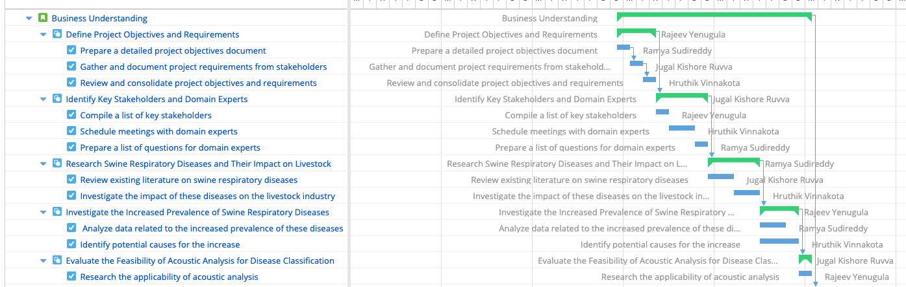

*Note.* The illustration presents the due dates and individuals responsible for each task during the initial phase.

**Data Understanding and Data Preparation.** In the Data Understanding and Data Preparation phases, documenting data sources, data cleansing processes, and data transformations is crucial. A Gantt chart can allocate time for data profiling, data cleaning, and preparing data for modeling. Figure 4 and 5 explain the complete phases of data understanding and data preparation respectively.

**Figure 4**

*Data Understanding Phase*

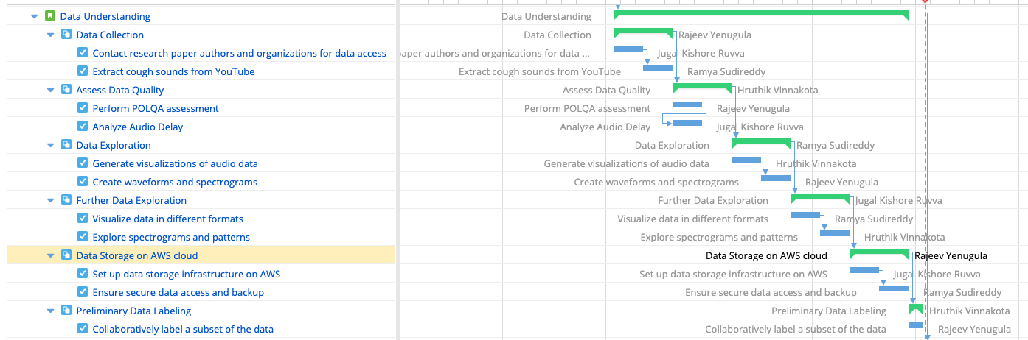

**Figure 5**

*Data Preparation Phase*

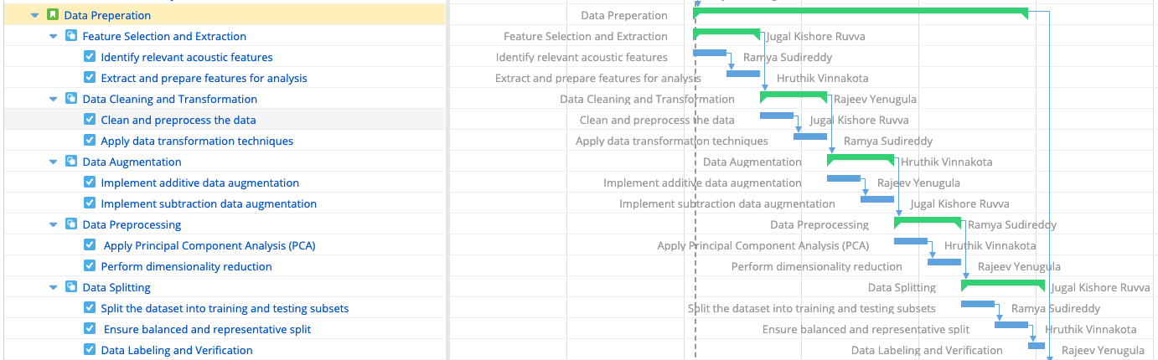

**Modeling.** The Modeling phase involves documenting the selection of algorithms, model development, and tuning. The Gantt chart can clearly show when these tasks are to be completed and when documentation on the chosen models and their performance metrics needs to be created. Figure 6 explains the complete phases of Modeling.

**Figure 6**

*Modeling Phase*

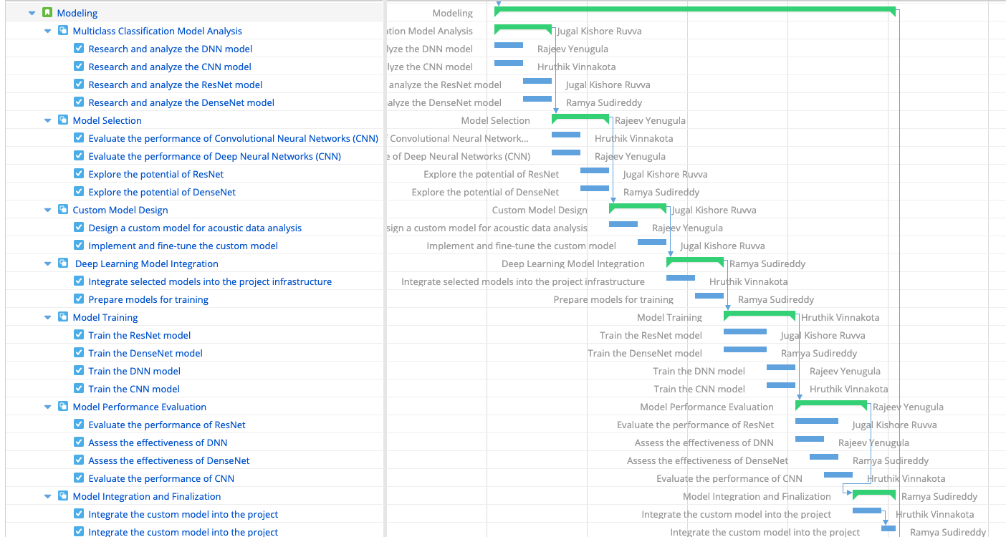

**Evaluation.** The Evaluation phase is about assessing model performance, and a Gantt chart can specify when and how this evaluation will be documented. This might include accuracy assessments, confusion matrices, and ROC curves. Figure 7 explains the complete phases of evaluation.

**Figure 7**

*Evaluation Phase*

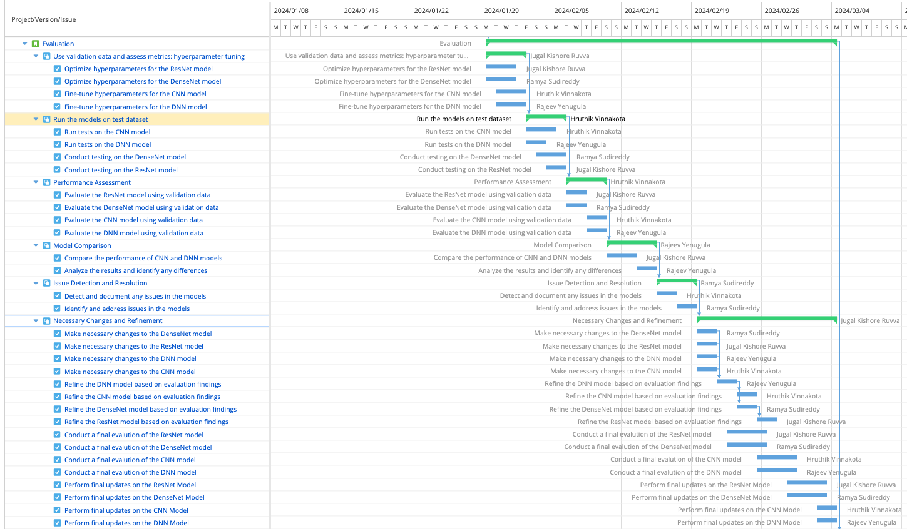

**Deployment.** In the Deployment phase, the Gantt chart can mark the timing for preparing documentation related to model deployment procedures, maintenance plans, and sharing insights with stakeholders. Figure 8 explains the complete phases of deployment. Complete Gantt chart can be seen in the Appendix.

**Figure 8**

*Deployment Phase*

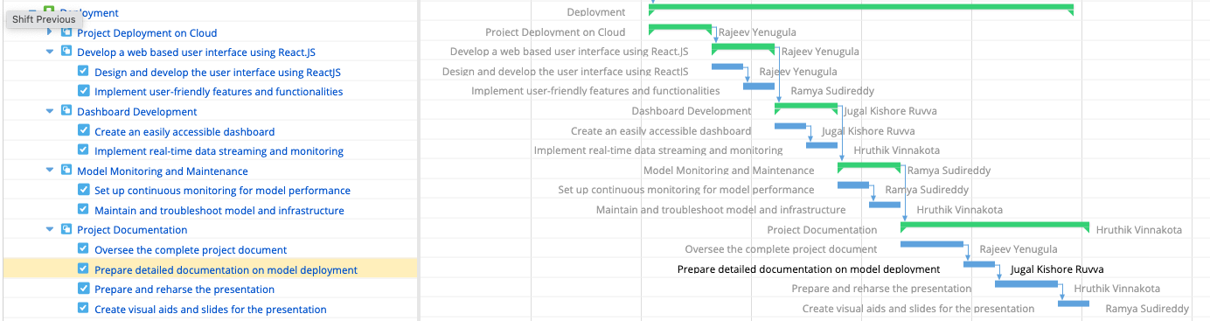

### Pert Chart

A PERT (Program Evaluation and Review Technique) chart is a valuable project management tool used to visualize and analyze the various tasks, their dependencies, and the critical path within a project. It's particularly useful for complex projects that involve multiple tasks and require careful planning and scheduling. The Pert chart developed for this project can be seen below in Figure 9.

**Figure 9**

*Pert Chart illustrating project flow and critical path*

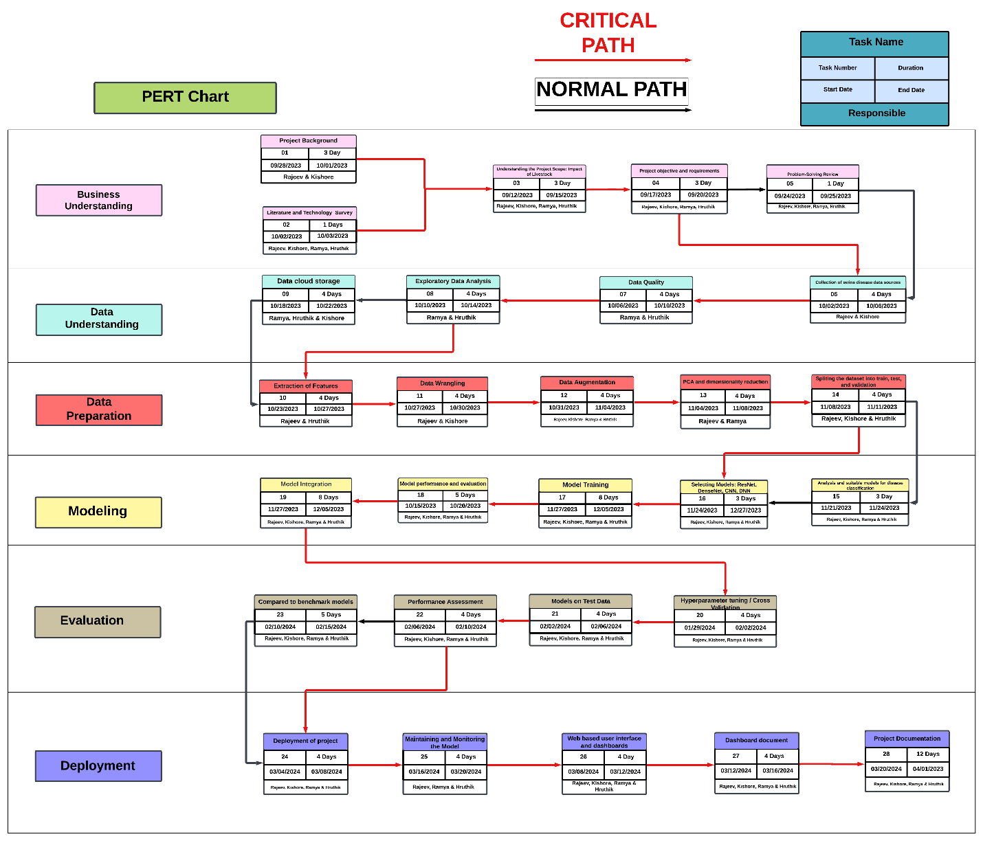

It was developed to address the unique challenges of projects with multiple interdependent tasks, helping project managers visualize the flow of activities, estimate the project's duration, and identify the critical path.

**Tasks/Activities.** Each task or activity in the project is represented as a node on the chart. Tasks are defined and labeled with a unique identifier.

**Arrows/Arrows.** Directed arrows connect the nodes to show the sequence and dependencies between tasks. These arrows illustrate which tasks must be completed before others can begin.

**Duration Estimates.** Each task is associated with the estimated time for completion. This may include optimistic, most likely, and pessimistic time estimates, allowing for a more accurate prediction of project duration.

**Critical Path.** The critical path within a PERT (Program Evaluation and Review Technique) chart is a pivotal sequence of tasks that dictates the minimum time required to complete a project. Delays in tasks along this critical path have a direct impact on the overall project timeline, making it crucial to focus the efforts on ensuring these critical tasks are completed on schedule to prevent project delays. PERT charts offer several advantages, including the visual representation of the project's workflow, simplifying comprehension of its structure. PERT charts facilitate risk assessment by integrating time estimates and considering uncertainties in task durations, and it aid in resource allocation to ensure efficient project execution.

# Data Engineering

## Data Process

The project involves the amalgamation of datasets of three diseases in swine which are collected from a multi-step process that involves collecting the video recordings of pigs displaying symptoms associated with the diseases such as pneumonia, PRRS (Porcine Reproductive and Respiratory Syndrome), and swine fever.

The project also consists of thirteen skin diseases where the image dataset for these diseases is collected from google images and Iowa state university. These images and video recordings are the primary source of data. Kaggle is used to load the disease data folders and exploration of data which focuses on understanding the spectrograms of the cough sounds.

Data is preprocessed by executing Exploratory Data Analysis (EDA) which is used to identify data anomalies such as noise data, outliers, and inconsistencies in the data. For this project EDA helps us understand the wave format of the pig cough sounds and the image formats so that the data inconsistency can be worked on to resize the data samples which speeds up the model training and performance.

EDA is followed by preprocessing of the data where MFCC (Mel-Frequency Cepstral Coefficients) are used for audio signal processing and feature extractions in machine learning tasks of audio data analysis and a pre-trained CNN (Inception-V3) is used to extract the features from pre-processed images.

The preparation of data for modelling continues with the segregation of dataset into training, validation, and test sets. This process is integral to evaluating the machine learning model’s performance on unseen data and preventing overfitting. Adopting an 80:20 ratio for training and testing, the training set is further divided into 2 segments of 60:20 allocating for training and validation respectively. The careful division ensures that the model learns a diverse set of data for effective training, validation, and testing. Figure 10 explains the workflow and all the stages that are involved in the data collection process beginning from the collection of data sources to the division of data for model training.

**Figure 10**

*Representation of workflow for Data Engineering*

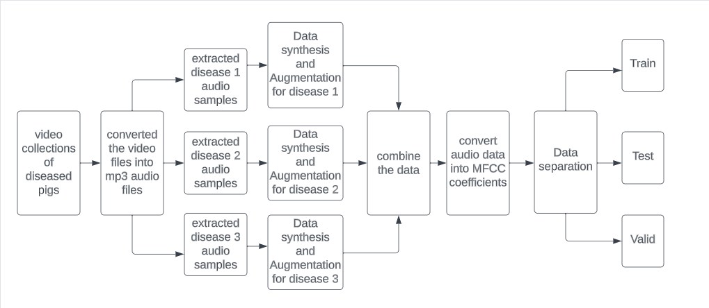

**Figure 11**

*Representation of workflow for Data Engineering for image file*

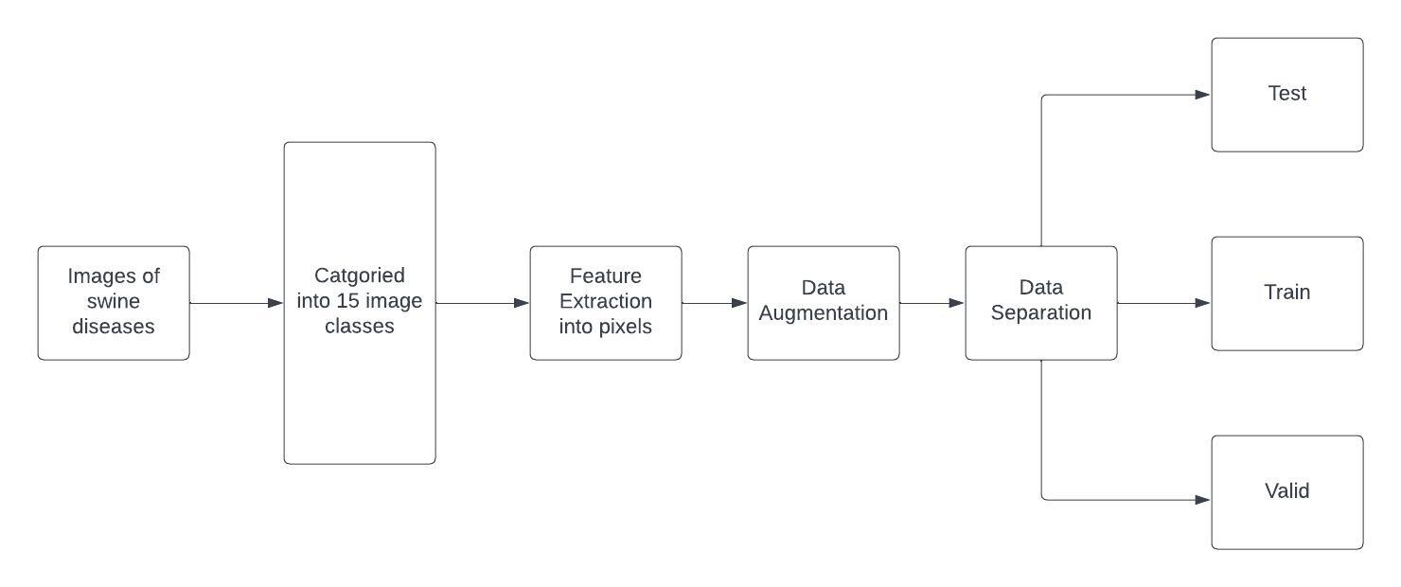

A thorough description of the workflow is given in Figure 11, which lists every step of the procedure for gathering images related to swine skin disease. These covers gathering data sources up front and splitting data later for training models. Initially, Swine skin disease images were collected and categorized by a 15 specific disease. Using feature extraction, the image data is transformed into pixel values where these values. The preparation of data for modeling involves the crucial step of segregating the dataset into training, validation, and test sets. This ensures that the model is trained on a diverse range of data and then validated and tested for accuracy after data augmentation. The training set is split into two portions with 60:40 allocations for training and validation, respectively, using an 80:20 ratio for testing. Due to the rigorous division, training, validation, and testing procedures are successful since the model acquires insight from a variety of data sets.

## Data Collection

The foundation of any successful machine learning model lies in the acquisition of extensive and high-quality data. The process of gathering large amounts of accurate data is the key for developing accurate and dependable machine learning models. The quality of training data directly influences the accuracy and reliability of the machine learning models. Machine learning models handle enormous amounts of data and update the data regularly to keep the model up-to-date and generate reliable outcomes. Data collection is the crucial component of a project. Data collection plan outlines the tools, methods and procedures that are used to collect the necessary data. Figure 12 explain the data collection plan for swine disease collection. The data collection tools and characters of the data that is used to detect diseases in swine.

The data collection for swine disease is a multi-step process where the initial data is collected from video recordings of diseased pigs. The video recordings are then converted into audio files using a website. Y2mate converts the video recordings into mp3 audio data as the model classifies the diseases based on the audio data files. The cough sounds of diseased pigs are extracted from the converted audio files using audacity application. The resulting wav format samples of three different diseases are stored in three different files.

**Figure 12**

*Data collection Plan*

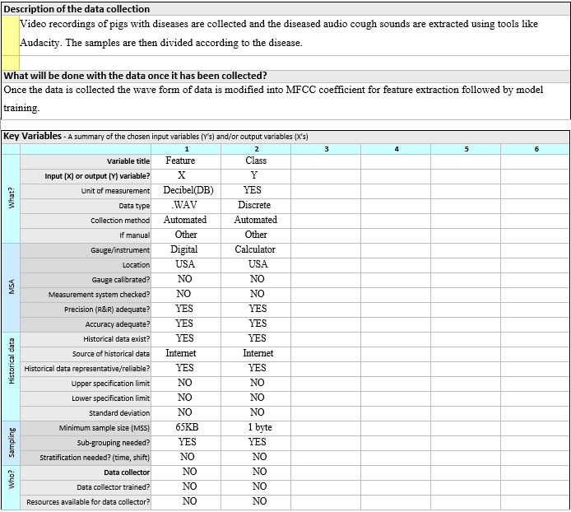

The video recordings that are collected have a limited number of samples available for extraction. Figure 13 shows the number of samples extracted from the video recordings. Achieving optimal performance and generalization in machine learning model typically requires substantial amount of data.

**Figure 13**

*Input samples of three diseases*

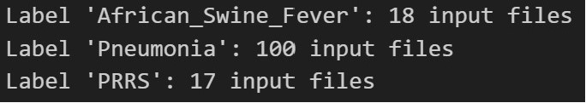

Data Augmentation and Data synthesis can address this issue by generating new data from raw recordings. To ensure effective generalization of the model, the synthesized data should encompass a diverse range of variations including instances of noisy data, audio stretching, pitch shifting and accelerated audio. Figure 14 shows the type of data samples of synthesized data.

**Figure 14**

*Samples of synthesized data*

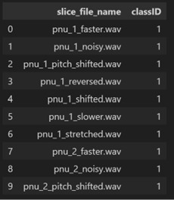

Generating audio data for the analysis of swine diseases through data augmentation and synthesis involves consideration of several factors. These factors encompass the original data’s length, background noise, and various parameters. Various types of augmented data are created including faster data, noisy data, pitch-shifted data and stretched data. This diverse and good amount of generated data contributes to a comprehensive analysis of swine diseases. Figure 15 shows the total amount of original data and data generated and the total number of data samples after the synthesis.

**Figure 15**

*Total number of data samples*

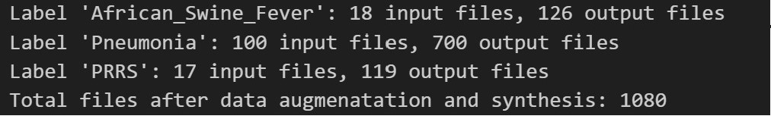

The data that is going to be supplied to train the model. Utilizing raw waveform of audio data is not suitable for training a model. Instead, feature extraction from the waveform can be achieved using techniques such as MFCC which represents the spectral characteristics of a waveform in a well-suited format for machine learning models. The above data is divided into 60:20:20 ratio for training, validation, and test purposes.

## Data Preprocessing

Data pre-processing is fundamental in machine learning workflows. This critical step involves a series of operations to prepare the data for practical model training. The various steps involved in preprocessing are data synthesis and augmentation, followed by data accusations and cleaning and validating the acquired data.

### Data Cleaning and Validation

In acquiring the dataset for swine disease classification, audio data was extracted from YouTube sources, a prevalent platform for diverse content. However, due to the uncontrolled nature of user-generated content on YouTube, the acquired audio data underwent extensive preprocessing to ensure its suitability for the intended machine-learning task. Figure 16 shows the conversion of the YouTube video into an MP3 and saving it.

**Figure 16**

*Converting video to MP3*

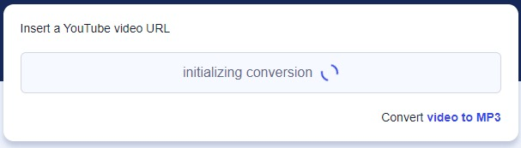

The initial dataset obtained from YouTube was subjected to rigorous filtering processes to eliminate irrelevant or extraneous content. Noise removal techniques were manually applied to enhance the audio quality and eliminate background noise, ensuring the focus remained on the disease-specific audio characteristics. Additionally, the audio files were meticulously chopped into distinct segments to create standardized pieces, facilitating uniformity and ease of analysis. Figure 17 illustrates the manual labor involved in extracting useful chunks of audio.

**Figure 17**

*Manually extracting useful parts of audio*

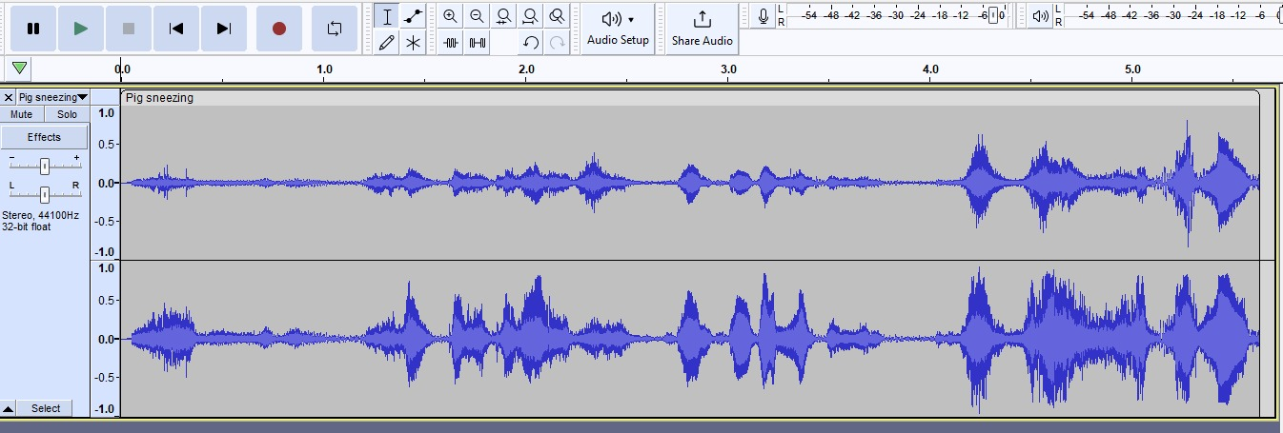

Following data extraction, the dataset underwent meticulous data-cleaning procedures. The cleaning phase addressed potential inconsistencies, errors, or silence within the audio data. This involved identifying and handling silence, ensuring each audio segment was unique, and avoiding data redundancy through suitable techniques such as imputation or removal, ensuring data completeness and accuracy. Subsequently, the validated dataset underwent thorough validation procedures to assess its quality, reliability, and suitability for model training. This ensured that the machine learning model's performance was assessed on the training and unseen validation data, verifying its ability to generalize well to new instances.

The validation phase evaluates the model's accuracy, robustness, and generalization capability, safeguarding against potential issues such as overfitting. The validated dataset, prepared through meticulous cleaning and validation processes, was a robust foundation for subsequent model training and testing, ensuring the model's proficiency in accurately classifying different swine diseases based on audio signals. Figure 18 shows chopping the useful and needful parts of audio into chunks.

**Figure 18**

*Trimming the large input MP3 file*

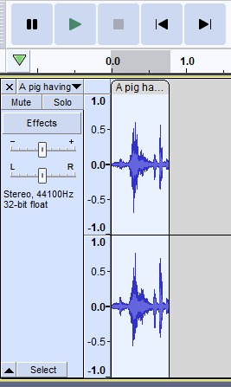

### Data Augmentation and Synthesis

Data synthesis and augmentation play a pivotal role in machine learning, especially when confronted with a limited number of audio samples for different swine diseases (such as African swine fever, Pneumonia, PRRS), as it allows for the creation of additional training samples by applying diverse transformations to existing data. Augmentation techniques enable the generation of additional instances by altering existing samples without introducing new data. Figure 19 shows the completed process of data synthesis and augmentation.

**Figure 19**

*Status update and statistics*

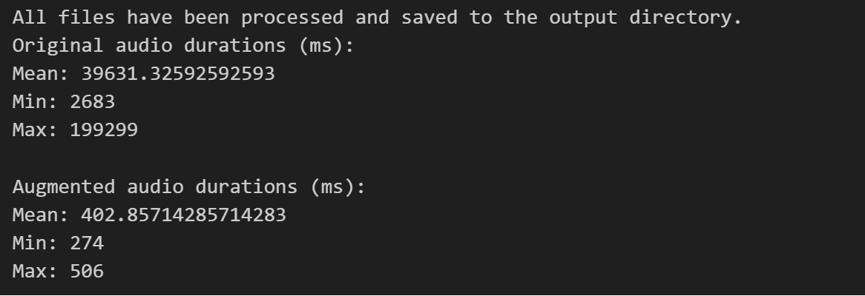

The transformation Techniques applied are speed changes, pitch shifts, time stretching, adding noise, and reversing the audio signals. Altering the playback speed of audio files by either speeding up or slowing down the tempo. This variation introduces changes in the audio's duration while preserving its content, providing the model with varied temporal information. Modifying the pitch of the audio by raising or lowering its frequency and manipulation changes the audio's tonal characteristics while maintaining its temporal structure, enabling the model to learn from different pitch variations. Adjusting the audio's duration without affecting its pitch is known as time stretching, and it modifies the temporal structure of the audio, allowing the model to capture diverse temporal patterns within the same audio sample. Introducing random noise to the audio signals. This technique helps the model become more resilient to background noise or environmental variations that might be present in real-world scenarios. Inverting the audio signals in time, creating mirrored versions of the original samples. This transformation adds further diversity to the dataset by presenting the model with reversed representations of audio sequences. Figure 20 illustrates the differences between original and augmented audio sequences.

**Figure 20**

*Different audio sequences before and after data augmentation and synthesis*

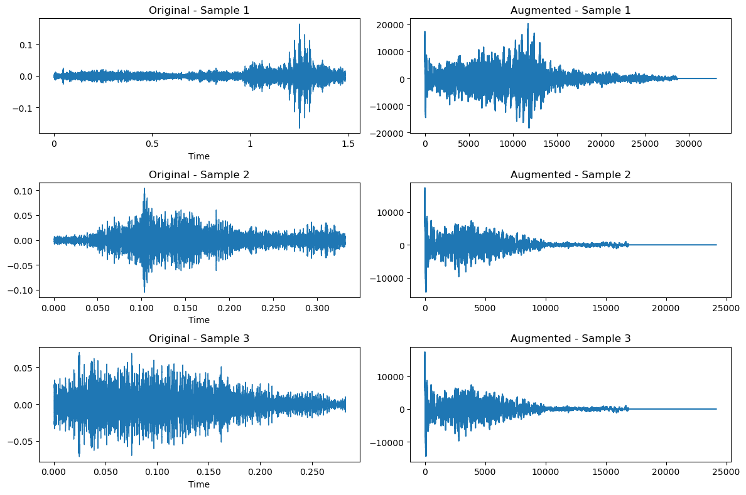

Applying these augmentation techniques to the original dataset significantly increases the dataset size. This augmentation strategy exposes the model to diverse variations of the same audio samples, effectively expanding its training set. Consequently, the model becomes more robust, capable of generalizing patterns across different instances of the same class, and more resilient to variations encountered during actual deployment scenarios. Figure 21 shows the range of input files.

**Figure 21**

*Pie chart illustrating volume of input files for each type of disease*

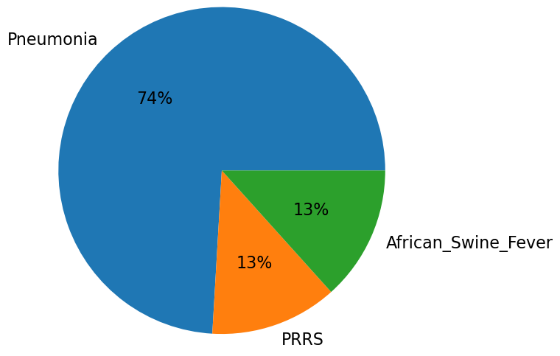

### Exploratory Data Analysis (EDA)

Exploratory Data Analysis (EDA) is a pivotal phase in any data-centric project, especially in machine learning applications like swine disease classification using audio data. This initial step involves leveraging libraries such as Librosa and Matplotlib to gain comprehensive insights into the raw dataset's characteristics, structure, and distribution. Utilizing the powerful audio processing capabilities of Librosa, the initial step in the EDA process involves loading the audio files. This step is crucial in understanding the fundamental structure of the data, including the format, duration, and sampling rate of each audio file. Through Librosa, one can extract essential metadata about the audio, such as the number of channels, duration in seconds, and the sampling rate. Figure 22 shows the reading and display of an audio file. This information provides a foundational understanding of the dataset and aids in subsequent preprocessing steps. Figure 23 illustrates the visualization of input file using Librosa library.

**Figure 22**

*The input file successfully loaded and displayed*

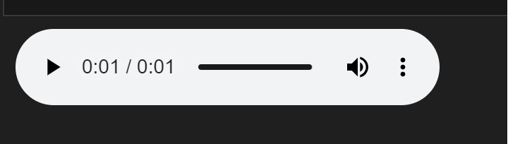

**Figure 23**

*Visualizing the wave plot of input audio file using Librosa*

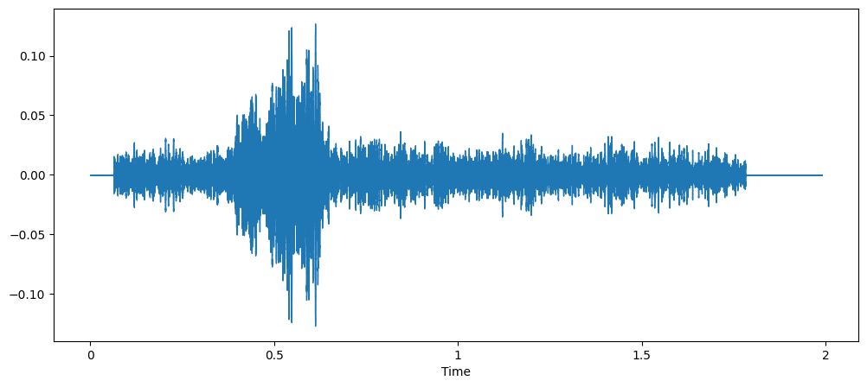

Matplotlib, a versatile visualization library, plays a crucial role in visualizing the waveforms of the audio signals. By plotting the waveforms, which represent the amplitude of the audio signal over time, insights are gained into the temporal characteristics of the audio. Observing the waveforms helps identify patterns, fluctuations, and potential anomalies within the audio data. These visual representations assist in recognizing variations and abnormalities across different audio samples, enabling a deeper understanding of the dataset's inherent characteristics. Figure 24 illustrates the use of Matplotlib to visualize the audio file.

**Figure 24**

*Visualizing wave plot of a sample input audio file*

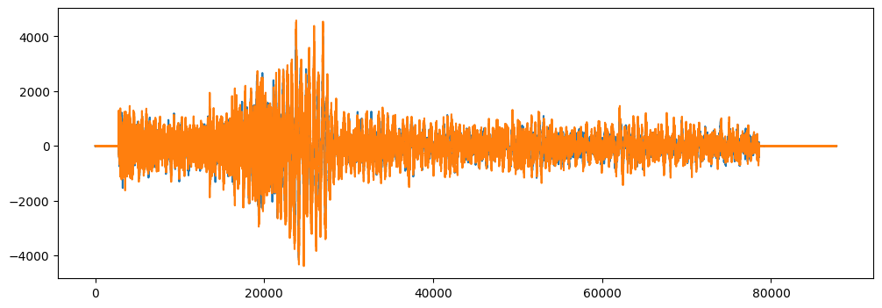

Understanding data distribution across different classes (African swine fever, Pneumonia, PRRS) is critical in ensuring a balanced or imbalanced representation among classes. Counting the number of audio files in each disease category provides insights into the dataset's class distribution. An imbalanced dataset could affect the model's ability to generalize well, as it might bias predictions toward the majority class. Therefore, this analysis helps strategize potential techniques to handle class imbalances, such as data augmentation or employing specific algorithms suited for imbalanced datasets. Figure 25 shows the number of files available for each type of disease.

**Figure 25**

*Number of files available for each type of disease*

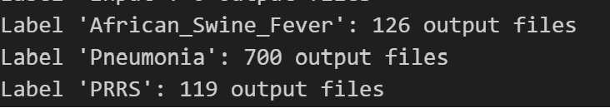

Visualization of audio signals, spectrograms, or transformed representations is crucial in understanding the dataset. Visualizing augmented audio samples allows for assessing their quality and fidelity after applying augmentation techniques. It helps ensure that the augmented data maintains its integrity and represents the original samples. Visualizing representations like spectrograms aids in observing how different swine diseases manifest in the audio signals. Certain diseases might exhibit specific patterns or spectral characteristics that can be visually identified, providing crucial insights for disease classification. Visualization helps identify challenges or variations within the dataset. It allows for detecting anomalies, inconsistencies, or patterns requiring special handling or preprocessing techniques to ensure the model's robustness. Figure 26 shows the use of different visualization techniques executed on the available data.

**Figure 26**

*Use of different visualization techniques on the available data*

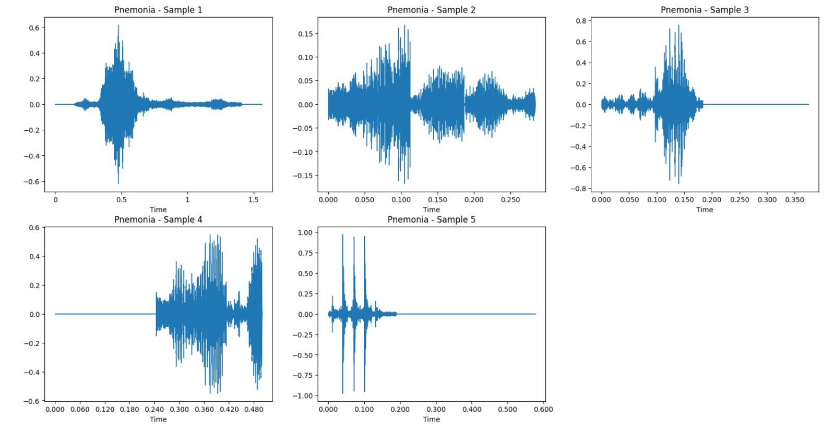

## Data Transformation

### Feature Extraction

Feature extraction is pivotal in converting raw audio signals into condensed yet informative representations, serving as vital input features for machine learning models. This transformation process, essential for practical audio analysis, utilizes techniques such as Mel Frequency Cepstral Coefficients (MFCCs) and spectrograms. MFCCs stand out as a robust method for feature extraction from audio signals. They encapsulate crucial frequency components by representing the power spectrum of sound on a mel scale. The aim is to capture essential spectral characteristics embedded within the audio. This technique condenses the intricate audio signal into concise coefficients, emphasizing significant aspects like pitch, timbre, and spectral content. This method makes the representation more manageable and better suited for subsequent analysis and model training.

Extracting MFCCs involves several steps, such as Pre-emphasis, which amplifies high-frequency components to enhance the signal-to-noise ratio. The next step is Frame Blocking, and in this step, the audio signal is divided into short frames to facilitate analysis, typically using techniques like the Hamming window to minimize spectral leakage. Followed by the Fast Fourier Transform (FFT), each frame undergoes FFT to convert the signal from the time domain to the frequency domain. Then, the power spectrum is passed through a bank of filters spaced on the Mel scale to mimic human auditory perception as part of Mel Filtering. After filtering, the logarithm of the filter bank energies is computed to linearize the magnitude response as part of Mel Filtering. Finally, the DCT is applied to the log filter bank energies to obtain the MFCCs. The resulting coefficients represent the compact features capturing the essential audio characteristics. The resulting MFCCs provide a structured representation of the audio, encapsulating its spectral content within a reduced set of coefficients. These coefficients serve as valuable features for training machine learning models, enabling effective classification or analysis of audio data. Figure 27 shows the features extracted from an input sample using MFCC.

**Figure 27**

*Features extracted from an input sample*

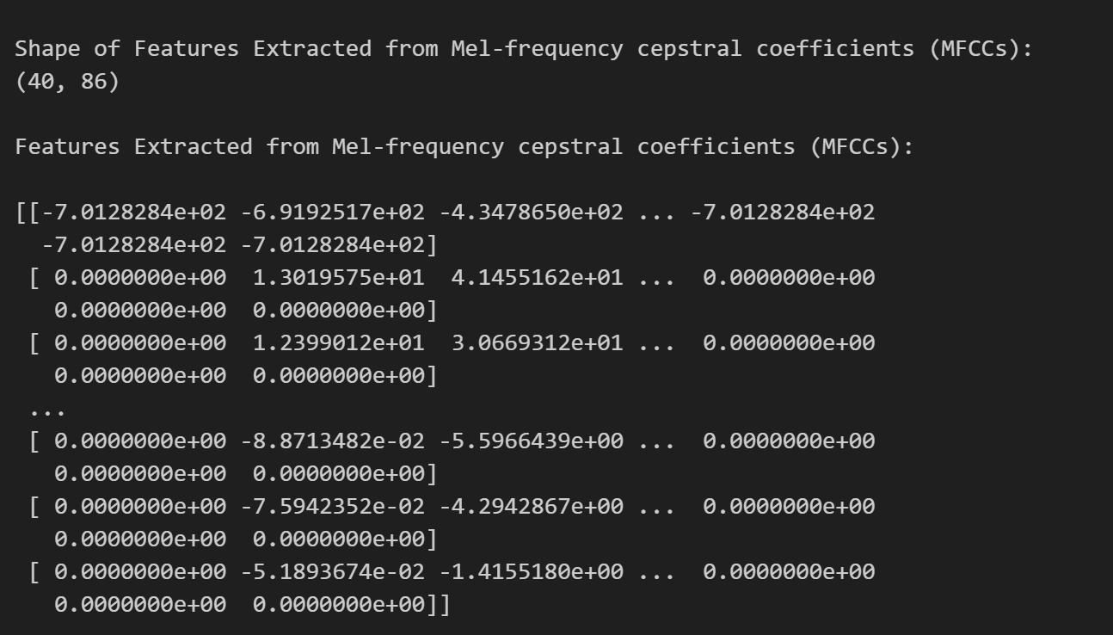

Figure 28 showcases a pandas data frame illustrating the extracted features and corresponding labels. This data frame provides a structured and organized view of the transformed audio data, with columns representing the MFCCs or other extracted features and rows denoting the audio samples and their respective labels. Such organized data facilitates seamless integration into machine learning workflows, allowing for efficient model training and analysis based on the extracted audio features.

**Figure 28**

*Dataframe with features and corresponding label*

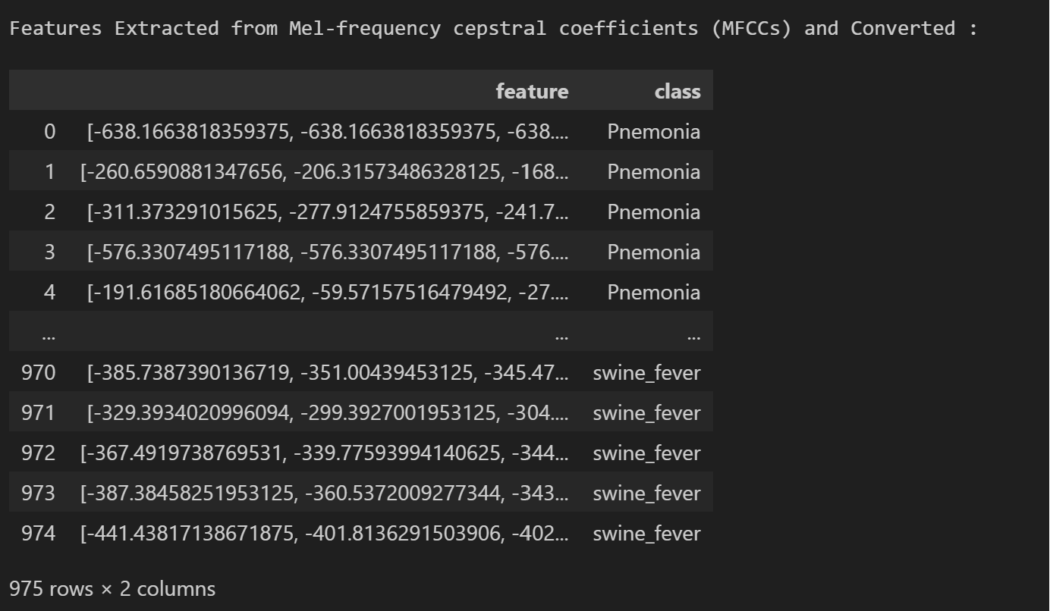

By representing the power spectrum of sound on a mel scale, MFCCs capture critical information related to the audio's spectral characteristics. They condense the complex audio signal into a set of coefficients, highlighting essential aspects of the audio, such as pitch, timbre, and spectral content.

Padding sequences to achieve uniform lengths is a crucial step following feature extraction, particularly in sequence-based data analysis, including natural language processing (NLP), time series analysis, and certain types of machine learning models. This process involves adjusting sequences' lengths to ensure consistency across the dataset, allowing for seamless integration into models that require fixed-length inputs. The significance of padding sequences lies in facilitating efficient computation and maintaining uniformity in the input data, optimizing model performance, and ensuring compatibility within the learning framework. The extraction of features often results in sequences of varying lengths due to the inherent differences in input data. Irregular sequence lengths pose challenges during model training, especially when using neural networks or other machine learning algorithms that demand consistent input dimensions. Padding addresses this issue by extending shorter sequences with placeholders (typically zeros) to match the most extended sequence length in the dataset, thereby establishing uniformity. Figure 29 shows the visualization of the extracted features.

**Figure 29**

*Visualizing the extracted features*

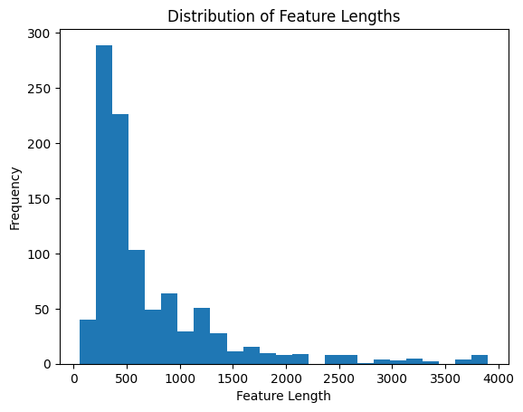

Many machine learning models, especially recurrent neural networks (RNNs) and convolutional neural networks (CNNs) necessitate fixed-length inputs for efficient computation. Padding sequences ensure that all inputs are the same length, aligning with the model's expectations and enabling seamless processing without encountering dimensionality discrepancies or computational inefficiencies. While padding sequences add placeholders to achieve uniform lengths, care is taken to ensure that the added elements do not distort or compromise the original information within the sequences. Using zero-padding or other appropriate padding techniques, the essential information within the sequences remains intact, maintaining the data's integrity despite adding artificial elements. Figure 30 shows the output after successful padding of the sequences.

**Figure 30**

*Padded sequences*

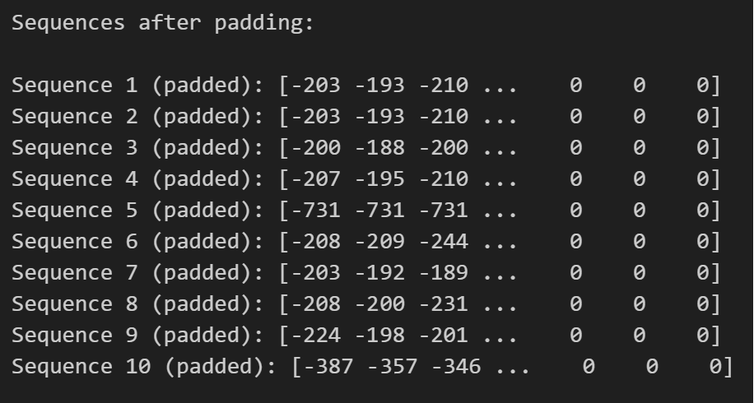

Consistent sequence lengths resulting from padding enhance computational efficiency during model training and inference. Batch processing, a common practice in machine learning, is more streamlined when input sequences have uniform lengths. This optimization reduces memory consumption and speeds up computations, resulting in more efficient model training and prediction. In various applications such as text analysis, sentiment classification, or speech recognition, input data may come in different lengths. Padding sequences resolves the challenge of handling variable-length data, ensuring that models process inputs uniformly, regardless of their original lengths. Consequently, this uniformity simplifies the learning process and aids in capturing patterns or relationships within the data more effectively. While padding sequences to the maximum length in a dataset is a common approach, other strategies exist. For instance, truncating longer sequences or dynamically padding sequences to the length of a mini batch can be employed based on specific model requirements or data characteristics. Attention mechanisms in specific models can also alleviate the need for fixed-length inputs, offering alternatives to padding in sequence modeling tasks.

Spectrograms, as visual depictions of audio signals' frequency content across time, are pivotal in extracting essential information for machine learning tasks. They offer a comprehensive view of how the spectral components evolve throughout the audio duration, aiding in analyzing sound characteristics, patterns, and changes. Leveraging the Short-Time Fourier Transform (STFT), spectrograms create a 2D representation, with time on the x-axis, frequency on the y-axis, and color or grayscale denoting intensity. These structured representations serve as rich inputs for machine learning models, enabling them to discern nuanced patterns, grasp significant audio characteristics, and make accurate disease classifications based on learned features.

A notable strategy to enhance data augmentation and synthesis involves performing these processes directly on spectrograms rather than raw audio data. By first converting audio signals into spectrograms, augmentation techniques such as time stretching, frequency shifting, or adding noise can be applied directly to the spectrogram representations. This approach offers several advantages, including preserving the structural integrity of the spectrogram and allowing for more controlled modifications of the spectral and temporal components of the audio. Moreover, augmenting data on spectrograms provides a more interpretable and semantically meaningful space for modification. Adjusting the spectrogram features directly influences the audio's spectral characteristics, allowing for augmentation while retaining the essential patterns and relationships within the data. This method may enhance the augmentation process by focusing on perturbations in the frequency domain, enabling the creation of diverse yet meaningful variations of the audio samples. Figure 31 illustrates the spectrograms of the same input file after various augmentation and synthesis techniques.

**Figure 31**

*Spectrograms of input file and altered file*

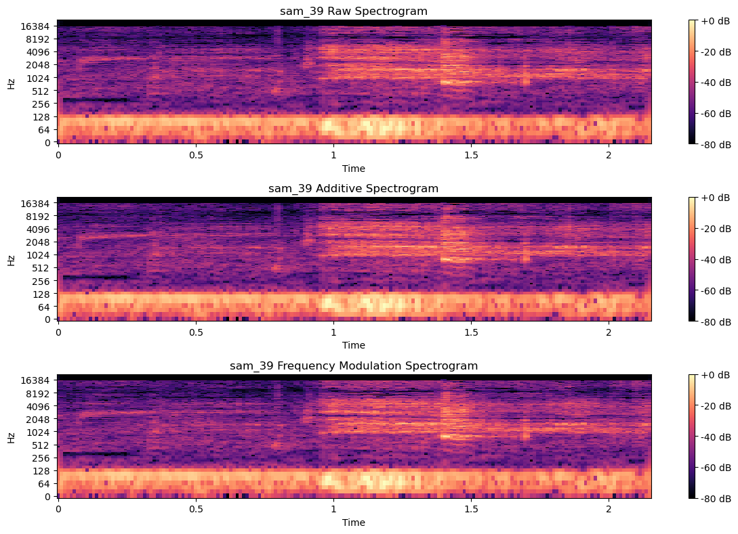

However, this approach has its challenges. Augmenting data directly on spectrograms demands careful consideration of the transformation's impact on the audio's perceptual quality and meaningfulness. Certain augmentations may introduce artifacts or distortions that could affect the interpretability or discriminative power of the learned features. Thus, thorough experimentation and evaluation would be necessary to ensure that the modified spectrograms retain their relevance and utility for disease classification tasks. So, the current project predominantly employs Mel Frequency Cepstral Coefficients (MFCC) as the feature extraction method. As discussed earlier, the decision to proceed with MFCCs stems from their proven effectiveness in capturing essential spectral features within audio signals. These coefficients offer a compact yet comprehensive representation, often serving as a cornerstone in audio-based machine-learning tasks due to their ability to encapsulate critical information related to pitch, timbre, and spectral content. Nevertheless, as the project progresses and models are evaluated, the performance and suitability of MFCCs may undergo scrutiny. Depending on the outcomes and specific requirements of the models, potential alterations or alternative feature extraction methods might be considered to optimize model performance and enhance the representation of audio features for improved classification or analysis tasks.

## Data Preparation

Data preparation in this audio-based classification project revolves around structuring the dataset into distinct subsets for training, validation, and testing while considering the inherent imbalances within the data. Initially, the transformed dataset is segregated into three segments: 60% for training, 20% for validation, and 20% for testing. This partitioning aims to ensure a substantial volume for training while reserving adequate data for robust validation and testing phases. The larger training subset facilitates exposure to diverse instances, enabling models to capture varied patterns and features from the audio data. However, acknowledging the imbalanced nature of the dataset, where certain classes might have significantly fewer instances, this distribution could lead to biased model training, significantly if minority classes are underrepresented. To counter this imbalance, alternative strategies such as k-fold cross-validation or under sampling might be considered based on the preliminary results from the initial division. Figure 32 shows the number of data points after the split.

**Figure 32**

*Number of data points for test, train, and validation after the split*

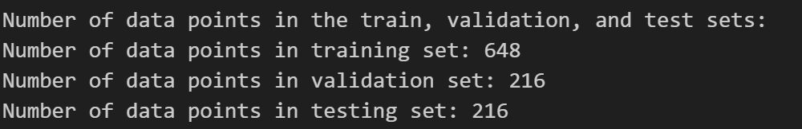

K-fold cross-validation offers a robust assessment method by dividing the dataset into 'k' subsets, training on 'k-1' folds, and validating on the remaining fold iteratively. This approach maximizes data utilization for training and validation across diverse subsets and mitigates the impact of class imbalance by ensuring proportional representation within each fold. Multiple iterations provide more reliable estimations of the model's generalization. Figure 33 shows the number of data points from each class after the split.

**Figure 33**

*Number of data points from each class in test, train, and validation*

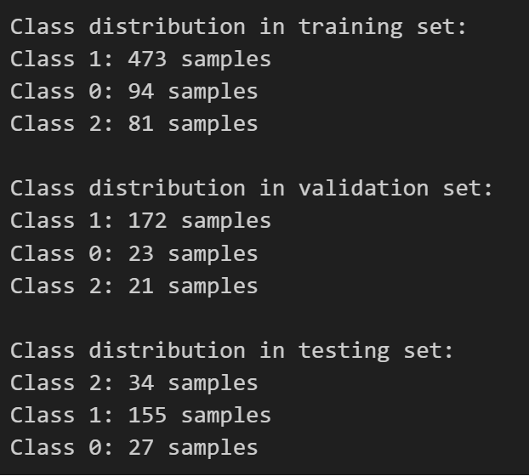

Under sampling is another strategy addressing class imbalance by randomly reducing instances from overrepresented classes to match minority class sizes. This technique balances class distribution during training, preventing bias towards majority classes. However, it risks information loss due to reduced training instances, potentially impacting the models' understanding of the entire data distribution. Figure 34 shows the visualization of a number of samples as a bar plot.

**Figure 34**

*Visualization of dataset distribution*

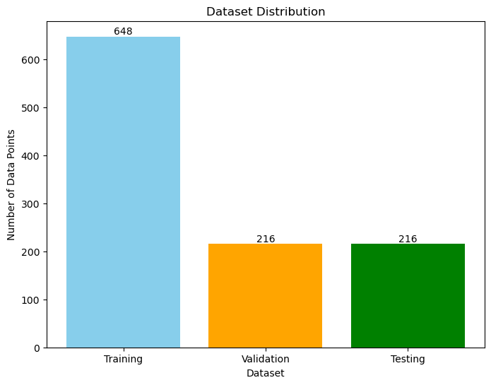

The consideration of stratification within the splitting or cross-validation process is crucial. Stratification maintains consistent class distribution across subsets or folds, preserving original proportions within each segment. This is pivotal in imbalanced datasets, preventing the exclusion of certain class instances entirely from any fold or subset and ensuring representation throughout training, validation, and testing. The final choice of approach will be guided by the need to balance maximizing model learning and ensuring fair representation of all classes within the dataset subsets or folds. Deep learning models can perform well even for imbalanced datasets and to see the effect of the imbalanced dataset on these models, just the data splitting has been applied. The above techniques might be implemented based on the results and fine-tuning the models.

## Data Statistics

Table 12 explains the data statistics of available, augmented, data samples for each disease and statistics after data pre-processing, transformation steps.

**Table 12**

*Data Statistics*

| **Stage** | **Dataset** | **Statistics** |
| --- | --- | --- |
| Raw data | Pneumonia | 100 samples, 17.2MB |
| PRRS | 17 samples, 1.32 MB |
| African Swine Fever | 18 samples, 1.80 MB |
| Data Augmentation | Pneumonia | 300 samples, 35.7MB |
| PRRS | 51 samples, 2.95 MB |
| African Swine Fever | 54 samples, 3.98 MB |
| Data Synthesis | Pneumonia | 400 samples, 47.6 MB |
| PRRS | 68 samples, 3.94 MB |
| African Swine Fever | 72 samples, 5.30 MB |
| Pre-Processing | Pneumonia | 800 samples, 100 MB |
| PRRS | 136 samples, 8.21 MB |
| African Swine Fever | 144 samples, 11 MB |
| End of pre-processing | Processed audio dataset | 1080 samples, 119 MB |
| Data Transformation | Class label dataset | 976 rows x 2 columns |
| MFCC feature dataset | 1080 rows x 2 columns |
| Padded dataset | 1080 rows x 3980 columns |
| Data preparation | Training set | 648 rows x 3980 columns |
| Testing set | 216 rows x 3980 columns |
| Validation set | 216 rows x 3980 columns |

Three different datasets were used with very few data samples and augmented data was added to generate sufficient data that is required to train the model. The total data is segregated based on the class_id of the disease. Figure 35 visualizes the distribution of data samples based on the disease class_id.

**Figure 35**

*Visualizations of data distribution based on class id*

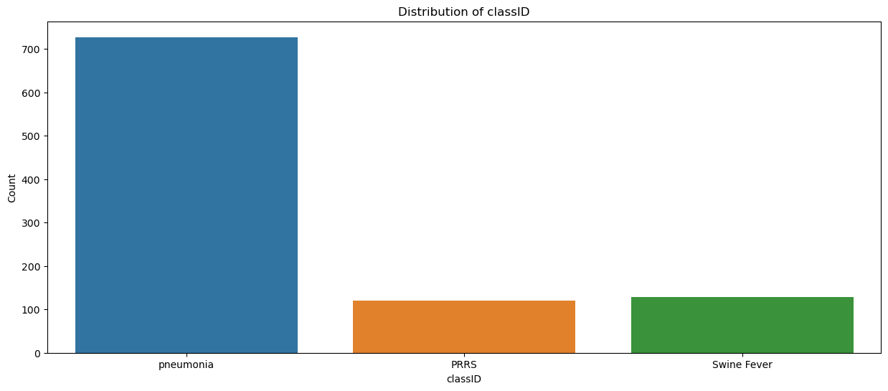

### Data Analytics results

In exploring data analytics, various visualization formats have been employed to comprehend essential aspects of the audio dataset, focusing on original and augmented data. Leveraging big data visualization techniques, the goal was to gain insights into the transformations and variations introduced during the augmentation process. One of the visualizations exhibited the durations of the original versus augmented data. This comparison facilitated a clear understanding of how augmentation techniques impacted the temporal aspects of the audio samples. Figure 36, a graphical representation, such as a bar graph, illustrated the alterations in audio durations post-augmentation, highlighting shifts in temporal dimensions.

**Figure 36**

*Duration comparison between original and augmented data*

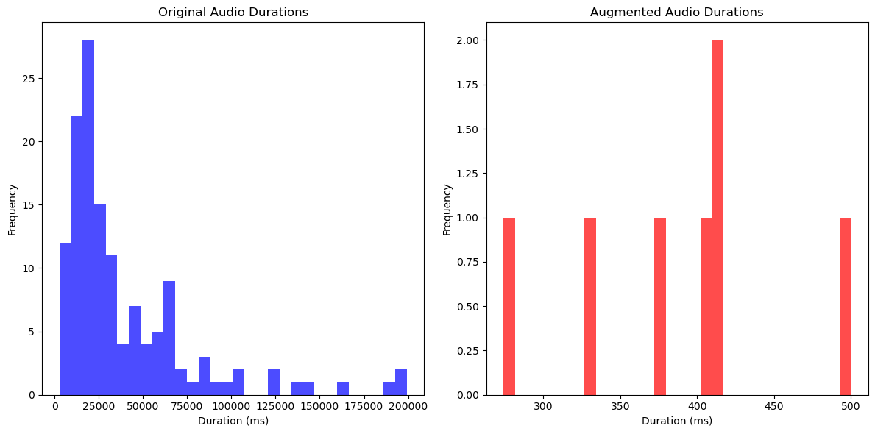

The visualization repertoire also encompassed spectrograms and Mel Frequency Cepstral Coefficients (MFCCs) of selected samples from the original dataset. Spectrograms visually portrayed the frequency content over time, providing an insight into the spectral characteristics of the audio signals. These representations enabled the perception of nuances and variations in frequency components within the audio samples. Figure 37 shows the spectrogram for the sample of original data.

**Figure 37**

*Visualization of spectrogram for sample of original data*

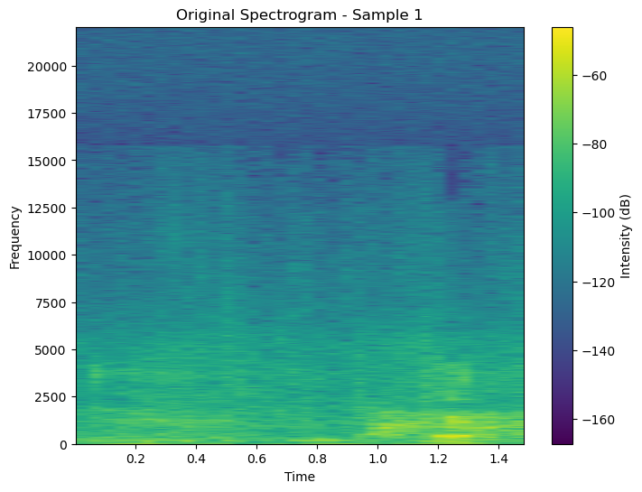

To augment the exploration, the original spectrogram and MFCC representations were contrasted with their augmented counterparts derived from the same audio samples. This comparison aimed to demonstrate the effects of augmentation techniques directly on the spectrogram and MFCC features. The visualizations showcased alterations, shifts, or distortions introduced in frequency and spectral content due to augmentation, providing insights into how these modifications impact audio signal characteristics. Figure 38 visualizes the spectrograms of the same sample audio after the augmentation.

**Figure 38**

*Visualization of spectrogram for the same sample after augmentation*

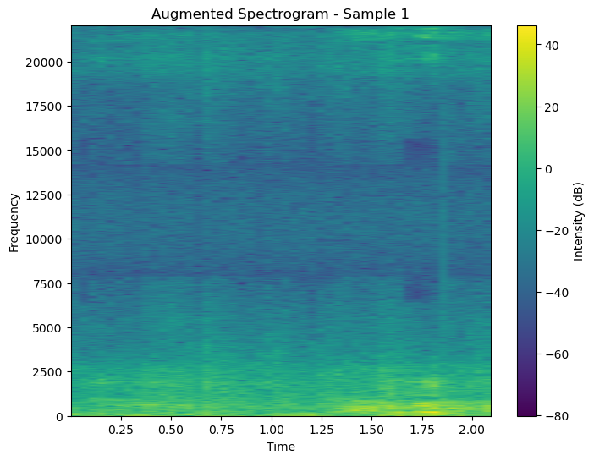

Similarly, the visual representation of Mel Frequency Cepstral Coefficients (MFCCs) for the same original audio samples condensed the spectral information into coefficients, encapsulating vital aspects such as pitch, timbre, and spectral content. This visualization enabled a concise yet informative interpretation of audio characteristics. In particular, Figure 39 depicted the visualization of MFCCs for a sample extracted from the original dataset, providing a structured and illustrative depiction of the spectral features captured within the audio signal. This visualization served as a concrete representation, aiding in the comprehension of the key spectral attributes inherent in the audio data.

**Figure 39**

*Visualization of MFCC of sample from the original data*

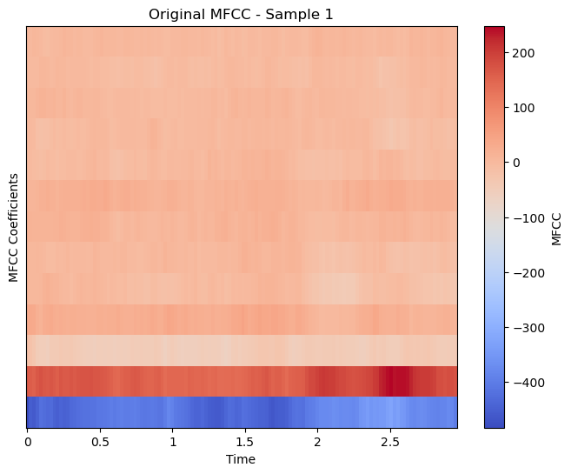

The visual representations utilized various big data analytics formats, such as heat maps (for illustrating changes in trends over time), scatter plots (for exploring relationships between variables), and area plots (for depicting variations in data components) in Figure 40. Additionally, these visualizations leveraged innovative techniques specific to audio data, presenting changes in audio features caused by augmentation techniques.

**Figure 40**

*Input samples of twelve diseases*

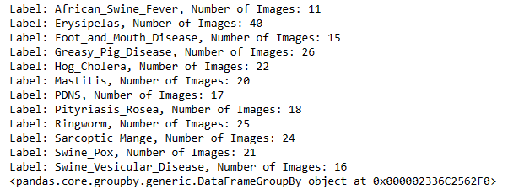

The dataset consists of a variety of images in Figure 41 that depict different swine diseases. Each disease category is represented by a label, and the dataset is organized into sub-folders corresponding to each disease. This includes loading, preprocessing, and analyzing image data in addition to organizing it into a format suitable for models. It involves assessing the availability of samples for each disease and ensuring a balanced representation for effective machine learning model training while also implementing techniques such as data augmentation or resampling*.*

**Figure 41**

*Labeled each type of diseases*

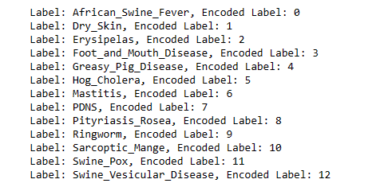

Here in Figure 42, the data conversion process involves converting categorical labels into numerical format. This is necessary for model algorithms. The detailed breakdown of the encoding process and printing out the mappings between label classes and their encoded counterparts ensure transparency and clarity regarding the employed label encoding scheme. This enhances the reproducibility of experiments and facilitates a better understanding of the dataset's label representation.

**Figure 42**

*Statistics and status report*

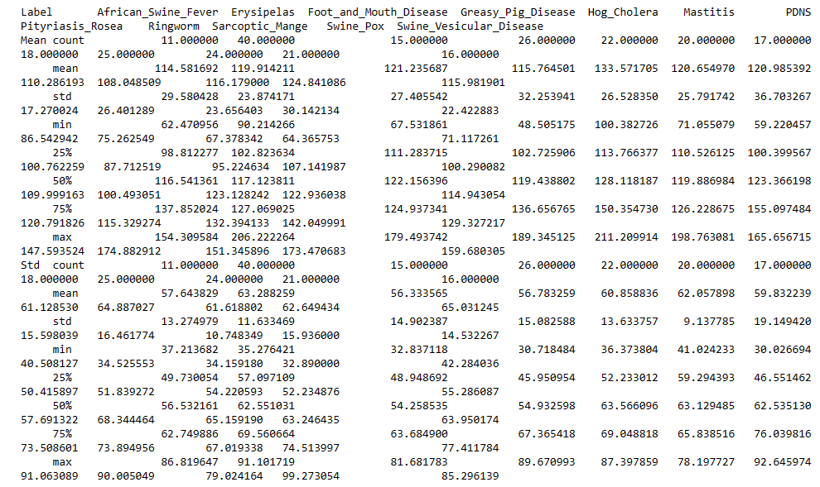

Statistics are provided for each of these labels in Figure 43. It indicates the mean, standard deviation, minimum, maximum, and quartile values for pixel intensity across the images in each category. These statistics are crucial for image preprocessing and normalization techniques as they enhance transparency, facilitate reproducibility, and aid in making informed decisions during model development and evaluation.

**Figure 43**

*Description of features*

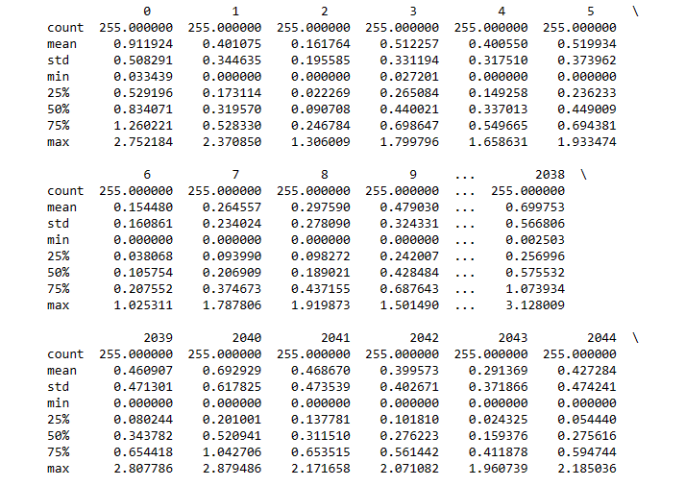

**Figure 44**

*Visual explanation of characteristics of Image data*

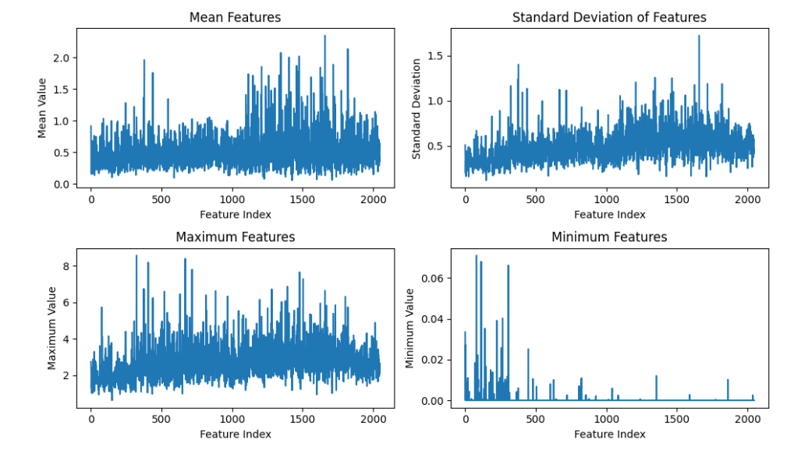

The overview of the distribution and characteristics of the features in the dataset from Fig 43 and Fig 44. It aids in understanding the central tendency, variability, and range of values present in the data. Unusually high or low values, or large variations in standard deviation, may indicate data quality issues or outliers. Understanding the range of values in the dataset is essential for preprocessing tasks such as normalization and scaling. It helps in deciding the appropriate normalization techniques to apply to the data. Knowledge of feature distributions can guide feature selection and dimensionality reduction techniques. Features with low variance or small variation may be candidates for removal during feature selection.

**Figure 45**

*Index of image with min & max size*

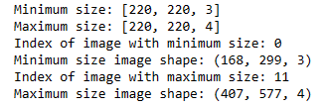

Read the image from a specified path and label it according to the folder name. Resize the image to pixels to (220, 220) in Figure 45. Decode the image from JPEG format to tensor format in order to obtain pixel values and color channels. Apply random flip, rotation, and contrast for image augmentation. Preprocess the image specific to its mode by normalizing and transforming it into the expected format for the model.

**Figure 46**

*Feature extraction into pixels*

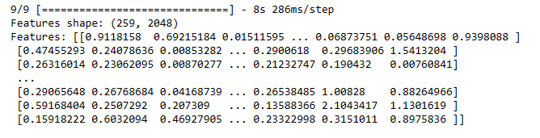

Feature extraction for Image data involves using a pre-trained CNN (Inception V3) to extract the features from the preprocessed images in Figure 46. This process allows us to capture and utilize meaningful information from the image data.

**Figure 47**

*Divide the data into test, validation, and train sets*

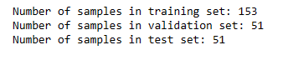

**Figure 48**

*Shape of test, validation, and train sets*

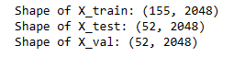

With this adjustment, 60% of the data is allocated for training, while 20% each is allocated for validation and testing. This ensures the desired 60:20:20 split ratio among the sets. For plotting class distributions can remain the same, as it's independent of the splitting ratio and adhere to the specified proportions for the training, testing, and validation sets. Adjusting the split ratios appropriately is crucial for ensuring a balanced and representative dataset for model training, evaluation, and validation from Figure 47 and Figure 48.

# Model Development



The recognition and analysis of pig cough sounds are crucial for the early detection of diseases in swine. Identifying an issue at its initial stages of certain diseases in pigs is essential for timely treatment, controlling the spread of the disease, minimizing treatment expenses, and improving overall well-being. The study aims to classify pig diseases by analyzing acoustic and visual data. This approach has the potential to decrease medical expenses and improve food safety measures. Detecting diseases at an early stage is crucial to prevent outbreaks, limit the spread of the disease, and mitigate the associated financial consequences. The dataset collection involves a wide range of audio and video recordings of swine. These recordings have been meticulously annotated by domain experts to identify specific disease features and characteristics. Data preprocessing is an essential step in improving the quality of a dataset. This process involves reducing noise and converting formats for better data accuracy and reliability. Hyperparameter tuning is employed to optimize model performance through feature extraction techniques like spectrograms and Mel-frequency cepstral coefficients (MFCCs).

This study underscores the significance of selecting deep learning models that strike a balance between complexity and interpretability. Project deliverables include an extensively annotated dataset, a standardized and efficient preprocessing pipeline, and a feature extraction pipeline that includes relevant audio features.

## Model Proposals

For the project, four models were suggested. The models included Convolutional Neural Network (CNN), Residual Network (ResNet), and DenseNet Connected Convolutional Network. ResNet, known as a residual neural network, is part of the convolutional neural network family. An important objective of ResNet is to establish "identity bypass connections," which bypass several layers in the hierarchy of identity representation. DenseNet is a convolutional neural network that consists of dense connections between layers. These layers are connected through Dense Blocks, promoting direct information flow throughout the network. This section consists of the proposed models for the disease detection and classification of swine diseases using image data. Two models named MobileNet and LSTM are employed for this project.

### Convolutional Neural Network (CNN)

Weizheng Shen et al. (2022) talked about the convolutional neural network (CNN), which is commonly employed for extracting in-depth features from sound signals augmenting the acoustic features obtained through pre-processing sound segments. Essential features are extracted from the input data using specialized layers, such as convolutional and pooling layers. Accurate results for various applications largely depend upon these extracted properties. The Convolutional Neural Network (CNN) network architecture is built upon the highly successful Lenet-5 model, which has consistently achieved remarkable results in various image classification tasks. Figure 49 illustrates CNN architecture.

In the evaluation of pig cough sound recognition, various CNN architectures are assessed using equations specific to Convolutional Neural Networks. The performance of these architectures is measured using multiple evaluation metrics including Accuracy, Precision, Recall, and F1-score and accuracy formulae is in (1).

Accuracy = (TP + TN) / (TP + TN + FP + FN)(1)

TP = True Positive (number of correctly identified cough sounds)

TN = True Negative (number of correctly identified non-cough sounds)

FP = False Positive (number of non-cough sounds incorrectly identified as cough sounds)

FN = False Negative (number of cough sounds incorrectly identified as non-cough sounds)

Recall = TP / (TP + FN) (2)

TP = True Positive (number of correctly identified cough sounds)

FN = False Negative (number of cough sounds incorrectly identified as non-cough sounds)

Precision = TP / (TP + FP)(3)

TP = True Positive (number of correctly identified cough sounds)

FP = False Positive (number of non-cough sounds incorrectly identified as cough sounds)

F1-score = 2 * (Precision * Recall) / (Precision + Recall) (4)

Precision = TP/(TP + FP) (number of correctly identified cough sounds)

Recall = TP/(TP + FN) (number of cough sounds incorrectly identified as non-cough sounds)

**Figure 49**

*The CNN architecture is used for extracting deep features*

*Note.* A 4-layer convolution block with various filter rates. The input of the previous feature maps is used by every layer that follows. From “Fusion of acoustic and deep features for pig cough sound recognition,” by Weizheng Shen et al. (2022).

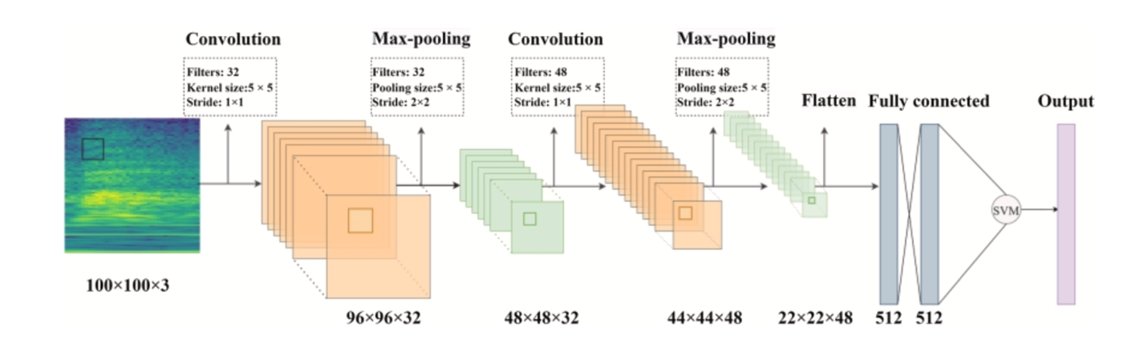

**Input.** The Pig cough noises recorded in two dimensions are fed into the CNN model. These are the Constant-Q Transform (CQT) spectrogram and the Short-Time Fourier Transform (STFT) spectrograms. Using the LibROSA toolkit, both types of spectrograms are produced from the sound samples, offering a thorough source for the model's analysis.

**The Lenet-5 Architecture*.*** The Lenet-5 architecture is a shallow network that has yielded outstanding performance on handwritten digit recognition tasks. It utilizes multiple layers of convolutional and pooling operations, followed by fully connected layers to categorize the digits. This architecture was specifically chosen for this study because it performs well with smaller datasets, which aligns with the limited and private nature of the dataset.

**Feature extraction using CNN.**Where a shallow CNN network was designed and implemented to extract deep features from segments of pig cough sound. The CNN architecture utilized in this study is depicted in Figure 49. This architecture incorporates convolutional layers, max-pooling layers, and fully connected layers for feature extraction purposes.

**Convolutional Layer.**To extract local features from the input data, the convolutional layer applies several filters. This is accomplished by convolving the filters with the input data, which generates an output feature map.

**Activation Function.** The feature map is then passed through an activation function, such as the rectified linear unit, which helps introduce non-linearity into the network and enables it to learn more complex patterns. This process enhances the network's ability to capture intricate relationships within the data.

**Max-Pooling layer.**Max-Pooling layer is an essential part of the network architecture utilized in convolutional neural networks. It plays a crucial role in reducing the spatial dimensionality of the feature maps, thereby preserving important information while minimizing computational complexity. Among different types of pooling operations, max pooling is commonly employed. This operation involves extracting the maximum value from a specific region within the feature map and propagating it to higher layers for further processing.

**Fully Connected (FC) Layer.**After performing several convolutional and pooling operations, the resulting feature maps are flattened into a one-dimensional vector. This vector is then passed through one or more fully connected layers, where every neuron in these layers is interconnected with each neuron from the preceding layer. The main objective of implementing these fully connected layers is to acquire meaningful representations of the input data at a higher level.

**Output Layer.**The output layer of a Convolutional Neural Network is usually represented by a SoftMax layer that generates a probability distribution across multiple classes. As per this distribution, the class with the highest assigned probability is regarded as the predicted class for that input data instance. The CNN model produces deep characteristics that are taken out of the spectrograms. The CNN architecture, which consists of several layers for convolution, pooling, and interaction, is used to extract certain information from the spectrograms. The spectrograms that represent the sounds made by pigs coughing can be used to teach and extract significant properties by the CNN model.

**Deep Feature Extraction.**The CNN architecture is utilized to extract complex and intricate features from the pig cough sound segments. Two distinct forms of time-frequency representations, specifically continuous wavelet transform and short-time Fourier transform, were employed as inputs to the CNN. The TFRs were simultaneously inputted into two parallel networks to obtain deep features, which were subsequently combined and forwarded to a classifier for accurate classification purposes.

The acoustic elements that were taken out of the sound signals are then blended with these deep features. Early fusion, in which the features are concatenated together, is the process that combines deep and auditory data. The aggregated features are then sent into a support vector machine to identify cough sounds made by pigs. Because SVM is a robust classifier for datasets with limited training sample availability, it is selected as the classifier. Utilizing spectrograms as inputs and deep features as outputs, the CNN model can efficiently identify pig cough sounds when combined with acoustic data.

### DenseNet

DenseNet is a deep learning model that addresses the vanishing-gradient problem and aims to improve the performance of convolutional neural networks by using a more complex network structure with deeper layers. In a study by Hang Song et al. (2022) talked about introducing dense connections between layers, DenseNet allows for better feature reuse throughout the network and alleviates the vanishing-gradient problem. This unique approach enhances information flow within the model, ultimately improving performance in various tasks. Figure 50 illustrates the schematic representation of the DenseNet.

**Figure 50**

*Schematic representation of DenseNet*

*Note.* A class of network models known for their exceptional performance and ability to include deeper layers. They accomplish this, astonishingly, with the least amount of computational complexity and parameter requirements. From “Research on improved DenseNet pig cough sound recognition model based on Senet’s” by Hang Song et al. (2022).

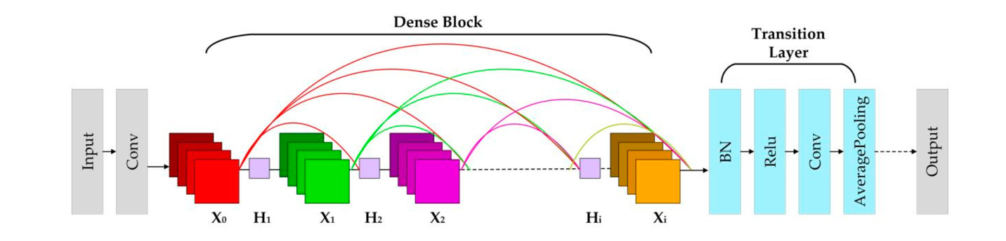

The vanishing-gradient problem, which occurs when gradients backpropagate through deep networks at an exponential rate, is successfully addressed by DenseNet and improves deep network training by using dense connections to allow gradients to flow directly from the output layer to each layer before it. The SE-DenseNet architecture incorporates the SENets attention module into each dense block, improving upon the original DenseNet model. The SE-dense block is composed of convolutional layers with 1x1 and 3x3 kernel sizes. Then, the SENets attention module is added to the Conv(3x3) layer. This improves the accuracy of pig cough sound recognition and allows for more effective feature extraction from pig sound signals. The model accepts 26-dimensional MFCC + ∆MFCC parameters as input to enhance performance. Compared to existing models in this domain, this technique achieves a high recognition accuracy rate and exhibits better recall, precision, and F1 score.

**Input:** Pig cough sounds are sent into the DenseNet model, which then gathers and analyzes the data to extract features such as the Mel Frequency Cepstral Coefficient, delta 2 MFCC (∆2MFCC), and delta MFCC (∆MFCC). These features are merged into six parameter groups; a 26-dimensional MFCC + ∆MFCC set is the most efficient combination.

The output feature of each dense block, denoted as Xi, is obtained by applying a nonlinear transformation function to the input feature X0. This transformation function consists of Batch Normalization (BN), Rectified Linear Units (ReLU), and Convolution (Conv). The output feature Xi is mathematically calculated as follows: Xi = Hi ([X0, X1, ........, Xi−1]) where "Hi" denotes the non-linear transformation function at a specific layer, while "Xi" represents the output feature that is subsequently passed on as input to the next dense block within the network. This implementation of a dense connection allows for efficient reuse of features throughout the transmission process and facilitates enhanced feature extraction capabilities. Additionally, a transition layer is employed to minimize parameter count and computational complexity in the network. It achieves this by integrating characteristics from preceding dense blocks through convolution with a 1×1 kernel and average pooling operations, resulting in a more lightweight model overall.

**Dense Blocks.** The core of DenseNet lies in the dense block module, which is iterated multiple times in the network structure. Within a dense block, features are repeatedly extracted using Conv (1 × 1) and Conv (3 × 3) kernels. One major benefit of dense blocks is that they establish strong connections between layers, enabling efficient reuse and propagation of features throughout the entire network. Consequently, the output from each dense block becomes the input for the subsequent one, forming a connected chain for effective feature extraction.

**Transition Layers**. The transition layers play a crucial role in combining the output characteristics of the dense blocks and minimizing the number of parameters involved. To achieve this, each transition layer incorporates essential components such as Batch Normalization, Rectified Linear Units, Convolutional operation with filter size 1x1 (Conv (1 × 1)), and average pooling. Leveraging Conv (1 × 1) can effectively reduce parameter count, while the average pooling operation further enhances model efficiency by reducing spatial dimensions of features.

**Output:** The results obtained for pig cough sound recognition are the outputs of the DenseNet model. It was created expressly to identify pig coughs accurately and provide pigs with early detection of respiratory diseases. The outcomes cover a variety of performance metrics, such as F1 score, accuracy, recall, and precision. In this study, the accuracy of pig cough sound recognition was 93.8%, recall rate was 98.6%, precision level was 97%, and F1 score was 97.8%. These inputs and outputs show how the DenseNet model can effectively identify cough sounds made by pigs. It also emphasizes how promising it is for the early diagnosis of respiratory disorders in pigs.

### Residual Networks (ResNet)

ResNet enables the use of skip connections to train incredibly deep CNNs. Taejun Kim et al. (2019) talked about ResNet and its architecture. Backpropagation is smoothed, and optimization is facilitated by skip connections, which provide gradients with clear pathways. When 'n' is the number of convolutional layers, the fundamental block with a single skip connection is referred to as a Res-n Block. ResNet were developed on top of VGGNets, which are widely recognized CNN architectures known for their effectiveness in image classification. The sample CNN architecture bears similarities to VGGNets; however, it differs by employing 1D filters and utilizing one-dimensional convolution and pooling techniques. ResNet have been widely demonstrated to perform exceptionally well in a wide range of image classification tasks.

One key advantage is that their skip connections facilitate easier optimization, fostering ensemble-like behaviors and allowing for effective training of deep networks. One kind of convolutional neural network that is utilized for picture and audio categorization is the Residual Networks model. By leveraging skip connections, it enables the training of extremely deep CNNs, improving the neural network's gradient backpropagation stability.

**Input:** High-dimensional sensory data, including picture or audio waveforms, are fed into the Reset model. Raw waveforms, which capture comprehensive information about the sound properties, can be used as the input for audio classification.

**Res-1 block.** The Res-1 block corresponds to the basic building block of a convolutional neural network. It consists of one convolutional layer and is characterized by its skip connection, represented by the dotted lines. This skip connection plays a crucial role in addressing the vanishing gradient problem commonly encountered during training deep networks. By allowing for more fluent backpropagation of gradients, the skip connection ensures an easier flow of information and facilitates the successful training of deeper networks.Figure 51 illustrates the implementation of shortcut path in ResNet.

**Figure 51**

*A skip connection from ResNet is used in the Res-n block*

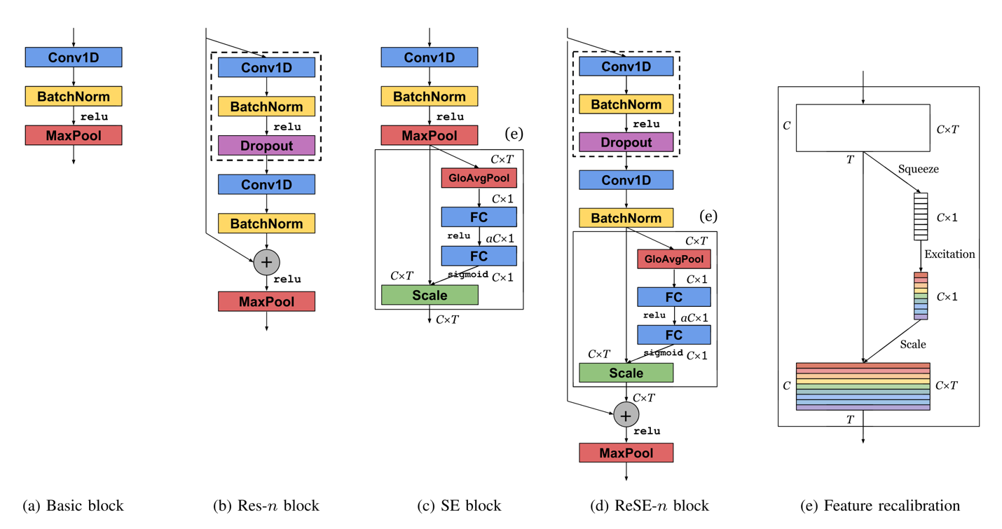

*Note.* Image classification tasks have made substantial use of the ResNet paradigm, with notable implementations including Alex Net, VGGNets, and ResNet. From “Comparison and analysis of SAMPLECNN architectures for Audio Classification” by Taejun Kim et al. (2019).

**The Res-2**.The Res-2 block is a variant of the Res-n block that consists of two convolutional layers. It incorporates two skip connections and includes a dropout layer with a drop ratio of 0.2 before the second convolutional layer to prevent overfitting, drawing inspiration from the Wide ResNet architecture. This addition helps tackle the vanishing gradient problem and facilitates training deep CNNs.

**Output:** As projected classes or labels for the input, the ResNet model's outputs are obtained. To anticipate whether an incoming image contains a dog or a cat, for instance, is one application of the model's image categorization capabilities.

***LSTM***

The emergence of Long Short-Term Memory (LSTM) networks represents a significant step forward in the evolution of recurrent neural networks (RNNs), providing a solution to one of the most persistent challenges in sequential data processing, the vanishing gradient problem. Hochreiter and Schmidhuber introduced LSTM networks in 1997 as a specialized architecture capable of learning and retaining long-term dependencies in sequential data, making them ideal for speech recognition, language modeling, and time series prediction tasks. Hochreiter and Schmidhuber (1997) pioneered LSTM networks by presenting a novel architecture designed to overcome the limitations of traditional RNNs. By incorporating explicit memory cells with gating mechanisms, LSTM networks enable the selective retention and utilization of information over long time intervals, facilitating the learning of complex temporal patterns.

Graves and Schmidhuber (2005) demonstrated the efficacy of LSTM networks in speech recognition, outperforming conventional RNN architectures. They demonstrated LSTM's ability to capture long-range dependencies in sequential data using phoneme classification tasks, improving the accuracy and robustness of speech recognition systems.

Greff et al. (2016) conducted subsequent research on the architectural space of LSTM networks to identify optimal configurations and hyperparameters. They gained valuable insights into the factors influencing LSTM performance by thoroughly analyzing various LSTM variants, paving the way for improved model design and optimization strategies.

Chung et al. (2014) contributed to empirically assessing LSTM and other gated recurrent neural network (GRNN) architectures for sequence modeling tasks. Their findings shed light on the strengths and weaknesses of various GRNN variants in capturing temporal dependencies within sequential data, informing researchers and practitioners about the models' suitability for specific applications.

LSTM networks are made up of specialized memory cells with gating mechanisms that control the flow of information, allowing them to retain and use relevant information over long periods. An LSTM cell's key components are the forget gate, input gate, cell state, and output gate, which each perform specific operations to process sequential input data.

**Forget gate.** The forget gate determines whether information from the previous cell state should be discarded or retained, allowing the LSTM to selectively forget or remember the last details based on their relevance to the current context.

(5)



**Input Gate.** The input gate regulates the flow of new information into the cell state, enabling the LSTM to update its memory with relevant inputs.

(6)



(7)



**Update Cell State.** The LSTM changes its cell state by selectively incorporating new information while retaining relevant information from the previous cell state, allowing it to adapt to changing input conditions and maintain long-term dependencies.

(8)



**Output Gate.** The output gate controls the flow of information from the updated cell state to the output, determining which parts of the cell state should be communicated to the next layer or output node.

(9)



Optimizing LSTM models entails adjusting various parameters and architectural choices to improve performance and avoid problems like overfitting or vanishing gradients. Figure 52 illustrates the architecture of LSTM.

**Figure 52**

*Architecture of LSTM*

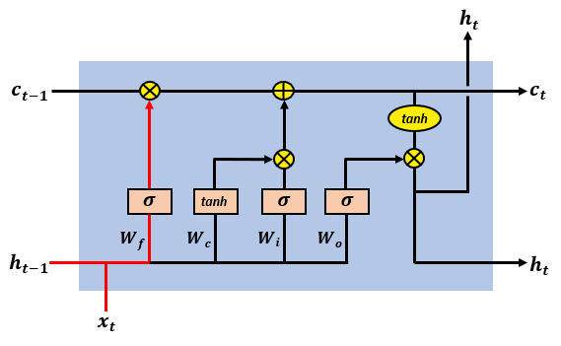

Increasing the number of hidden units in the LSTM layer can improve the model's ability to detect complex patterns in data. However, caution must be exercised to avoid overfitting, as extensive models may struggle to generalize to new data. Optimizing the Learning Rate: Fine-tuning the learning rate can significantly impact the LSTM's training dynamics. A suitable learning rate promotes efficient convergence during training while avoiding oscillations and divergence.

Regularization Techniques such as Dropout or L2 regularization can help prevent overfitting by introducing noise or imposing constraints on model parameters. These regularization methods encourage the LSTM to learn strong representations that can be generalized to new data. Gradient clipping reduces the exploding gradient problem, which can destabilize the training process, particularly in deep LSTM networks. Gradient clipping, which limits the magnitude of gradients during backpropagation, ensures more stable training dynamics and smoother convergence.

***MobileNet***

MobileNetV2 is a convolutional neural network tailored for mobile devices, featuring an inverted residual structure with bottleneck layers. Pravin R. Kshirsagar et.al., 2022 explained the architecture of MobileNet in image classification models. MobileNet architecture comprises an initial layer of 32 filters, succeeded by 19 residual bottleneck layers. Figure 53 explains the architecture of MobileNet. Each layer includes three sub-layers, a 1 x 1 convolutional with ReLu6, depth-wise convolutional for feature filtering and non-linear convolutional layer with ReLu6 for enhanced resilience in low-precision scenarios. The design incorporates a residual layer with a stride of 1 and a shrinking layer with a astride 2, which promotes an efficient information flow. The compatible use of ReLu6 with 3 x3 filter size maintains model stability. The synergy of these components facilitates model adaptability, making MobileNetV2 a well-suited architecture for image classification models.

**Figure 53**

*Architecture of MobileNet.*

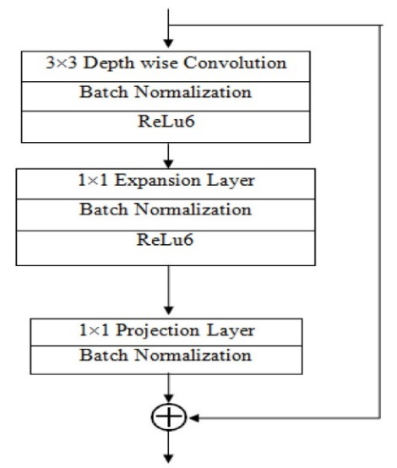

Each layer includes three sub-layers, a 1 x 1 convolutional with ReLu6, depth-wise convolutional for feature filtering and non-linear convolutional layer with ReLu6 for enhanced resilience in low-precision scenarios. The design incorporates a residual layer with a stride of 1 and a shrinking layer with a astride 2, which promotes an efficient information flow.

The compatible use of ReLu6 with 3 x3 filter size maintains model stability. The synergy of these components facilitates model adaptability, making MobileNetV2 a well-suited architecture for image classification models.

## Model Supports

### Environment, Platform, Tools

To ensure optimal performance in deep learning tasks and bring value to organizations, it is crucial to have access to advanced hardware capable of handling complex computations. Selecting the most suitable hardware can be challenging with a wide range of options including CPUs, GPUs, TPUs, and ASICs available. To expedite model training, executing tasks concurrently rather than sequentially is recommended. Table 1 gives details of the hardware requirements for training, testing, and evaluating the regression model in this study. Concurrent task execution enhances model training speed. Models can seamlessly run on local machines or cloud platforms like Google Cloud Platform (GCP), offering diverse services for data management, processing, training, and deployment. Replication in the production environment ensures smooth model development and deployment. Table 1 gives the details of the libraries used for model development.

**Table 13**

*Hardware requirements*

|  |  |
| --- | --- |
| **Assistance** | **Fundamental specifications** |
| Control Processing Unit | AMD Ryzen™ 7 7840HS Processor (3.80 GHz up to 5.10 GHz) |
| Graphical Processing Unit | NVIDIA GeForce RTX™ 3050 Laptop GPU 6GB GDDR6 |
| Network | 1 Gbps Ethernet |
| RAM | 16 GB LPDDR5X-6400MHz |
| Storage | 1 TB SSD M.2 2280 PCIe Gen4 TLC |

These requirements are necessary to ensure the continuous running of the deep learning model on a large acoustic collection. The models can be conveniently hosted and managed on both local machine and cloud-based platforms like Google Cloud Platform (GCP), which offer various services including data storage, processing, training, and deployment of models. To ensure the model's development without any difficulty, it can be replicated in the production environment. Table 13 shows the list of software requirements.

Convolutional neural network models are created by combining machine learning frameworks such as TensorFlow with deep learning networks such as DenseNet and ResNet. These models involve establishing layers like ReLU, Conv1D, Batch Normalization, and several others to enhance their performance and accuracy.

**Table 14**

*Software requirements*

| **Assistance** | **Fundamental specifications** |
| --- | --- |
| Operating System | Windows 11 Pro 64 |
| Virtual Environment Tool | Anaconda 4.10 |
| Application development environment | Jupyter Lab v3.6.0a4 |
| Programming Language | Python 3.9 |
| Version Control System | Git 2.32 |
| Cloud Platform | Google Vertex AI |
| Containerization Tool | Docker 20.10.8 |
| API Development | Swagger UI |
| Testing Framework | Pytest 7.0 |
| Documentation | Microsoft Word |

To ensure effective development and implementation of deep learning models, it is essential to utilize libraries that provide a wide range of tools and operations for data processing, analysis, and outcome visualization. The platform in which these models are created should be flexible, scalable, and conducive to productivity. Developers can use tools like Anaconda or Docker to establish a distinct and consistent environment which can create a virtual environment with the required packages and libraries by using these tools. Developers can use a variety of tools in this environment to perform operations like feature engineering, data preparation, data purification, model training, and evaluation. The development of the models suggested in this study is made simpler by using this method.

Python is widely used and popular for data analysis. Its readability and ease of use make it an excellent tool for deep learning. For this study, Jupyter Lab was utilized as a web-based Python IDE due to its interactive nature and ability to display the terminal, text editor, console, and file directory simultaneously. This enhanced user interface optimizes the workflow.

**Table 15**

*List of libraries needed and used*

| **Library** | **Method** | **Purpose** |
| --- | --- | --- |
| os | os.listdir, os.path.join, os.makedirs | File and directory manipulation, joining path components, creating directories. |
| random | random.uniform, random.choice | Generation of random numbers within specified ranges, random selection. |
| librosa | librosa.load, librosa.feature.melspectrogram, librosa.power_to_db, librosa.effects.time_stretch, librosa.effects.pitch_shift | Audio file loading, computing spectrograms, converting power spectrograms to dB units, time-stretching, and pitch-shifting audio signals. |
| numpy | np.array, np.random.randn, np.max | Array creation and manipulation, generation of random numbers, finding maximum value. |
| soundfile | sf.write | Writing the audio data to file and save it in a specific folder. |
| pydub | AudioSegment.from_file, AudioSegment.silent, AudioSegment.export, AudioSegment.speedup, AudioSegment.reverse, AudioSegment.overlay | Loading audio files, creating silent segments, exporting audio, modifying playback speed, reversing, overlaying audio segments. |
| matplotlib | plt.figure, plt.plot, plt.imshow, plt.title, plt.show | Data visualization, creation of figures, plotting graphs, displaying images. |
| glob | glob.glob, glob.iglob | Filename pattern matching, retrieving file/pathnames that match specified patterns. |
| fnmatch | fnmatch.fnmatch, fnmatch.filter | Unix filename pattern matching, filtering filenames based on patterns. |
| pandas | pd.DataFrame, pd.read_csv, pd.concat | Data manipulation, creation of data frames, reading and concatenating CSV files. |
| seaborn | sns.pairplot, sns.heatmap, sns.countplot | Statistical data visualization, creating pair plots, heatmaps, and count plots. |
| IPython.display | ipd.Audio | Displaying audio objects as HTML5 audio elements. |
| math | math.ceil, math.floor | Mathematical operations, rounding up or down. |
| tensorflow | tf.keras.layers, tf.keras.models.Sequential, tf.keras.utils.to_categorical | Deep learning model creation, neural network layers, one-hot encoding. |
| sklearn | StandardScaler, train_test_split | Data preprocessing, scaling features, splitting datasets. |
| warnings  OpenCV  Torch | warnings.filterwarnings  CV2  Dataloader, imagefolder, transformer | Controlling display of warning messages.  To read and display the images.  To load image data, read images , resize the image data, normalize. |

For managing dependencies and installing packages, the virtual environment tool Anaconda was selected. The Vertex AI service on the Google Cloud Platform was used in the model training procedure. Git was the version control system used for managing and collaborating on code. Conversely, the program was containerized using Docker so that it could run across several platforms without requiring any changes. Table 3 shows the list of libraries needed and used.

Swine audio and image data analysis is achieved by leveraging an extensive array of tools and platforms to establish a robust and adaptable framework for building and deploying deep learning models. Developers may focus on modeling and analysis rather than infrastructure concerns during deployment due to this integrated development environment, which streamlines the development process. Deep learning model development, testing, and deployment are efficiently supported by this platform because of its unique characteristics.

With Python 3, the OSI-approved, open-source Python programming language has been greatly improved and expanded. This version of Python was used to build tools and packages. Python and pandas libraries were used for data preprocessing activities. Furthermore, an enormous amount of work has been invested in Keras integration and Fourier transformations. TensorFlow was used to package and deploy the trained model, and Librosa, a Python module, made audio and music analysis easier. Librosa audio analysis features include the ability to load audio files in different formats, compute features like chroma and Mel-spectrograms, examine beat tempo details, discern between harmonic and percussive parts, and create visualizations of the audio data.

### Model Architecture and Data Flow

The data utilization process involved the meticulous collection of diverse raw swine audio datasets from multiple sources, which were subsequently stored both locally and on the Google Cloud platform. Following this, a comprehensive data management strategy was implemented. All audio files associated with specific pig disease sounds were meticulously organized into distinct categories, facilitating a structured and organized dataset. Subsequently, data synthesis techniques were applied to enhance the dataset's diversity and richness. To work effectively with the audio data, the renowned library, Librosa, was employed for loading and processing.

The initial preprocessing steps involved removing silent intervals and eliminating unwanted disturbances, ensuring the dataset's integrity. Furthermore, data padding was implemented to maintain consistent audio lengths, and feature extraction was performed using Mel-Frequency Cepstral Coefficients (MFCC) with the addition of white noise for enhanced robustness. Figure 54 shows the system framework plotted using the Lucid Chart webpage.

**Figure 54**

*System Framework and Data Routing*

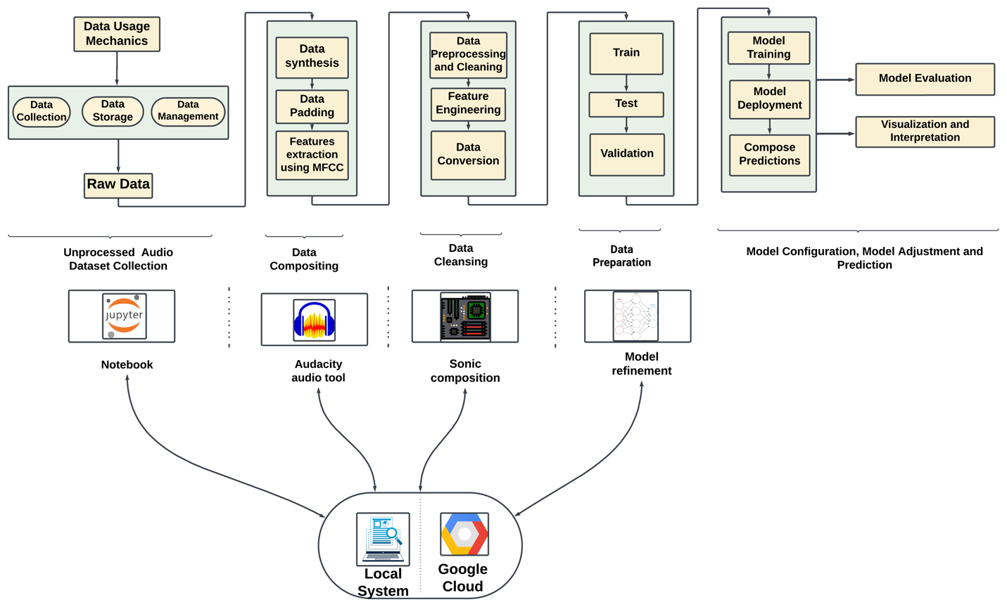

The cleaning phase commenced with thorough data preprocessing, encompassing various techniques for refining, and enhancing the dataset. Feature engineering strategies were then applied, followed by the implementation of data conversion methods to ensure compatibility with subsequent modeling steps. For the model-building phase, the dataset was divided into training (60%), testing (20%), and validation (20%) set to enable effective model training, evaluation, and validation. Three distinct deep learning models were employed to capture the intricate patterns within the audio data.

The subsequent stages involved model training and deployment techniques, paving the way for predictions. Model configurations were fine-tuned, and adjustments were made to optimize performance. The evaluation process meticulously documented the accuracy of the models, presenting results in a systematic order. The report encapsulated the model configuration, adjustments made, and detailed predictions. Finally, the findings were communicated through clear and insightful visualizations, providing a thorough interpretation of the model's performance.

## Model Comparison and Justification

For object recognition in audio and images, convolutional neural networks are the method most frequently employed. CNN designs have been showing a tendency toward greater network depth over time. While more modern models like DenseNet have 19 layers, the original LeNet5 only had five. Conversely, as of last year, InceptionV3 Networks and Residual Networks have more than 100 layers. However, as CNNs get deeper, a new research challenge emerges as input or gradient information moves through numerous layers and toward the end of the network, it may begin to disappear. Using techniques like identification signals from one layer to another in ResNet and Highway Connections can help to mitigate this problem.

A Stochastic depth approach removes layers at random during training to improve gradient and information flow in ResNet. Through the integration of many parallel layer sequences, can achieve a significant nominal depth while maintaining short pathways by utilizing FractalNets. While the network structure and training process of various techniques differ, they are always characterized by the establishment of brief paths between layers. As a result, convolutional networks that have fewer connections between their input and output layers can demonstrate significant gains in precision, effectiveness, and depth. To address the drawbacks of the conventional models, the Dense Convolutional Network (DenseNet) model was developed. DenseNet is a neural network development for visual object detection. Between DenseNet and ResNet, there are a few key distinctions. DenseNet uses an additive approach (+) to merge the output of the previous layer with that of the following layer, in contrast to ResNet.

The fact that DenseNet addresses the problem of disappearing gradients, which can interfere with training, is one of its key benefits. DenseNet also has a connectivity pattern that connects all layers with matched feature-map sizes directly, which aids in feature propagation and reuse. This encourages the network's tiers to exchange information at their greatest rate. In addition, when compared to alternative topologies, DenseNet also achieves a significant reduction in parameters. Subsequent layers transfer their feature maps to all previous layers and get new inputs from them to preserve their feed-forward nature.

This dense connection design may have the paradoxical benefit of having fewer variables than conventional convolutional networks because duplicate feature maps do not need to be learned again. An algorithm with a state that is transferred from layer to layer might be thought of as a feed-forward architecture. Every layer transfers the state from the one before it to the one after it. It communicates data that needs to be kept in addition to altering the state. ResNet explicitly expresses this information representation using additive identity transformations. Recent research has demonstrated that many ResNet layers add relatively little and can be arbitrarily removed during training.

Consequently, in terms of their states, ResNet are comparable to (unfolded) recurrent neural networks. However, because each layer has a weight assigned to it, ResNet have a significantly higher number of parameters. Conversely, DenseNet architecture clearly distinguishes between new and conserved data. As a result, DenseNet layers only include a limited number of feature maps (for instance, 12 filters each layer) in the "collective knowledge" of the network, and the final classifier bases its decisions on all characteristic maps from the whole network. Furthermore, DenseNet improved gradients and information flow make the training process simpler to comprehend and follow. By giving the layers direct access to gradients formed from the beginning of the input signal as well as the loss function, they provide implicit deep supervision. This makes it possible to train more complex network topologies. In addition, for smaller training sets, the normalizing impact of extensive connections helps minimize overfitting. Table 4 compares the functional and non-functional aspects of the chosen models.

**Table 16**

*Comparison of functional and non-functional aspects of the models*

| **Characteristics** | **ResNet** | **DenseNet** | **CNN** |
| --- | --- | --- | --- |
| Architecture | Is an artificial neural network architecture that includes skip connections between layers. These skip connections allow information to bypass certain intermediate layers and propagate directly from one layer to another. | Is distinguished by the existence of straightforward connections between every layer. | Multiple essential elements, such as fully linked layers, pooling layers, and convolutional layers. |
| Data Type | Audio Dataset | Audio Dataset | Audio Dataset |
| Data Size | Suitable for big datasets | Suitable for both small and big datasets | Uses modest filter dimensions and performs well with minimal datasets. |
| Complexity | Better in terms of computing than Dense | Minimizes the complexity of computing | Moderate |
| Complications with underfitting | It’s possible that ResNet layers aren't deep enough to accurately represent the convoluted nature of the data. | Due to its highly coupled layers, DenseNet architecture might be challenging to train. | Possibly if not sufficiently deep to capture complicated patterns. |
| Complications with overfitting | Deep layers in ResNet may make it more likely to overfit, which can happen if regularization isn't done. | If correct regularization is not applied, DenseNet densely connected layers may cause overfitting. | Prone to overfitting, particularly in cases with limited data |
| Strengths | Shorten the training period while increasing precision | Diminish the issue of the vanishing gradient, enhance the distribution of features, encourage the reuse of features, and significantly lower the quantity of characteristics. | Suitable for jobs involving images; with preprocessing, applicable for audio |
| Limitations | Issue with vanishing gradients, increasing complexity might make computing more difficult; careful adjustment is needed. | The fact that feature maps are repeatedly replicated and combined with earlier layers is a drawback, potentially costly computationally and resource-intensive | Restricted capacity to identify distant relationships in audio sequences |
|  |  |  |  |
| Approach | Deep Learning | Deep Learning | Deep Learning |
| Hardware requirements | GPU ( Google Colab Pro, energy efficient T4 GPU) | GPU ( Google Colab Pro, energy efficient T4 GPU) | GPU ( Google Colab Pro, energy efficient T4 GPU) |
| Accuracy | Achieved good accuracy score on test data i.e. 96.4% | Achieved good accuracy score on test data i.e. 96.4% | Achieved good accuracy score on test data i.e. 96.4% |
| Training Speed | Fast | Moderate | Slowest |
| Training Time | A few hours | Several hours to a few days | Several hours |
| Space complexity | Low | Moderate | Largest |
| Known issues | Known for its speed and simplicity, but not very accurate | Slow prediction makes it hard to do real-time processing | Large model, requires large memory and computational resources |
| AI Features | Skip connections for improved representation | Dense connections for feature distribution and reuse | Combination of fully linked, pooling, and convolutional layers |

DenseNet are renowned for their capacity to generate productive and compact models. DenseNet increases resource usage efficiency and facilitate training by reusing features inside the network. Additionally, enhance efficiency by supplementing input variance and concatenating feature maps from different layers. Since decision trees have a straightforward design and are capable of processing noises and audio data efficiently, they are a good choice for grouping swine audio recordings in order to categorize their ailments. It's crucial to remember, though, that decision tree models could need a lot of processing capacity and careful hyperparameter adjustment during the training process.

An identity function allows gradients to flow directly from later layers to previous layers in a neural network architecture called ResNet. They provide a different method for modeling input data, which has led to their widespread adoption for the development of strong deep-learning models. Furthermore, DenseNet functions as an extension of ResNet by creating what is referred to as a "dense block" by concatenating output feature maps from earlier convolutional layers rather than putting them together within each layer. The same convolutions and a stride value of one are usually used by both dense and residual blocks to guarantee consistent form maintenance. Due to this design decision, DenseNet can perform better than ResNet models with a noticeably smaller number of parameters.

When comparing MobileNet, a convolutional neural network (CNN) architecture primarily used for image classification, to LSTM, a recurrent neural network (RNN) architecture designed for sequence modeling, several distinguishing characteristics and considerations emerge.

MobileNet uses a deep CNN architecture, with multiple convolutional layers followed by global average pooling and fully connected layers. With lightweight convolutional operations, it is optimized for efficient inference on mobile and embedded devices. MobileNet is specifically designed to process image data and excels at image classification, object detection, and segmentation tasks. MobileNet is well-suited to processing large-scale image datasets but may need help with highly sparse or unstructured data.

Overfitting may occur when MobileNet is trained on small datasets, or the model capacity exceeds the complexity of the task. Before data is fed into MobileNet, it is usually necessary to perform preprocessing steps such as image resizing and normalization. Training time and computational complexity are determined by the model's size and the dataset's complexity. MobileNet provides high accuracy in image classification tasks while remaining efficient and low computational cost, making it ideal for resource-constrained environments. MobileNet's performance may need to improve on complex tasks like object detection or semantic segmentation compared to more intricate CNN architectures.

In contrast, LSTM is a type of RNN architecture that includes specialized memory cells and gating mechanisms. It is designed to handle sequential data, making it appropriate for tasks like natural language processing, time series prediction, and speech recognition. LSTM is adaptable and can take a wide range of sequential data, including text, time series, speech, and audio. It is especially effective at detecting long-term dependencies and patterns in sequential data streams. LSTM can process small and large datasets, including sparse and irregularly sampled time series data. Its ability to retain its internal state over time makes it resistant to data scarcity.

**Table 17**

*Characteristic comparison of MobileNet and LSTM*

| **Characteristics** | **MobileNet** | **LSTM** |
| --- | --- | --- |
| Architecture | Convolutional Neural Network | Recurrent Neural Network |
| Data Type | Image | Text, Time Series, Speech, Audio |
| Data Size | Suited for large-scale images | Effective for both small and large datasets, resilient to sparsity |
| Overfitting/Underfitting | Prone to overfitting on small datasets | May suffer from overfitting on noisy or highly variable data |
| Model Complexity | Requires images preprocessing | Requires preprocessing for sequential data, computationally intensive training |
| Strengths | High accuracy for image classification | Captures temporal dependencies, suitable for sequential data |
| Limitations | Performance degradation on complex tasks | Sensitivity to hyperparameters, training data quality |

Overfitting can also occur with LSTM models, especially when trained on noisy or highly variable sequential data sets. Dropout or L2 regularization are standard techniques used to reduce overfitting in LSTM models. Tokenization or feature engineering may be required before using LSTM models with text or time series data. Table 5 shows the characteristic comparison of MobileNet and LSTM.

Training LSTM models can be computationally intensive, especially for large datasets or deep architectures with many parameters. LSTM excels at capturing temporal dependencies and long-range patterns in sequential data, making it ideal for tasks like language modeling, sentiment analysis, and time series prediction. LSTM performance can be influenced by hyperparameter selection, training data quality, and noisy or irrelevant features in sequential data.

## Model Evaluation Methods

The evaluation metric is an essential component of any model to guarantee performance. Finding an appropriate model requires evaluating how well different processes and techniques fit the gathered data. Several metrics like Confusion Matrix, Precision, Recall, F1-Score and Accuracy are implemented.

### Confusion Matrix

Also referred to as an error matrix, a confusion matrix contrasts the outcomes of several test predictions with actual values. The structure of a confusion matrix in Table 6. This table helps with the computation of several evaluation measures, such as recall, accuracy, and precision.

**Table 18**

*Confusion matrix*

|  |  |
| --- | --- |
| **Actual-Values** | **Predicted-Values** |
| Yes/No | |  |  | | --- | --- | | No | Yes | |
| No | |  |  | | --- | --- | | True-Negative(TN) | False-Positive(FP) | |
| Yes | |  |  | | --- | --- | | False-Negative(FN) | True-Positive(TP) | |

*Note.* True Positive Rate (Sensitivity/Recall): TPR = TP / TP+ FN,

False Positive Rate: FPR = FP / FP + TN

### Area Under Receiver Operating Characteristic Curve (AU - ROC)

A popular graphical method for assessing a model's performance is the Receiver Operating Characteristic curve or ROC curve. By graphing the true positive rate and false positive rate against one another at different threshold levels, it is possible to examine the trade-off between the two. Can evaluate the effectiveness of the model in differentiating between the positive and negative classes by examining the graph.

A graphical representation of the True Positive Rate against the False Positive Rate at different classification thresholds. The area under the ROC curve, or AUC, is a numerical representation of the model's performance. It shows the degree to which it can distinguish between positive and negative scenarios with accuracy. Better discrimination ability in the model is demonstrated by higher AUC values. It is a widely used metric in machine learning, particularly for binary classification problems.

AUC = (10)



### Precision

Precision is a metric that expresses "how often selected elements are appropriate." This indicates that it displays the proportion of positive observations relative to those that the method forecasted. The formula TP/(TP+FP), where TP stands for true positives and FP for false positives, can be used to determine precision.

### Recall

Recall is a metric that shows how many pertinent data points were chosen. Out of all the actual positive measurements, it shows the percentage of positive observations that the algorithm anticipated. Recall is calculated using the formula TP/(TP+FN), where TP stands for true positives and FN for false negatives.

### F1 Score

This metric is used to calculate algorithm performance; it accounts for both precision and recall. As a result, other names for it include f1-score and f1-measure. It can be described mathematically as F1 Score = 2*(Recall * Precision) / (Recall + Precision), which stands for the harmonic mean of precision and recall.

### Accuracy

For multi-label classification issues, the accuracy measure is an essential tool, measures the ratio of correctly predicted instances to the total number of instances in a dataset. It quantifies the model's precision in predicting outcomes correctly across all classes. Represented as a percentage, accuracy gauges the overall correctness of predictions, offering a simplistic yet fundamental measure of model performance. However, in scenarios with imbalanced datasets, accuracy might not fully represent the model's effectiveness, as it doesn't consider class distribution. Despite its simplicity, accuracy remains a crucial metric for assessing the overall correctness of predictions in classification tasks. Table 7 illustrates the comparison of different evaluation metric scores.

**Table 19**

*Comparison of evaluation metric scores*

|  |  |  |
| --- | --- | --- |
| **Metrics** | **Explanation** | **Model** |
| AU - ROC | Measures the capacity of a binary classification model to differentiate between classes and ranges from 0 to 1, with higher values indicating superior performance. | CNN, DenseNet, ResNet |
| Precision | Evaluated as the proportion of accurate output to all generated responses. True Positives / (True Positives + False Positives) equals precision. | CNN, DenseNet, ResNet |
| Recall | Indicates the percentages of the audio's accurate results among all possible correct responses. True positives / (True Positives + False Negatives) equals recall. | CNN, DenseNet, ResNet |
| F1 Score | Balances precision and recall in one metric for classification model evaluation. Ranges from 0 to 1; higher is better. Particularly useful with imbalanced classes. | CNN, DenseNet, ResNet |
| Accuracy | Compiled by tallying the number of accurate audio outputs produced in relation to a predetermined list. (Total number of forecasts / Number of correct predictions) equals accuracy. | CNN, DenseNet, ResNet |

## Model Validation and Evaluation

### DenseNet

The DenseNet confusion matrix demonstrates that the model struggled to correctly classify instances belonging to the second and third classes, as evidenced by the nonzero values outside the main diagonal. Figure 55 shows the evaluation metrics for DenseNet.

**Figure 55**

*Evaluation metrics for DenseNet model*

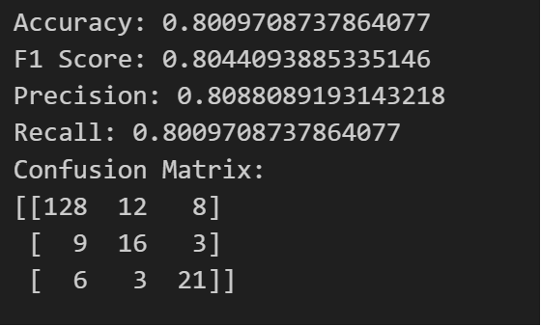

Despite achieving moderate accuracy, DenseNet's precision and F1 score indicate that it struggled to identify positive instances, resulting in lower overall performance correctly in Figure 55. DenseNet's architecture, which encourages feature reuse via dense connectivity patterns, provides advantages for extracting fine-grained features from images. However, the model may need help effectively leverage these features for classification, resulting in suboptimal performance.

### CNN

CNN's confusion matrix performs better than DenseNet in all classes, with fewer misclassifications. CNN's superior performance is due to its ability to automatically learn hierarchical representations of features from raw data, making it ideal for image classification tasks. Figure 56 shows the evaluation metrics for CNN. CNN's success can also be attributed to its adaptable architecture, which enables easy adaptation to various data types and tasks. CNNs can effectively capture spatial hierarchies and learn discriminative features from images by stacking multiple convolutional layers followed by pooling layers and fully connected layers, respectively.

**Figure 56**

*Evaluation metrics for CNN*

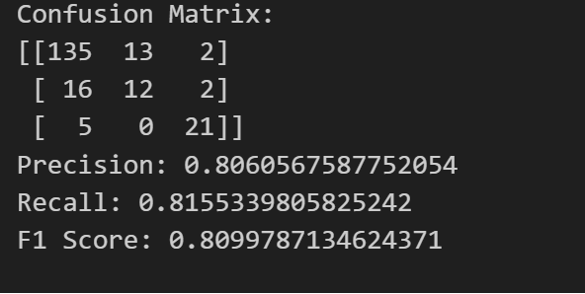

### ResNet

ResNet performed similarly to CNN regarding the accuracy, precision, recall, and F1 score. However, it had a higher precision score, indicating it performed better at identifying positive instances. From Figure 56 the confusion matrix reveals some misclassifications, particularly in the second class, where several cases were incorrectly classified as belonging to the third class. Figure 57 shows the evaluation metrics for ResNet.

**Figure 57**

*Evaluation metrics for ResNet*

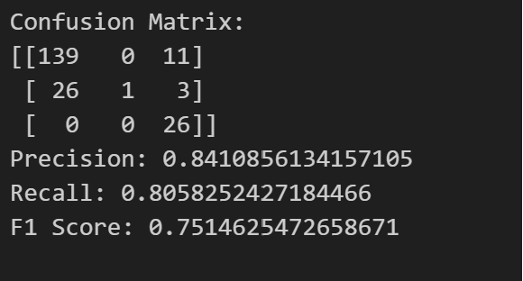

ResNet's success can be attributed to its innovative residual connections, which mitigate the vanishing gradient problem and make it easier to train deep networks in Figure 57. ResNet allows information to flow through the network via shortcut connections, which promotes effective feature reuse and the development of more discriminative representations.

### LSTM

The evaluation results show that LSTM has an accuracy of 36.8%. The LSTM performs significantly worse than the MobileNet, indicating difficulties in effectively learning from sequential data. The model may have struggled to detect underlying patterns and dependencies in the data, resulting in poor classification performance.

The architecture of LSTMs, which is designed to maintain and update a memory state over time, makes them ideal for tasks that require temporal dependency modeling. However, in this case, the model may have needed help effectively leveraging the sequential nature of the data to make precise predictions.

### MobileNet

The evaluation results show that MobileNet has an accuracy of 46.2%. When comparing LSTM and MobileNet, it is clear that LSTM exhibits significantly lower performance in terms of accuracy. MobileNet outperforms LSTM in terms of accuracy, indicating that it is better suited for the given image classification task.

The lower performance of LSTM may be attributed to the architectures not being optimized for the specific task or dataset. LSTM, designed for sequential data modeling, may not have been able to capture the patterns in the image data effectively. MobileNet, optimized for efficient image processing, may have struggled to extract relevant features from the images in the dataset. Table 8 shows the comparison of all the evaluation metrics for all the models.

**Table 20**

*Comparison of all the evaluation metrics for all the models*

|  |  |  |  |  |
| --- | --- | --- | --- | --- |
| **Model** | **Accuracy** | **Precision** | **Recall** | **F1 Score** |
| DenseNet | 80.01% | 53.02% | 72.82% | 61.36% |
| CNN | 81.55% | 80.61% | 81.55% | 80.99% |
| ResNet | 80.58% | 84.11% | 80.58% | 75.15% |
| LSTM | 36.8% | - | - | - |
| MobileNet | 46.2% | - | - | - |

For the audio data, the comparison shows that CNN outperforms the other models regarding accuracy, precision, recall, and F1 score in Table 20. ResNet performs similarly to CNN in most evaluation metrics. DenseNet performs moderately, while LSTM and MobileNet underperform compared to the other models.

# Data Analytics Systems

## System Requirement Analysis

### System limits and Use Cases

The pork industry is an important contributor to the worldwide livestock sector, supplying a crucial source of protein-rich food to fulfill the demand for meat consumption. An ongoing challenge facing the swine sector is early illness identification which is evident prerequisite. The occurrence of illnesses within pig populations can result in significant financial impact, impair animal well-being, raise concerns about food safety, and impose higher maintenance expenses on farmers as users. To overcome this project is to give farmers a tool to monitor and control the health of their pigs by properly detecting and classifying pig ailments. The system's possible application includes various data from the pig farming industry which can lead to early detection of diseases, ultimately lowering healthcare expenses and improving food safety. It uses visual, audio, and image-based information to categorize diseases in pigs. A significant amount of audio and footage was gathered, showing swine behavior in various settings and circumstances. This appraisal is a significant issue in the pig farming sector, which is highly pertinent and influential. The swine industry is crucial for meat, but timely disease detection is challenging. Farmers play a key role as actors in caring for pigs, yet tracking all pigs in a large facility can be difficult. Late examination may lead to severe issues, rendering some pigs unsuitable for the meat industry, resulting in heavy losses. To address this, early disease detection using pig vocalizations and skin images is essential. These applications benefit both farmers and the meat and food industries, fostering a healthy relationship in various settings.

### System high-level data analytics requirements

This project intends to create the best optimal disease detection from pig sector in order to effectively accommodate the different kinds of treatment according to the disease such as African swine fever, swine pox, erysipelas etc. Within the context of models, the system serves good analysis by various purposes such as predicting the early ailments detection based on the various audio data and swine skin images estimating the valid output after training the data to predict the output with high accuracy, forecasting type of illness, including the User Interface (UI) with detailed presentation with detailed image description and valid outcomes, utilizing several tools such as audacity where the audio files were carefully extracted from videos and meticulously chopped into distinct segments. Moreover, well-known Python package Librosa was used to process the audio data in which preprocessing procedures involved eliminating undesired disruptions and silence intervals to preserve the integrity of the dataset. The process of extracting features is crucial in audio analysis, using techniques such as spectrograms and Mel-frequency cepstral coefficients (MFCCs) to process data and padding sequences is used after feature extraction to ensure uniform lengths, especially in the analysis of sequence-based data such as natural language processing, time series analysis, and certain machine learning models.

To detect swine diseases early, data analytics necessitates the collection, processing, and analysis of insubstantial data volumes crucial for supporting the system's essential operations. This involves analyzing data with low volume, falling within the scope of incomplete and inaccurate system analysis. The data is collected from various sources such as professionals in swine health and acoustics, relevant organizations, and research paper authors were contacted. Additionally, pig cough sounds and images were collected from easily accessible sources such as YouTube and veterinary organizations websites. Data that is accurate are necessary for precise evaluation. The dataset is subjected to extensive data cleansing and validation processes in order to find errors, resolve them, deal with discrepancies, and fill in any missing data. Machine learning models are extensively used to analyze and interpret both audio and image data in order to make predictions with high accuracy as mentioned in Figure 58. This involves thoroughly analyzing the particular disease of swine, accurately anticipating the expected output, and strategically planning for the effective implementation of control measures for the diseases in order to minimize their impact on the swine industry. To understand, evaluate, and act upon the insightful information that the system generates, data visualization tools and statistics are created which helps users make sense of the data and make decisions based on research findings about swine diseases. In the end, maximum efficiency guarantees that the system for predicting swine disease is analyzed carefully to meet the specific need for cure. For the system connected to swine audio and image data to operate reliably in a variety of operational settings, certain advanced data analytics specifications are necessary.

**Figure 58**

*Structural System Boundaries, Use Cases, Users*

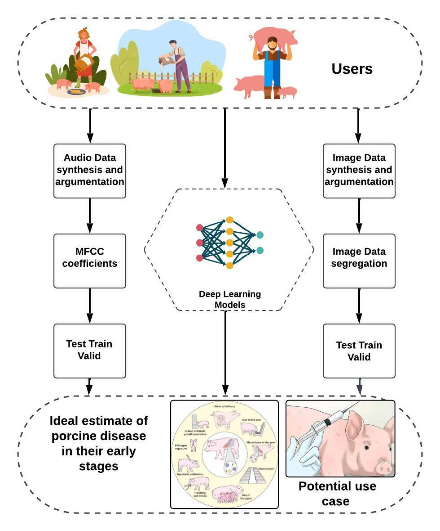

## System Design

### System Architecture and Infrastructure

The Pig Disease Classification System is designed to efficiently classify diseases in pigs using a combination of audio and image data. The system comprises both frontend and backend components, providing users with a seamless experience for disease prediction from Figure 58.

The frontend of the system is responsible for user interaction and initiating disease prediction. Users access a website where they can input relevant data and trigger the prediction process. The output of the prediction is displayed on the front-end screen for easy interpretation. The backend of the system is responsible for processing the dataset, training deep learning models, and handling the prediction process. The dataset, consisting of both audio and image data, is stored in two locations for redundancy and accessibility. It is stored on a local drive and on Amazon Web Services (AWS) for scalability and reliability. Prior to model training, the raw audio and image data undergo preprocessing. This involves cleaning, normalization, and transformation of the data to make it suitable for deep learning models.

Deep learning models are employed to classify pig diseases based on the preprocessed data. These models are trained using state-of-the-art algorithms, leveraging the power of deep neural networks. Training occurs on both audio and image datasets separately. After model training, the system undergoes rigorous testing using a separate set of test data. This ensures the robustness and accuracy of the trained models in predicting pig diseases. Once the models pass the testing phase, they are integrated into the prediction pipeline. When a user initiates a prediction from the frontend, the backend processes the input data through the trained models, predicts the disease, and sends the results to the frontend for display. Figure 59 illustrates the system architecture of the project.

The predicted disease output is presented on the front-end screen in a user-friendly format. This output includes information about the predicted disease based on the input data provided by the user. The integrated front-end and backend architecture of the Pig Disease Classification System provides a robust, efficient, and user-friendly solution for predicting pig diseases using both audio and image data. The use of deep learning models ensures accurate predictions, contributing to the early detection and management of pig diseases.

**Figure 59**

*System Architecture*

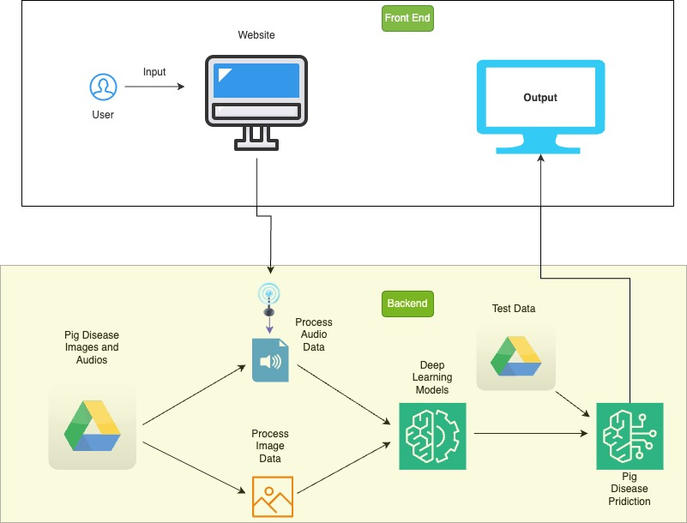

### System Supporting Platforms and Cloud Environment

In the initial phase of the project, as discussed, audio data was collected from YouTube using the YouTube Data API. In Figure 60, Specific queries were employed to extract relevant audio content, Simultaneously, image data was collected from Google Images using the Google Images API. Custom queries were applied to obtain diverse and relevant images, and a web scraping tool was implemented for downloading images. The collected audio and image data were stored in Google Cloud Storage. Proper organization of storage buckets and access controls was ensured. Team members accessed the data collaboratively using Google Colab, a Python development environment. Subsequently, the data was transferred to an AWS S3 bucket for cross-platform compatibility. AWS IAM roles and permissions were configured to secure access, and AWS Lambda was employed for automating data transfer tasks.

Team members collaborated on data analysis using Google Colab notebooks. The integrated Python environment in Colab facilitated preprocessing and initial exploration of the collected data. Additionally, AWS Lambda was utilized for serverless computing to automate data processing tasks. Functions were implemented to clean and transform data before storage.

Model training took place using Amazon SageMaker, an integrated machine learning service. Both pre-built algorithms and custom scripts were employed for audio and image analysis. Flask was integrated into the system for creating a web application framework, and Keras was used for building and deploying machine learning models. Endpoints were developed for model inference and predictions. Amazon SageMaker was leveraged for generating visualizations based on model outputs. The integrated tools within SageMaker facilitated data exploration and visualization. Flask played a crucial role in developing a user-friendly web interface to interact with visualizations. Endpoints were created for fetching and displaying results. Tableau was utilized to showcase image-related insights.

The comprehensive system seamlessly integrated data collection, storage, processing, and visualization across platforms, capitalizing on the strengths of both Google Cloud and AWS. The collaborative features of Google Colab and the scalable infrastructure of AWS S3 and Lambda contributed to a robust and efficient workflow for handling audio and image data. The machine learning models, developed using Amazon SageMaker, along with Flask and Keras, provided a powerful solution for the analysis and visualization of the collected data.

**Figure 60**

*Frameworks, Cloud Environments and Supporting Environments*

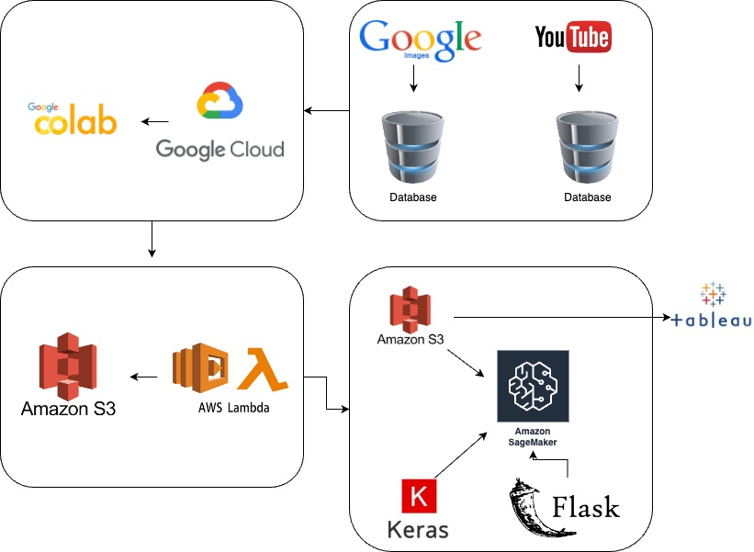

### System Data Management Solution

The data flow in Figure 61 begins with the user submitting pig images and audios through the frontend. This input data is then processed in AWS, where a series of preprocessing steps take place, including cleaning, normalization, and transformation of both image and audio data. The preprocessed data is subsequently fed into the deep learning model for training, utilizing sophisticated algorithms and neural networks to discern patterns and features associated with pig diseases. Following the training phase, the system undergoes thorough testing using a separate set of data to assess the model's accuracy and effectiveness.

Upon successful testing, the deep learning model is ready for predictions. When a user triggers a prediction, the input data is processed through the trained model, and the predicted disease output is displayed on the frontend screen. This output provides comprehensive information about the detected pig disease, offering users valuable insights based on the input data they provided. The seamless flow of data from user input to output display ensures an efficient and reliable process for pig disease classification within the system.

**Figure 61**

*Data flow chart from input to output*

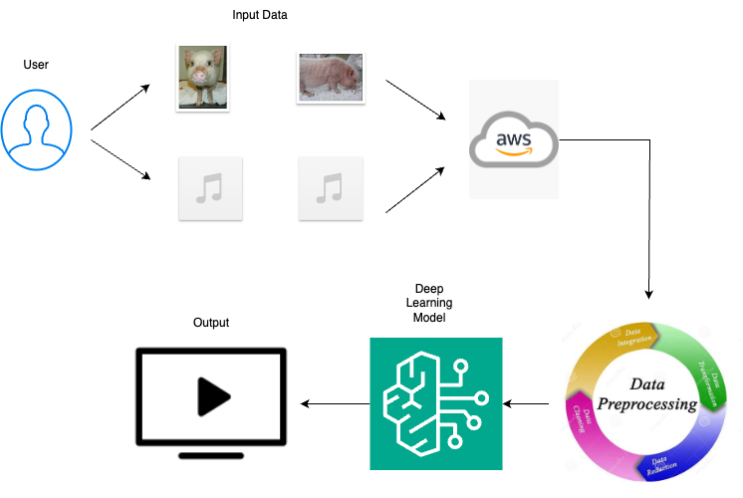

### System User Interface

A graphical user interface (GUI), as depicted in Figure 62 was developed using Flask to facilitate pig disease prediction. The GUI incorporated a user-friendly design, featuring an "Upload File" field that allowed users to select images directly from their local machines. Upon selecting an image and clicking the "Upload" button, the chosen image was processed, and the predicted results were displayed below the upload section. This seamless integration of file upload and result presentation enhanced the user experience, making the prediction process intuitive and accessible. The interface not only provided a platform for users to contribute input images effortlessly but also ensured clear and immediate visibility of the model's predictions.

**Figure 62**

*Sample graphical user interface*

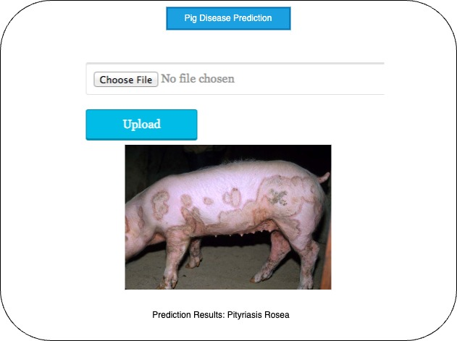

## System Development and Implementation

### AI and Machine Learning Models Development

The project focuses on improving swine health using advanced technology to detect and classify diseases in swine. In Figure 62, the project includes a dual approach, utilizing both audio and image datasets to identify different types of diseases like the one that affects the internal organs where the symptoms are observed using cough sounds and skin diseases can be identified using the images of the effected pigs. The primary goal is to enhance disease detection in swine, benefiting both farmers and food industries significantly. This initiative can be further expanded to identify disease in various domestic animals which aids farmers on a large scale. The project adopts deep learning models, to work on both forms of data. Two distinctive datasets, one for audio and another for images are processed separately and dedicated models are developed for each.

The data that is required for the project is collected from various sources like extracting audio cough sounds of diseased swine from multiple videos on the internet and the image dataset is collected for 13 skin diseases using google images. The video files are converted into mp3 audio files, and the cough sounds are extracted using Audacity application. The necessary cleaning like external noise removal of the cough sounds is done during the extraction process. Whereas the image data collected from google images is clean which did not require much cleaning process.

The models employed for the project are based on the type of data that is used. To detect the disease that symptomizes the cough sounds which is audio data, deep learning models like LSTM, ResNet, DenseNet are used whereas models like MobileNet and LSTM are used to classify the skin diseases using image data. Feature extraction for audio data is done using MFCCs and CNN is used to extract features from image data. Both the models selected have their own advantages and disadvantages. LSTMs are effective in analyzing the temporal patterns in audio signals like the cough sounds of diseased swine. In the same way ResNet is also beneficial for capturing intricate patterns within complex audio data associated with swine diseases. LSTMs can also retain the trained information for longer duration, which helps them to capture the dependencies and nuances of the audio data that are important for disease detection. Residual connections are crucial for addressing the vanishing gradient problem, which ensures a smooth information flow in the network. This is particularly essential in processing audio data which is provided by ResNet model. MobileNet model is used for Image dataset in classifying swine diseases as MobileNet is specially designed for mobile and embedded devices which helps all the farmers for easy access and focuses on efficiency. It is also faster due to its lightweighted architecture which makes it appropriate for real-time applications. While LSTM excels in real-time object detection and accurate predictions and quick processing, it is also convenient for applications with low latency.

### Implement Designed System

Creating a user-friendly system is the priority, to meet the needs of users while achieving the goals. The system is developed as a python application using the flask framework, which emphasizes seamless integration with an aesthetically pleasing user interface (UI). The UI is designed to be not only visually appealing but also for users to navigate and comprehend. All the data that is collected is stored on AWS and follows a meticulous process of cleaning and transforming the data to ensure its accuracy and reliability. The next step involves developing a deep learning model that classifies the disease based on the data.

To enhance the user experience, essential web pages are developed using a combination of JavaScript, HTML, and CSS. These pages are carefully designed to be intuitive, providing a seamless interaction for users. The integration of these pages with the saved deep learning models combines with python web application. The application is conducted on a dedicated server, ensuring accessibility and reliability.

The development phase involves making all the content available on the live website. Testing is conducted within the team to identify any possible issues or the areas of improvement. All the required actions are implemented to improve the performance of the system. Implementing the designed system is a crucial phase, where the plan is executed to bring the system to action. This system development life cycle requires accuracy and careful execution to ensure that the system functions as expected. The process consists of various stages including coding, proper testing, and the final development of the robust system.

### Input and Output Requirements

The input requirements for the swine disease detection and classification project include audio and image data collected from various sources. For audio data input consists of cough sounds extracted from video files of diseased swine, converted into MP3 format, and processed using Audacity application to remove external noise. Image data is collected from google images focusing on 13 skin diseases of affected swine. Both datasets undergo necessary cleaning ensuring high-quality input for model training.

The output requirements depend on the type of model and data for audio-based disease detection, the output includes the classification of diseases based on the analysis of cough sounds. In the case of image-based classification, the output involves identifying specific skin diseases affecting swine. The output should be clear, interpretable, and provide valuable information for both farmers and the food industry.

### System Support Environment

The project’s purpose is to build a system which can help farmers and the food industry to focus on the health of the animals to detect the state of the diseases early. Many environments were employed to assist the functioning and development during development of the project. Jira has been used as a project management application to track the strategy, pipeline, and overall project development. The project relies on cloud infrastructure, especially AWS is used to store all the image data and audio files, ensuring scalability and accessibility. Tableau is used to visualize the data to extract useful insights. Visual Studio is used to run all deep learning and machine learning models. A code repository is created on GitHub with all the project documentation. Flask API is used to create a web application and GUI for easy accessibility to users.

### Supporting Systems and Solution APIs

**Jira.** Jira, served as the central project management tool, which aids in task assignment, project organization, and status tracking. Leveraging features like Work Breakdown Structure (WBS) and Gantt charts, Jira simplified the project planning.

**AWS*.*** Due to the diverse nature of the data which includes both audio and image data, the data is stored in Amazon Web services (AWS). By creating a S3 bucket, a cloud-based storage solution, which enables seamless storage and access to the data.

**Visual Studio (VS Code).** Visual Studio provides a robust environment for developing deep learning projects with its integrated tools and debugging features. VS Code streamlines code development and ensures a smooth workflow, enhancing efficiency and facilitating the creation of sophisticated deep learning models.

**Tableau.** Tableau is used to visualize and interpret the input data and output results in deep learning projects. It transforms complex model outputs and data into interactive, easy-to-understand visualizations. Tableau is also used to visualize the features extracted from audio data and image data.

**GitHub.**GitHub repositories serve as storage directories for a project, housing files like models, data processing code, and documentation. This collaborative platform enables code review, modifications, and issue tracking. With the entire project team working collectively, GitHub facilitates efficient project management and collaborative development.

**Draw.io*.*** Draw. io is a important tools in project development as an intuitive drawing tool. It assists in creating flowcharts, system architectures, and visual representations of project structures with the user-friendly interface. Draw.io streamlines communication among team members, enhancing project planning, design, and documentation processes.

## System Support Environment

The system support environment for the project aimed at enhancing animal health monitoring in the agricultural and food industry encompasses a robust set of tools and solutions tailored to facilitate development, management, and development. Leveraging a combination of project management applications, cloud infrastructure, development environments, visualization tools and collaborative platforms, the project maximizes efficiency and effectiveness in achieving its objectives.

### Jira

Jira stands as the cornerstone of project management, offering an extensive array of functionalities for assigning tasks, organizing projects, and tracking progress. Its robust features such as Work Breakdown Structure (WBS) and Gantt charts, streamline project planning and execution. By leveraging these tools. Jira empowers teams to allocate resources efficiently, monitor project advancement, and pivot strategies as needed. This ensures that project milestones are achieved promptly, maintain momentum, and fostering project success.

### AWS

The project’s foundation heavily leans on cloud infrastructure, with a primary reliance on Amazon Web Services (AWS) for scalable and accessible storage of a variety of data types, ranging from image to audio files. Leveraging AWS’s S3 bucket, data is securely stored and easily accessible, facilitating seamless integration with different components of the system. This cloud-based storage solution not only improves data management but also provides essential scalability, crucial for accommodating datasets and meeting evolving user needs.

### VS Code

Visual Studio Code (VS Code) stands out as a pivotal tool in the development of deep learning and machine learning models. Offering integrated tools and debugging features, VS Code furnishes a robust coding environment that optimizes workflow and upholds code quality standards. Its versatility and efficiency streamline the development process, enabling the team to craft sophisticated models designed to effectively detect early signs of animal diseases.

### Tableau

Tableau functions as the cornerstone of data visualization and interpretation, converting intricate model outputs and input data into interactive visual representations. Through its intuitive insights, tableau empowers informed decision-making and allows stakeholders to swiftly grasp crucial information. Its capability to visualize features extracted from audio and image data enriches comprehension of animal health indicators, thereby catalyzing actionable insights and informed strategic decisions.

### GitHub

GitHub serves as the central hub for project assets, encompassing code, models, data processing scripts, and documentation. Functioning as a collaborative platform, GitHub nurtures teamwork by facilitating version control, code review, issue tracking and seamless collaboration among team members. It champions transparency, fosters accountability, and promotes efficient project management, thereby ensuring alignment towards project goals and objectives.

### Draw.io

Draw.io serves as a vital asset in project development by offering an intuitive drawing tool for crafting flowcharts, system architectures, and visual depictions of project structures. It is a user-friendly interface fosters improved communication among team members, thereby facilitating streamlines project planning, design, and documentation processes.

The system support environment integrates a comprehensive suit of tools and solutions designed to enhance the development, management, and development of the animal health monitoring system. By leveraging project management applications, cloud infrastructure, development environments, visualizing tools, and collaborative platforms, the project is positioned to achieve significant impact in the agriculture and food industry. This approach empowers stakeholders to prioritize animal health and early disease detection, ultimately leading to more effective outcomes.

# System Evaluation and Visualization



## Analysis of Model Execution and Evaluation Results

Measuring the performance of deep learning models for swine disease classification involves a rigorous methodology and process to evaluate the accuracy, precision, recall, and F1 score. This task is particularly challenging due to the complexity of the data and the nuances associated with different deep-learning architectures. In this project, DenseNet, RNN, and ResNet were implemented on audio data, while LSTM and MobileNet were applied to image data.

Each deep learning architecture is trained on its respective data type (audio or image) using appropriate training strategies. This involves splitting the dataset into training, validation, and test sets. The training set is used to optimize model parameters through backpropagation, while the validation set is utilized to tune hyperparameters and monitor performance during training. Finally, the test set, which remains unseen during training, is used to evaluate the final model performance. Figure 63 shows the DenseNet prediction.

**Figure 63**

*DenseNet predicts the class of a test case*

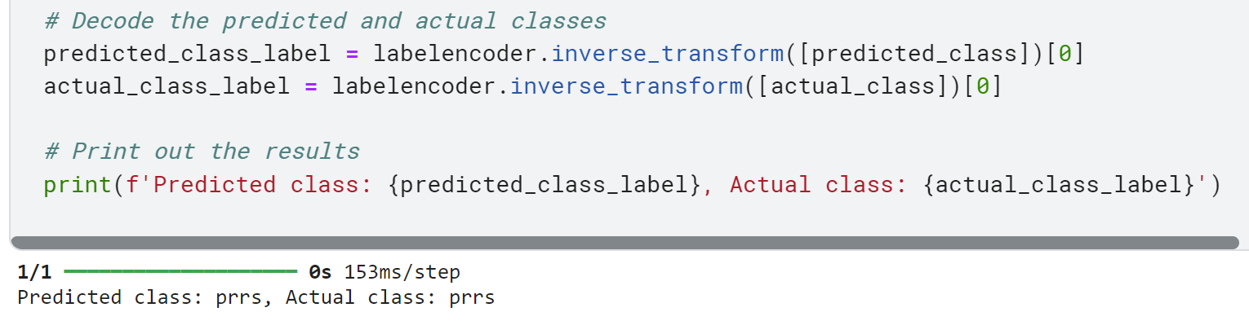

DenseNet achieved an accuracy of 80.01%, with a precision of 53.02%, recall of 72.82%, and F1 score of 61.36%. A confusion matrix is constructed to measure these metrics for DenseNet using the model's predictions and the ground truth labels from the test dataset. From the confusion matrix, the number of true positives (TP), false positives (FP), true negatives (TN), and false negatives (FN) are calculated. Subsequently, accuracy, precision, recall, and F1 score are computed using the respective formulas. This methodology provides insights into the overall correctness, ability to avoid false positives, capture all positive instances, and balance between precision and recall for DenseNet. Figure 64 illustrates the ROC curve of DenseNet model.

**Figure 64**

*AU Roc Curve of the DenseNet*

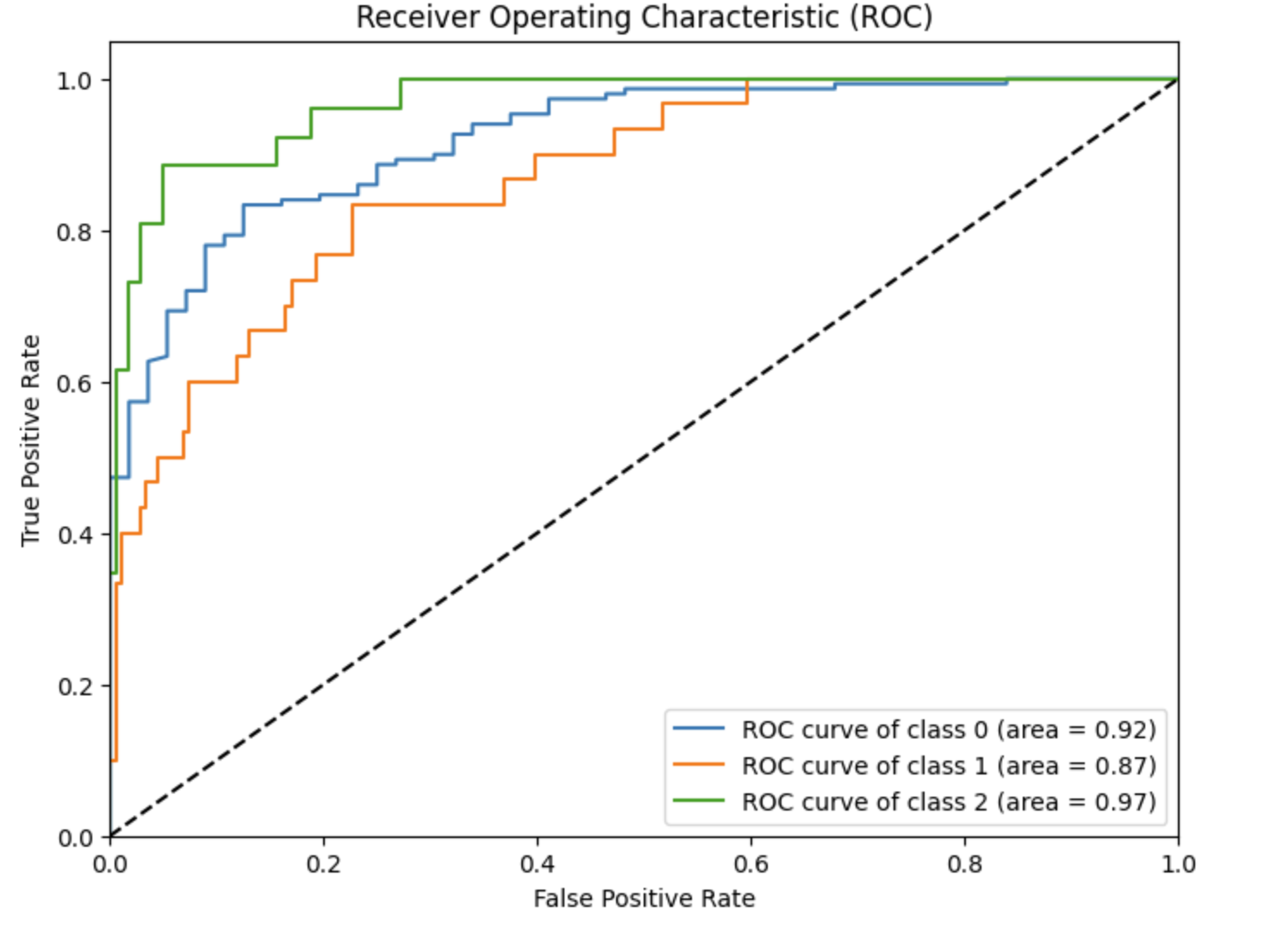

Similarly, RNN achieved an accuracy of 81.55%, precision of 80.61%, recall of 81.55%, and F1 score of 80.99%. The methodology for measuring these metrics for RNN follows the same process described for DenseNet. A confusion matrix is constructed using the model's predictions and ground truth labels, and accuracy, precision, recall, and F1 scores are calculated accordingly. This approach enables a comprehensive evaluation of RNN's performance in swine disease classification, providing valuable insights into its effectiveness. Figure 65 shows the confusion matrix.

**Figure 65**

*Confusion matrix*

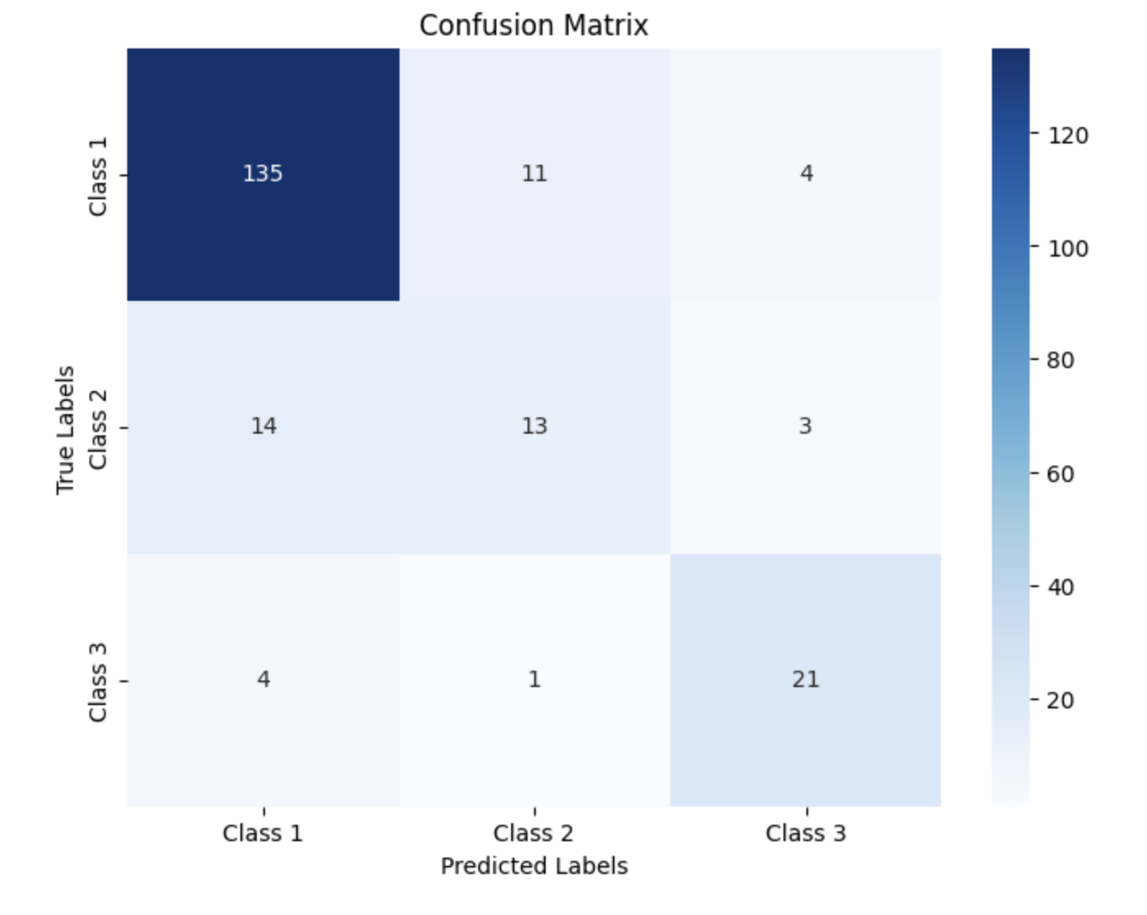

ResNet achieved an accuracy of 80.58%, precision of 84.11%, recall of 80.58%, and F1 score of 75.15%. The methodology for measuring these metrics for ResNet mirrors that of DenseNet and RNN. Constructing a confusion matrix and applying the appropriate formulas, accuracy, precision, recall, and F1 score are calculated to assess ResNet's performance in classifying swine diseases in Figure 65. This systematic approach facilitates a detailed analysis of ResNet's strengths and weaknesses.

LSTM achieved an accuracy of 36.8%. Consequently, only accuracy can be evaluated for LSTM using the same methodology described earlier. An assessment of LSTM's overall correctness in predicting swine disease classification can be made by constructing a confusion matrix and calculating accuracy. Figure 66 shows the overfitting accuracy curves of LSTM.

**Figure 66**

*Accuracy curves indicating overfitting*

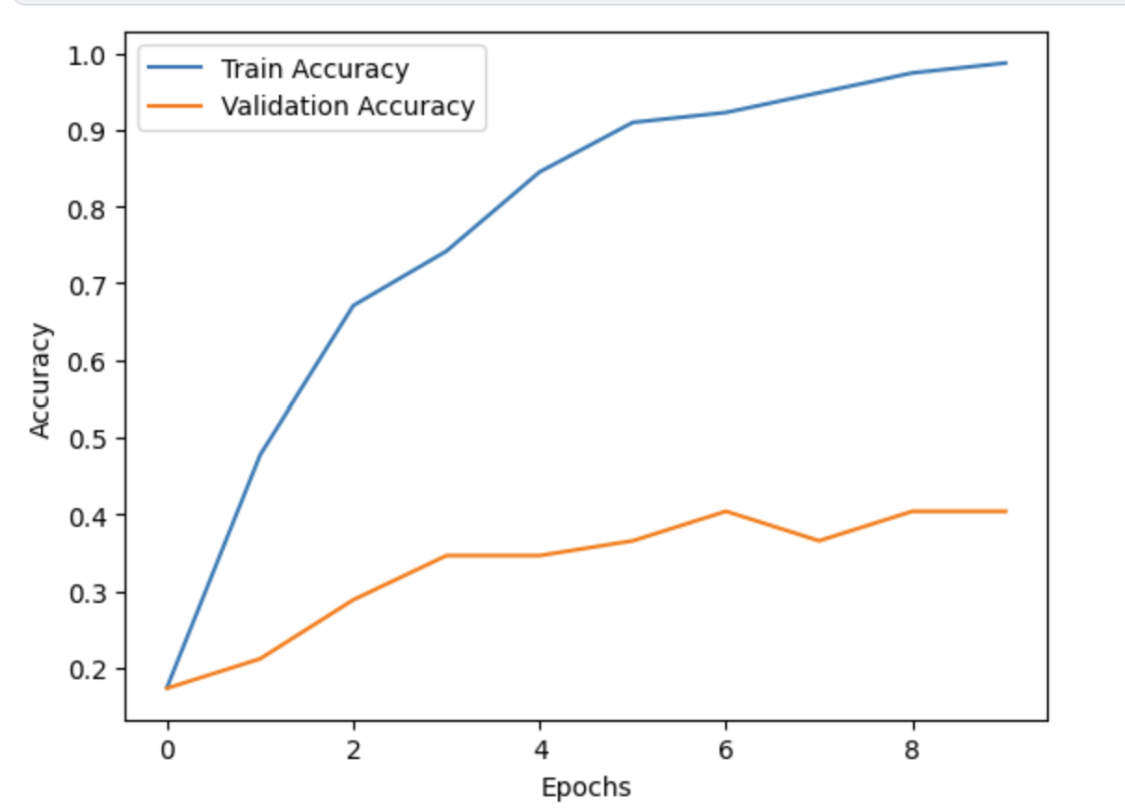

MobileNet achieved an accuracy of 46.2. Similar to LSTM, only accuracy can be assessed for MobileNet using the same methodology. MobileNet's performance in swine disease classification can be evaluated by employing a confusion matrix and calculating accuracy. Once the performance metrics are calculated for each model, they are interpreted to assess the effectiveness of the models in swine disease classification. A higher accuracy, precision, recall, and F1 score indicate better performance. However, it is essential to consider the trade-offs between these metrics and the application's specific requirements.

## Achievements and Constraints

### Achievements

Solving a complex problem, such as swine disease classification using deep learning, involves numerous achievements and challenges.

**Improved Disease Detection**. One of the primary achievements in solving the target problem is the improved detection of swine diseases. Deep learning models, such as DenseNet, CNN, ResNet, LSTM, and MobileNet, have demonstrated promising results in accurately identifying diseased pigs based on audio and image data. By leveraging the power of deep learning algorithms, researchers and practitioners have developed robust models capable of detecting diseases early, facilitating timely intervention and treatment.

**Enhanced Accuracy and Precision.** Another significant achievement is enhancing accuracy and precision in swine disease classification. The deployment of state-of-the-art deep learning architectures has led to notable improvements in model performance, with accuracy rates exceeding 80% for several models. Moreover, 53% to 84% of precision values indicate the models' ability to minimize false positives, reducing the likelihood of misclassifying healthy pigs as diseased.

**Effective Utilization of Audio and Image Data.** Deep learning models have effectively utilized audio and image data for swine disease classification, showcasing the versatility and adaptability of these algorithms. The models have demonstrated a comprehensive understanding of the diverse manifestations of swine diseases by extracting relevant features from audio signals, such as spectrograms and MFCCs, and leveraging image processing techniques for image data. This interdisciplinary approach has enabled a holistic assessment of pig health, leading to more accurate diagnoses.

**Balanced Precision-Recall Trade-off.** To minimize false positives and negatives, a balanced precision-recall trade-off is critical in swine disease classification. The F1 scores ranging from 61% to 80% indicate that the models have struck a balance between precision and recall, considering the specific requirements and challenges of the task. This equilibrium ensures that the models identify diseased pigs accurately and minimize the risk of missing positive instances, optimizing overall performance.

**Potential for Real-World Deployment.** The achievements in swine disease classification using deep learning hold significant promise for real-world deployment in agricultural settings. By providing farmers and veterinarians with accurate and timely information about pig health, these models can contribute to disease prevention, treatment optimization, and overall herd management. The potential economic and social benefits of deploying such technologies are substantial, paving the way for a more sustainable and efficient livestock industry.

### Constraints Encountered

**Data Availability and Quality.** One of the primary constraints encountered in swine disease classification is data availability and quality. Collecting labeled datasets for training deep learning models is challenging due to data scarcity, labeling errors, and class imbalance. Limited access to diverse and representative datasets hinders the generalization and scalability of the models, affecting their real-world applicability.

**Model Interpretability.** Despite their high performance, deep learning models often need more interpretability, making it difficult to understand the underlying decision-making process. These algorithms' "black box" nature poses challenges in explaining why specific predictions are made, raising concerns about model transparency, trustworthiness, and accountability. Addressing this constraint is essential for fostering user confidence and acceptance of the technology in practical settings.

**Computational Resources and Complexity.** Training deep learning models, especially large-scale architectures like DenseNet, ResNet, and LSTM, requires substantial computational resources and expertise. The computational complexity of these algorithms, coupled with the need for extensive hyperparameter tuning and model optimization, poses challenges in resource-constrained environments. Access to high-performance computing infrastructure and skilled personnel is crucial for overcoming this challenge.

**Ethical and Regulatory Considerations.** Deploying deep learning models in agricultural settings raises ethical and regulatory considerations regarding data privacy, animal welfare, and societal impact. Ensuring compliance with ethical guidelines, safeguarding sensitive data, and addressing potential biases in the models are essential aspects of responsible AI deployment. This project addresses these concerns to ensure the adoption and acceptance of the technology by stakeholders and regulatory bodies.

**Integration with Existing Practices.** Integrating deep learning-based solutions into existing agricultural practices and workflows is challenging due to technological readiness, user acceptance, and organizational resistance to change. Farmers and veterinarians may require training and support to utilize these technologies effectively, and seamless integration with existing systems and processes is essential for maximizing their impact and scalability.

## System Quality Evaluation of Model Functions and performance

The system quality evaluation for swine disease detection using image and audio data with deep learning models requires assessing both model correctness and runtime performance. Correctness measures the model’s ability to effectively detect and classify diseases, excelling random guessing which is a major criterion for model development. Additionally, runtime performance is crucial, ensuring the model meets system response time targets for real-time development. While short predictions within milliseconds might be necessary for integration with live modules, the evaluation determines if the model’s training and testing time aligns with the projects needs. This comprehensive assessment ensures both the accuracy and efficiency of the model functions.

Many models were implemented in swine disease detection and classification project using image data and audio data. Evaluating the models with respective system requirements. For audio data ResNet displayed high precision among other models. The model takes around 1 min 30.3 secs to complete the training and the model can detect diseases in 3 sec which is very fast and accurate. The overall performance of the model is 84.11%, which is measured in terms of precision. Whereas MobileNet model is implemented for image data which displayed better performance compared to other models. MobileNet is trained in 11.02 sec and the model can make the prediction in 37 milliseconds which is very fast, and the overall performance of the model measured in terms of accuracy is around 46.02%. Apart from this. Remaining models performance are mentioned in the below table 9. As per the table there is not much difference in the models performance using image data. Whereas there is a small gap between the models performance using audio data.

**Table 21**

*Model Performance*

|  |  |  |  |  |  |
| --- | --- | --- | --- | --- | --- |
| **S.No.** | **Data Type** | **Model** | **Device Specification** | **Training Time** | **Test Time** |
| 1. | Image | MobileNet | Kaggle  GPUs : T4  CPUs = 2 x vCPU  RAM : 32 GB | 11.02 seconds | 37 milli sec |
| 2. | Image | LSTM | Kaggle  GPUs : T4  CPUs = 2 x vCPU  RAM : 32 GB | 3.246 seconds | 5 milli sec |
| 3. | Audio | ResNet | Kaggle  GPUs : T4  CPUs = 2 x vCPU  RAM : 32 GB | 1 min 30 sec 34 milli sec | 1 sec  34 milli sec |
| 4. | Audio | RNN | Kaggle  GPUs : T4  CPUs = 2 x vCPU  RAM : 32 GB | 23.91 sec | 1sec  14 milli sec |
| 5. | Audio | DenseNet | Kaggle  GPUs : T4  CPUs = 2 x vCPU  RAM : 32 GB | 6.11 sec | 3 milli sec |
|  |  |  |  |  |  |

## System Visualization

System visualization entails the representation of complex systems, assessment of data, and dissemination of findings through interactive and visual depictions. System visualization is crucial for understanding and optimizing the various aspects of swine disease classification. It facilitates action by offering a comprehensible and clear grasp of numerous factors. The integration of both audio and image data, pixel information, and predictive analysis enables a holistic perspective that supports advanced strategic planning and managerial supervision.

**Figure 67**

*Specific swine diseases categorized in Tableau*

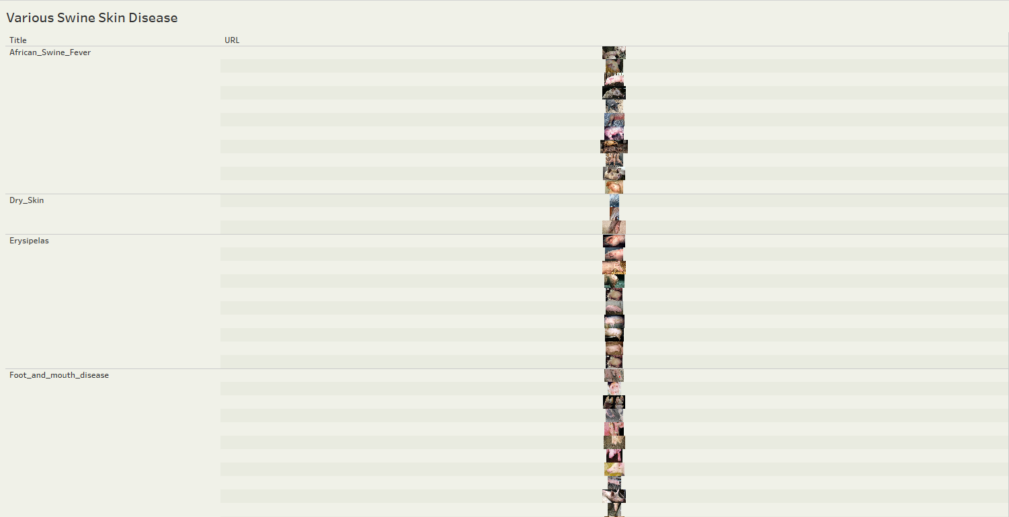

Figure 67 displays the images stored in a Tableau dashboard, organized in a linear format. The images are showcased across various levels of disease categories for easy reference and analysis.

**Figure 68**

*Bar Plot of Class Distribution*

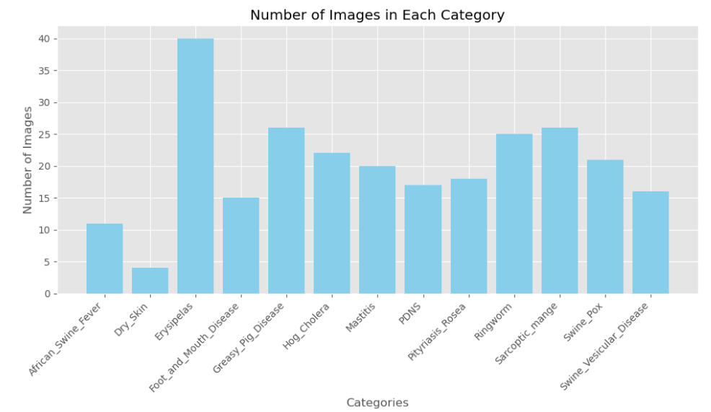

This section from Figure 68 illustrates the distribution of classes or categories within the dataset by generating a bar plot. The x-axis displays the categories, while the y-axis indicates the count of images in each category.

**Figure 69**

*Types of swine skin disease images*

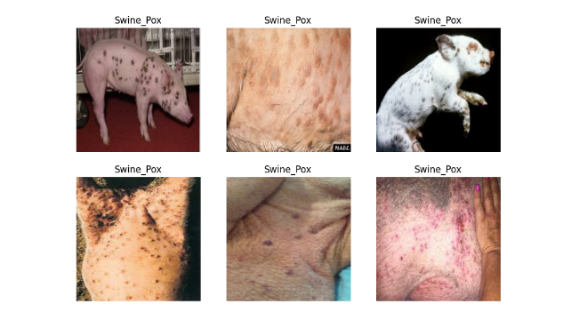

Different categories of swine skin disease images are displayed in Figure 69, showcasing various types of conditions.

**Figure 70**

*Distribution of the features of each category*

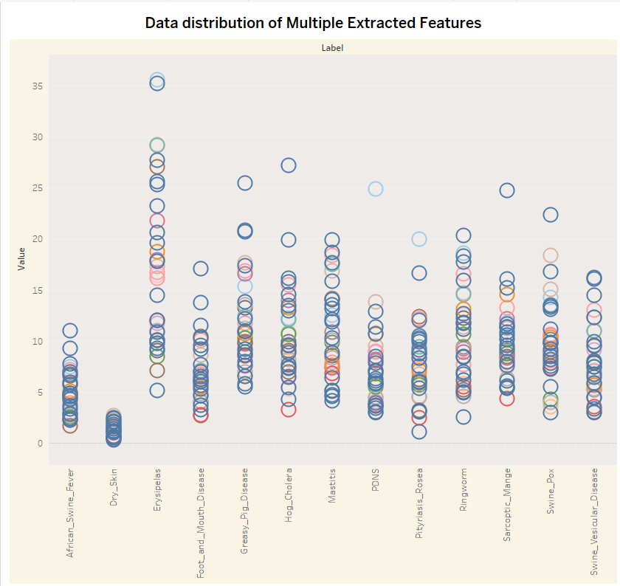

**Figure 71**

*The values and distribution of the retrieved characteristics of data*

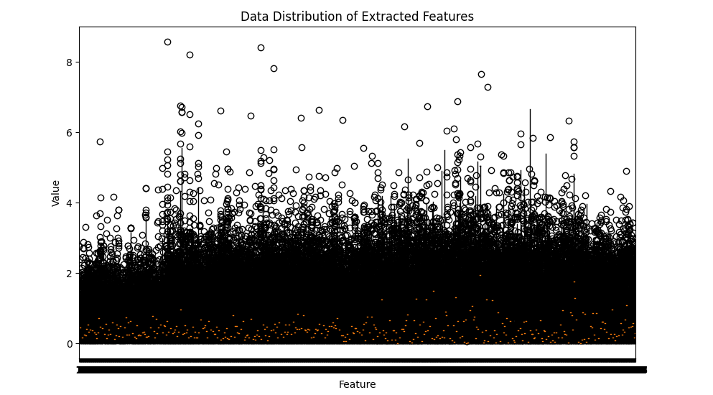

Both Figure 70 and Figure 71 illustrate the features of various images of swine disease in a scatter plot within the Visual dashboard, showcasing different values where the data for dry skin images is described as having a low factor.

**Figure 72**

*Examining the Average Value of the Features*

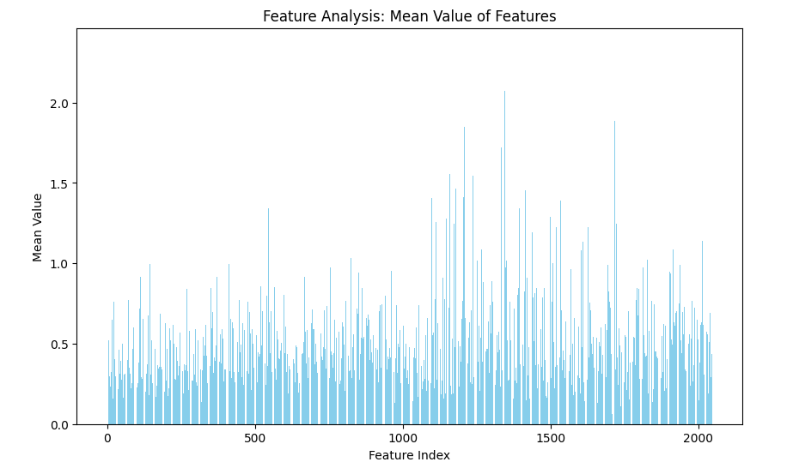

This section illustrates the average values of the attributes derived from images utilizing the InceptionV3 model. It aids in comprehending the distribution and significance of various attributes in the dataset from Figure 72, which is fundamental for activities such as feature prioritization, reduction of dimensionality, and comprehension of the encoding acquired by the model. Which deals with the feature index and calculates the mean value using a specific visualization technique.

**Figure 73**

*Distribution of classes in the training, validation, and test set*

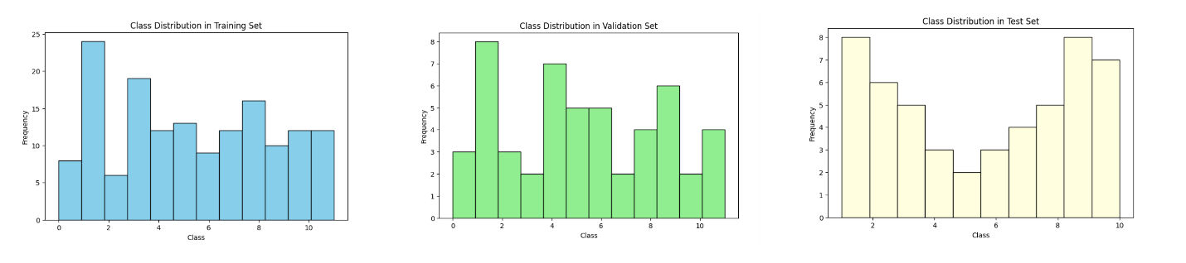

This part of the process from Figure 73 is crucial as it ensures that the dataset is properly split for training, validation, and testing purposes. It also provides insights into the distribution of classes within each set, which is essential for understanding the dataset's characteristics and potential biases. There are 153 samples in the training set, 51 samples make up the validation set, and 51 samples in the test set.

**Figure 74**

*Dispersion of the features that were extracted.*

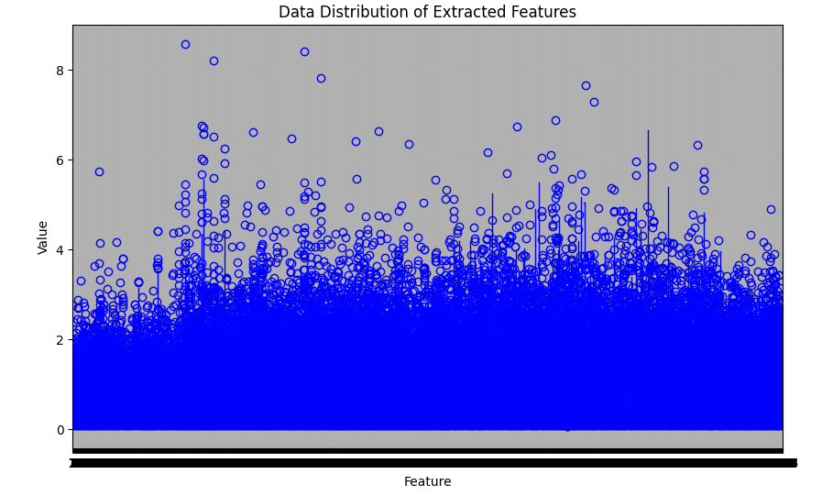

Presents a thorough graphical representation of the distribution of extracted characteristics through a box plot. Figure 74 Enables quick identification of anomalies, data range, and median values for each characteristic from Figure 75, which supports comprehension of the feature sets properties.

**Figure 75**

*Min, Max, and Standard deviation of features*

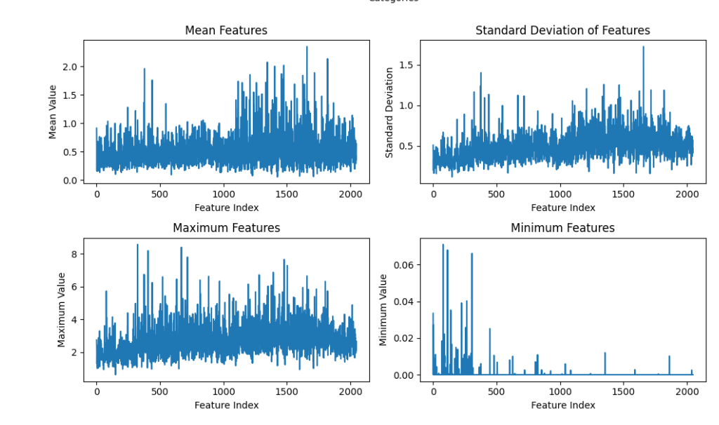

Here, it is crucial to gain insights into both the distribution of images across categories and the statistical properties of the extracted features in Figure 75. This understanding is essential for subsequent analysis, model development, and decision-making processes.

**Figure 76**

*Histogram of pixel distribution*

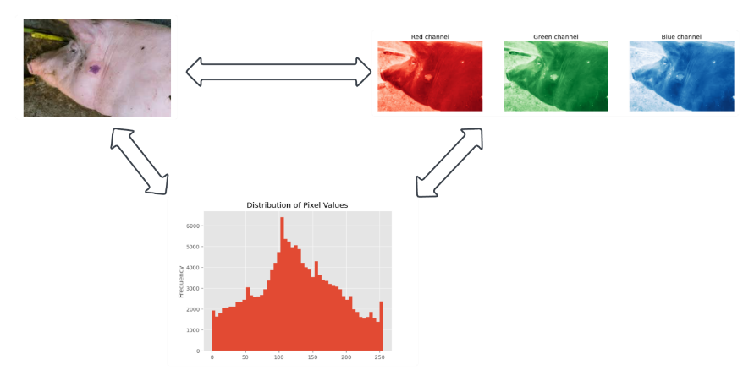

By examining the distribution of pixel values and visualizing individual color channels of the swine image. These visualizations from Figure 76 understand the characteristics and properties of the image dataset into red, blue, and green channels and can aid in identifying any patterns or trends that may exist within the data. Furthermore, by analyzing the statistical properties of the images and several parameters of a pixel distribution fitted to the edge histogram and image entropy can be able to gain insights into the relationship between the statistical measures.

**Figure 77**

*Different categories of diseases*

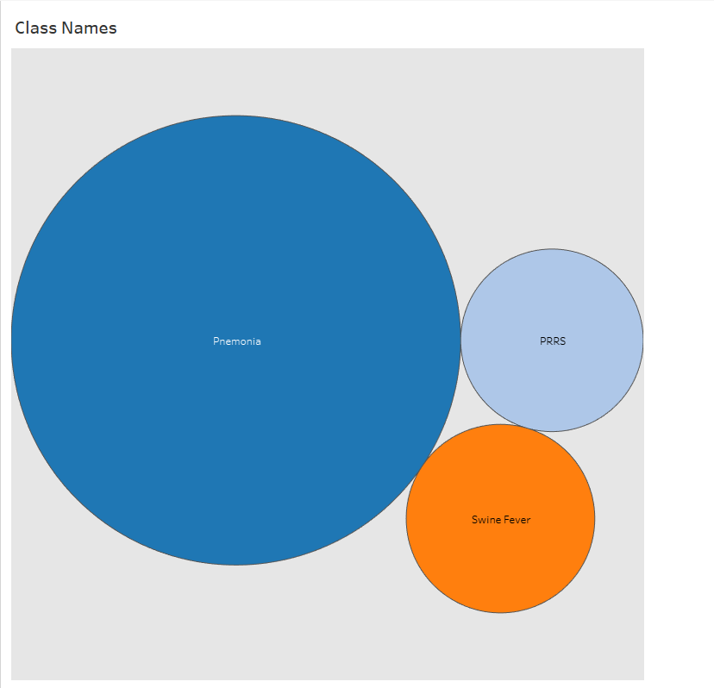

In Figure 77, the Dashboard features an engaging and insightful visual representation that vividly captures the distribution of three various diseases: Pneumonia, Porcine Reproductive and Respiratory Syndrome, and Swine Fever. In this section, we will distinguish in a bubble chat to create a clear representation of the disease which deals with swine acoustic classification.

**Figure 78**

*Distribution of Class ID*

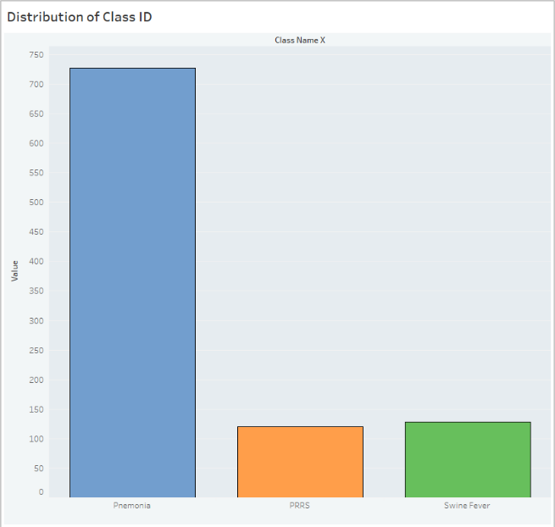

Facilitates mapping class IDs to their names by Pnemonia, prrs, swine_fever visualizing the distribution of classes, and defining paths to directories containing training data from Figure 78 each disease distributed into various measures. Here, Prrs is low around 100 compared with others whereas Pneumonia states at the top over 700 count samples of audio data, which are essential steps in data preprocessing and analysis for classification tasks.

**Figure 79**

*Distribution of feature lengths by their frequency*

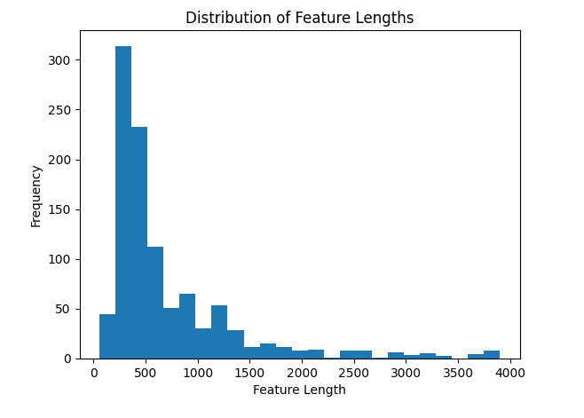

By extracting Mel-frequency cepstral coefficients (MFCC) in Figure 79 features from the audio data, can store them along with corresponding class labels, and important to visualize the distribution of feature lengths as part of the workflow for audio data classification.

**Data Analytics Results**

**Figure 80**

*Big data statistics*

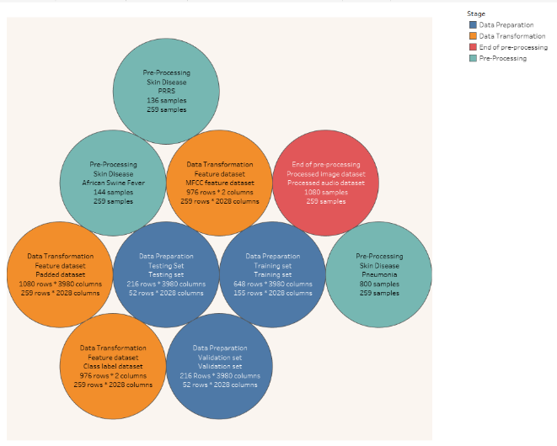

According to the statistics derived from Big Data analysis provided in Figure 80, the process involves four distinct stages: pre-processing, End of pre-processing, Data Transformation, and Data Preparation. These stages encompass handling swine audio datasets associated with three distinct diseases. Each data set consists of numerous samples, varying in size, to provide comprehensive insights.

Additionally, another dataset contains processed images related to swine skin diseases. This dataset, along with a feature dataset, comprises training, testing, and validation datasets. Through meticulous analysis, these datasets yield generic results, facilitating informed decision-making and contributing to a deeper understanding of the subject matter.

Machine learning results and data analytics outcomes.

**Figure 81**

*Data analytics Results in graphical format.*

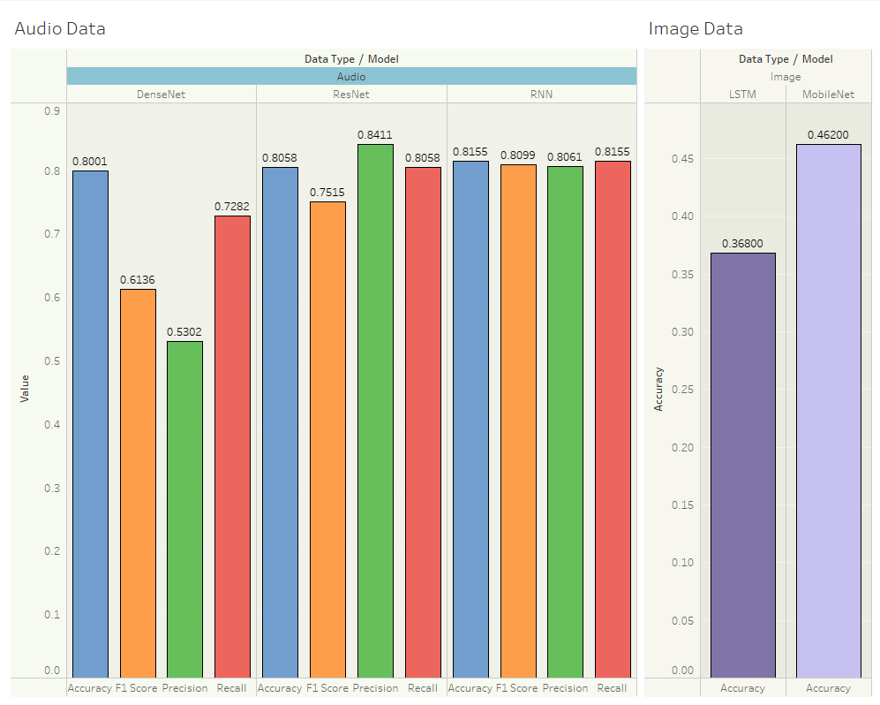

The results from deep learning models visualized on a Tableau dashboard, are categorized into two sections: one for audio data and the other for image data. The evaluation metrics of accuracy, precision, recall, and F1 score are displayed for each model. Through Figure 81 among the audio data models, RNN exhibits high accuracy, whereas DenseNet shows both high and low accuracy levels along with precision. However, RNN outperforms both DenseNet and ResNet models in terms of recall and F1 score, indicating its effectiveness in capturing relevant information. Switching to image data models, MobileNet demonstrates the highest accuracy rate at 46%, surpassing LSTM, which achieves a lower accuracy of 36%. These findings shed light on the comparative performance of different models in handling audio and image data, aiding in informed decision-making and model selection processes.

**Figure 82**

*Confusion matrix of machine learning outcomes*

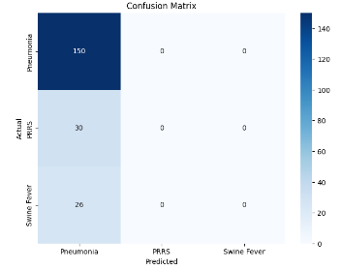

These visualizations from Figure 82 are instrumental in gaining insights into the performance of the models, including classification accuracy, precision, recall, and the trade-off between true positive rate and false positive rate. Provide a comprehensive understanding of how well the models perform across various metrics.

**Figure 83**

*Web Dashboard - User Interface*

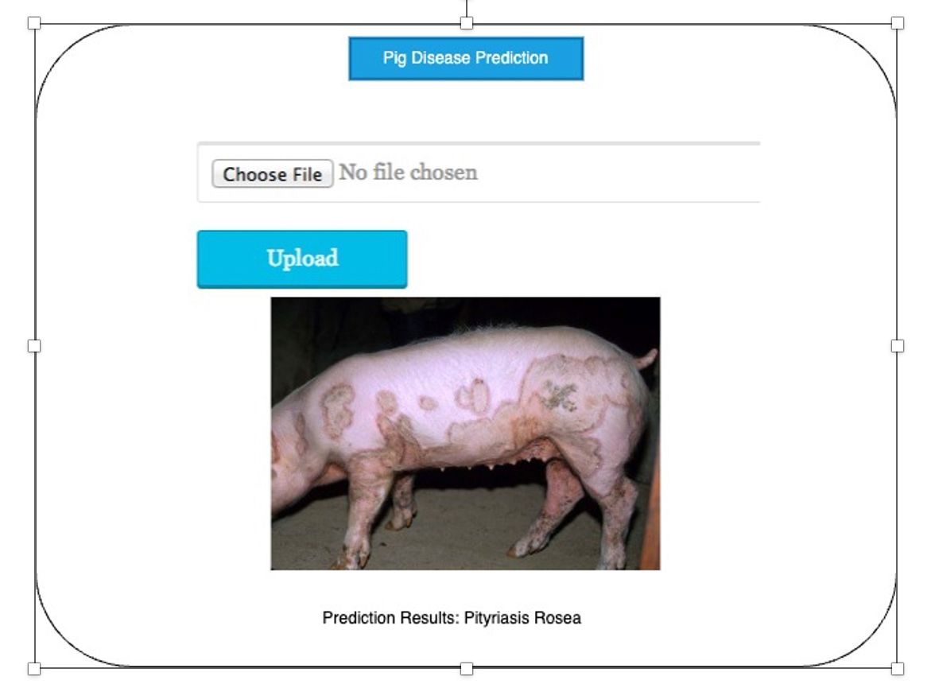

The website serves as a disease classification platform, employing a forward-looking approach to ensure comprehensive coverage from Figure 83. It not only accommodates audio datasets related to swine diseases but also allows users to upload skin images for accurate disease prediction. By encompassing diverse data types, the website significantly enhances its effectiveness in addressing the needs of the swine farming sector. This innovative platform is dedicated to delivering precise and reliable results, aligning with the project's commitment to excellence.

# Conclusion

## Summary

This project is used to develop a system to detect and classify diseases in swine using audio and image datasets. This system consists of various components such as backend, frontend, and pipeline for data processing. The user application was developed on Flask in python language. Users can make use of this application in various cases. To detect if the swine is affected with any disease. Or to identify what kind of disease the swine is infected with by uploading the images or audio files of the diseased swine into the portal. This project can also be expanded to other livestock in future. Below is the summary of the complete project.

The audio and image data that is required for this project is collected through various sources for about 15 diseases combinedly. The dataset also includes normal audio sounds of swine to train the model so that the model can identify non diseased swine. The image data is collected from Iowa State University veterinary department, The Center for Food Security and Public Health, and Google Search. For audio datasets, the audio files are extracted from video files using Y2mate and are segmented using Audacity. The quality of audio files is evaluated using SNR(sound-to-noise ratio >=10).

The project is adhered to the CRISP DM methodology for the project development, employing pert and Gantt charts to schedule tasks and meet deadlines. Tasks are assigned using JIRA software, and track progress to ensure seamless collaboration among team members. The above structured methodologies and tools enable us to maintain an organized workflow, enhance productivity, and achieve project objectives efficiently.

All the collected data is deployed into S3 bucket for storage and prepare the data to train the model. Each data went through various preprocessing steps to prepare the data. Features for audio data are extracted using MFCCs. The extracted coefficients from the resulting MFCCs represent the compact features which capture the essential audio characteristics, which serve as valuable features. Feature extraction for image data is done through a pre-trained CNN (inception-V3) from the preprocessed images. The preprocessing data is divided into 3 subsets in the ratio of 60:20:20 for training, validation and testing respectively.

Model selection for this project is done after going through various research papers, journals, blogs, and articles. As the data used for this project is image and audio deep learning models are a better choice for this project. There are many popular CNN models for image dataset and audio datasets out of which DenseNet, RNN, ResNet are chosen for audio dataset and LSTM, MobileNet are chosen for image dataset of this project. Accuracy, precision, recall, and F1-score are the metrics that are considered to evaluate the performance of the model.

The best model from the above implemented models is RNN with an overall better performance of 81.55% accuracy for audio dataset and MobileNet displayed a better performance for image dataset.

## Benefits and Shortcoming

### Benefits

The proposed solution for the project is beneficial in many ways compared to the traditional solutions. This approach saves a lot of money and time for farmers. Not only for swine but this project can be expanded to other animals which help a lot of farmers to control diseases. This project uses deep learning models which can analyze large volumes of data quickly and accurately which enables early detection of diseases in swine. The solution for diseases detection is a deep learning model that can automate the process of disease detection that reduces the need for manual inspection and labor-intensive diagnostic procedures which indirectly decreases the expenses for farmers. Deep learning models can also adapt to new data and emerging disease patterns over time which makes the application adaptable and improves its performance so that users can rely on it.

### Shortcomings

Professionals are essential for interpreting clinical signs, laboratory findings, and epidemiological data, crucial for accurate disease detection and classification in swine farming. Timely disease surveillance depends on early reporting of suspected cases. However, obstacles such as concerns about financial losses, insufficient incentives for reporting, and poor communication between farmers, veterinarians, and authorities can slow down this process, compromising the efficiency of disease control measures in swine farming.

## Potential System and Model Applications

This project has multiple applications in the real world. The major application of this project is for farmers where they can track the health of animals for timely treatment and reducing the severity and spread of diseases . Apart from farmers, food industry can also get advantage of this applications to check for diseased animals as food industry and swine farming contribute to the economy in various countries. This application can assist veterinarians in diagnosing animals to some extent, expediting their work processes. This application can be integrated with any other animals to protect animal life consists of various forms of data like image, audio, and video types for better understanding. Not only animals but this application can be extended to plants using only the images of diseased plants which intern can help large scale of farmers in early detection of diseases and reduce financial losses. Combining health records of animals and diagnostic findings with environmental data from sensors enables farmers to understand disease patterns and take required measures. These are some of the potential applications of the project. There are still more cases where we can use this application.

## Experience and Lessons Learned

Working on this project has proven exceptionally beneficial for the team on a technical level. The team acquired good knowledge and skills through this project from this course. Through this project the team members have seen a significant growth in deep learning proficiency by exploring various models and advancing data engineering skills. The project has also taught new skills on how to work with audio data that consists of noise and external sounds and to deal with quality of audio files based on SNR (sound-to-noise ratio). The ability to work with various kinds of data has increased as the project dealt with different types of datasets and the way they are collaborated on in the same project. In addition to model building, the project has provided valuable lessons on constructing a user interface tailored for real-world users.

## Recommendations For Future Work

Based on the current project experience, it is crucial to prioritize enhancing the accuracy of disease detection and classification model. This can be achieved by exploring ensemble methods to merge predictions from audio and image data models to potentially boost accuracy and robustness which can enhance the overall performance across diverse datasets. This project can be expanded to include a real-time monitoring system that analyzes audio and image data streams from swine facilities, promptly detecting and alerting farmers, or veterinarians about potential disease outbreaks.

## Contributions and Impact on Society

The project enhances swine health management by equipping farmers and veterinarians with advanced disease monitoring and diagnostic tools. This empowers farmers to implement more effective treatment strategies, leading to healthier swine populations. By preventing and controlling disease in swine, the project indirectly elevates food safety standards. Healthy animals yield safer pork products, mitigating the risk of foodborne illness for consumers. Furthermore, the project drives technological progress by investigating audio image datasets for disease detection. This interdisciplinary approach fosters agricultural innovation, pushing the boundaries of animal health monitoring research. As a result, the project sets a precedent for future advancements in disease surveillance and management across the livestock industry, ultimately benefiting both agricultural stakeholders and public health.

# References

Chung, J., Gulcehre, C., Cho, K., & Bengio, Y. (2014). Empirical evaluation of gated recurrent neural networks on sequence modeling. In NIPS 2014 Workshop on Deep Learning, December 2014

Chung, Y., Oh, S., Lee, J., Park, D., Chang, H.-H., & Kim, S. (2013). Automatic detection and recognition of pig wasting diseases using sound data in Audio Surveillance Systems. *Sensors*, *13*(10), 12929–12942. https://doi.org/10.3390/s131012929

Colaco, S. J., Kim, J. H., Poulose, A., Neethirajan, S., & Han, D. S. (2023). DISubNet: Depthwise separable inception subnetwork for Pig Treatment Classification using thermal data. *Animals*, *13*(7), 1184. https://doi.org/10.3390/ani13071184

DEY, K. (n.d.). (tech.)

Exadaktylos, V., Silva, M., Aerts, J.-M., Taylor, C. J., & Berckmans, D. (2008). Real-time recognition of Sick Pig Cough sounds. *Computers and Electronics in Agriculture*, *63*(2), 207–214. https://doi.org/10.1016/j.compag.2008.02.010

Ferrari, S., Silva, M., Guarino, M., Aerts, J. M., & Berckmans, D. (2008). Cough sound analysis to identify respiratory infection in pigs. *Computers and Electronics in Agriculture*, *64*(2), 318–325. https://doi.org/10.1016/j.compag.2008.07.003

Graves, A., & Schmidhuber, J. (2005). Framewise phoneme classification with bidirectional LSTM and other neural network architectures. *Neural Networks*, *18*(5–6), 602–610. https://doi.org/10.1016/j.neunet.2005.06.042

Gutierrez, W. M., Kim, S., Kim, D. H., Yeon, S. C., & Chang, H. H. (2010). Classification of porcine wasting diseases using sound analysis. *Asian-Australasian Journal of Animal Sciences*, *23*(8), 1096–1104. https://doi.org/10.5713/ajas.2010.90483

Hakansson, F., & Jensen, D. B. (2023). Automatic monitoring and detection of tail-biting behavior in groups of pigs using video-based Deep Learning Methods. *Frontiers in Veterinary Science*, *9*. https://doi.org/10.3389/fvets.2022.1099347

Ji, N., Shen, W., Yin, Y., Bao, J., Dai, B., Hou, H., Kou, S., & Zhao, Y. (2022). Investigation of acoustic and visual features for Pig Cough Classification. *Biosystems Engineering*, *219*, 281–293. https://doi.org/10.1016/j.biosystemseng.2022.05.010

Lee, S. *et al.* (2019) ‘Practical monitoring of undergrown pigs for IOT-based large-scale Smart Farm’, *IEEE Access*, 7, pp. 173796–173810. doi:10.1109/access.2019.2955761.

K. Greff, R. K. Srivastava, J. Koutník, B. R. Steunebrink and J. Schmidhuber, "LSTM: A Search Space Odyssey," in IEEE Transactions on Neural Networks and Learning Systems, vol. 28, no. 10, pp. 2222-2232, Oct. 2017, doi: 10.1109/TNNLS.2016.2582924. keywords: {Logic gates;Computer architecture;Training;Microprocessors;Speech recognition;Handwriting recognition;Recurrent neural networks;Functional ANalysis Of VAriance (fANOVA);long short-term memory (LSTM);random search;recurrent neural networks;sequence learning},

Kim, T., Lee, J., & Nam, J. (2019). Comparison and analysis of SAMPLECNN architectures for Audio Classification. *IEEE Journal of Selected Topics in Signal Processing*, *13*(2), 285–297. https://doi.org/10.1109/jstsp.2019.290947

Kshirsagar, P.R. et al. (2022) ‘Deep learning approaches for prognosis of automated skin disease’, Life, 12(3), p. 426. doi:10.3390/life12030426.

Nasirahmadi, A., Sturm, B., Olsson, A.-C., Jeppsson, K.-H., Müller, S., Edwards, S., & Hensel, O. (2019). Automatic scoring of lateral and sternal lying posture in grouped pigs using image processing and support vector machine. *Computers and Electronics in Agriculture*, *156*, 475–481. https://doi.org/10.1016/j.compag.2018.12.009

S. Hochreiter and J. Schmidhuber, "Long Short-Term Memory," in Neural Computation, vol. 9, no. 8, pp. 1735-1780, 15 Nov. 1997, doi: 10.1162/neco.1997.9.8.1735.

Shen, W., Ji, N., Yin, Y., Dai, B., Tu, D., Sun, B., Hou, H., Kou, S., & Zhao, Y. (2022). Fusion of acoustic and deep features for pig cough sound recognition. *Computers and Electronics in Agriculture*, *197*, 106994. https://doi.org/10.1016/j.compag.2022.106994

Silva, M., Ferrari, S., Costa, A., Aerts, J.-M., Guarino, M., & Berckmans, D. (2008). Cough localization for the detection of respiratory diseases in pig houses. *Computers and Electronics in Agriculture*, *64*(2), 286–292. https://doi.org/10.1016/j.compag.2008.05.024

Song, H., Zhao, B., Hu, J., Sun, H., & Zhou, Z. (2022a). Research on improved DenseNets pig cough sound recognition model based on SENets. *Electronics*, *11*(21), 3562. https://doi.org/10.3390/electronics11213562

Yinggang Xie, Y. X., Yinggang Xie, Y. X., Yangpeng Xiao, X. P., & Xuewei Peng, Q. L. (2023). Animal vocal recognition-based breeding tracking and disease warning. 電腦學刊, *34*(4), 127–143. https://doi.org/10.53106/199115992023083404011

Ying-Ming Shi, Y.-M. S. (2022). An improved machine learning model for Pig Abnormal Voice recognition. 電腦學刊, *33*(6), 155–166. https://doi.org/10.53106/199115992022123306013

Yin, Y., Tu, D., Shen, W., & Bao, J. (2021). Recognition of sick pig cough sounds based on convolutional neural network in field situations. *Information Processing in Agriculture*, *8*(3), 369–379. https://doi.org/10.1016/j.inpa.2020.11.001

Kshirsagar, P.R. et al. (2022) ‘Deep learning approaches for prognosis of automated skin disease’, Life, 12(3), p. 426. doi:10.3390/life12030426.

# Appendix A

# System Testing

In this appendix, we will outline the process of executing website functionalities from input provision to Swine disease prediction. The flow includes steps such as logging in, uploading images, and predicting Swine disease. After uploading an image, the system proceeds to predict the presence of Swine disease among a selection of 15 diseases.

## Figure A1

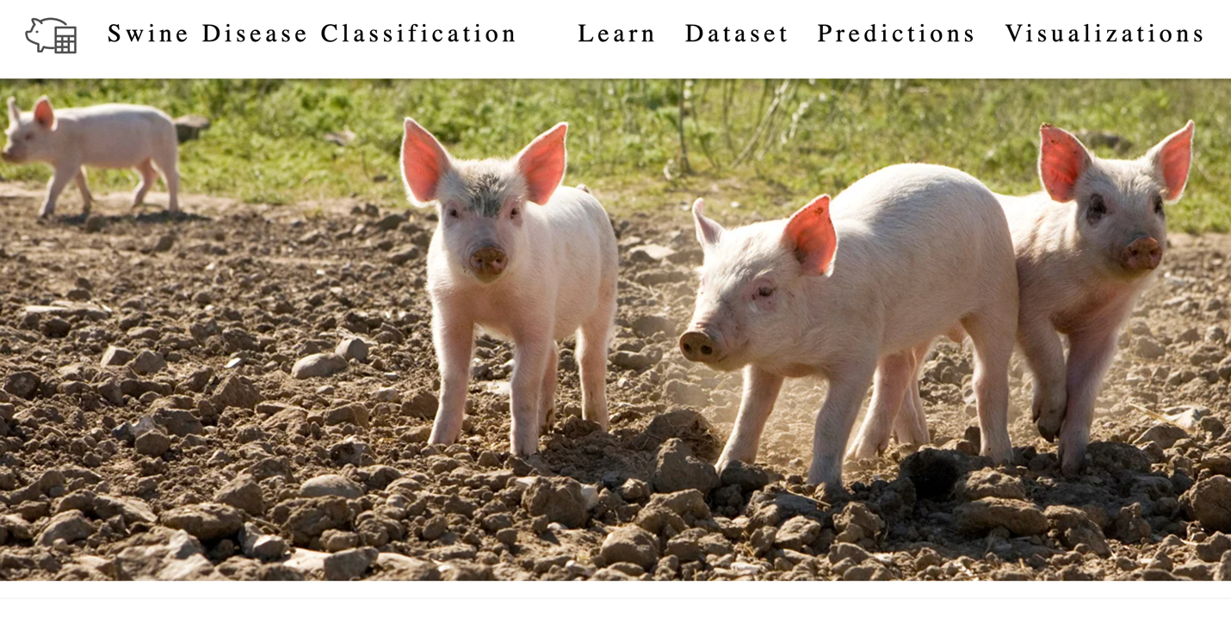

## Figure A2

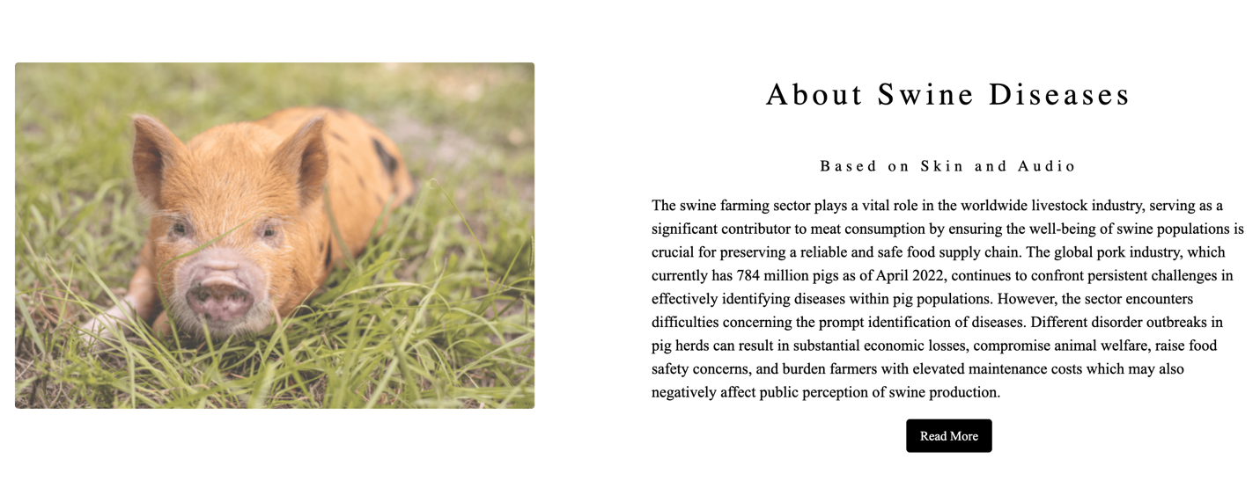

## Figure A3

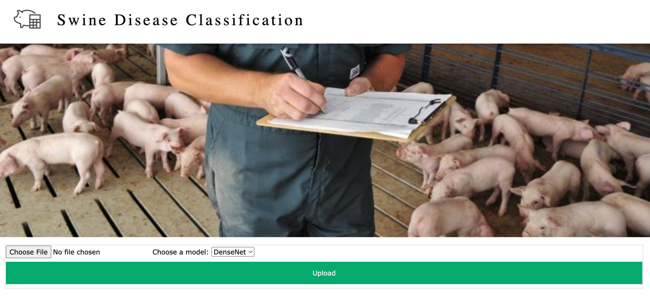

## Figure A4

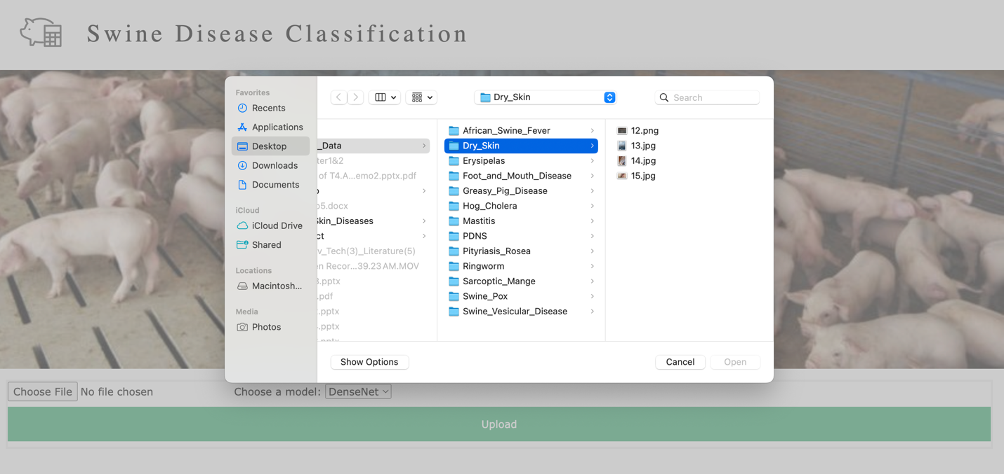

## Figure A5

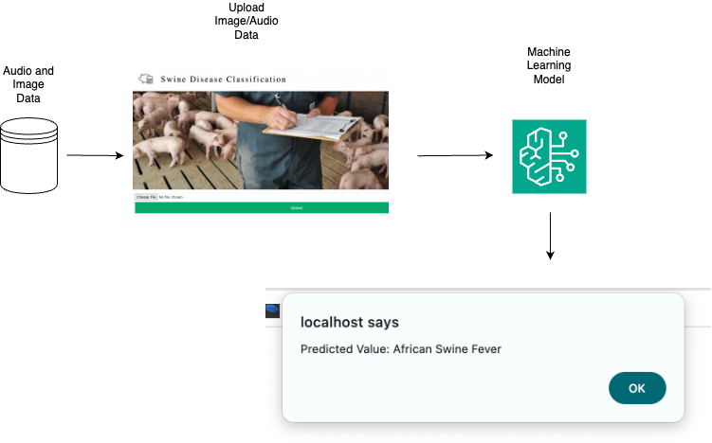

# Appendix B

# Project Data Source and Management Store

In our project, the primary dataset consisted of pig skin images sourced from the Veterinary Department of Iowa State University. These images were downloaded from their official repository. The link to access and download these pig swine images is provided below. Additionally, some of the disease images were also collected from open-source platforms such as Google Images.

<https://drive.google.com/drive/folders/1enWfG15gC7cSVrc-T8ZP1rnVT_hcTCNk>

The audio data utilized consists of segments extracted from YouTube videos. These segments will be extracted using the Audacity tool from the respective YouTube videos. To maintain the quality and integrity of the audio data, various measures will be implemented, including noise reduction techniques and validation checks.

<https://drive.google.com/drive/folders/1I0l5-Y8_S0zC7SHHDmjfumCLo_4K9u4y>

# Appendix C

# Project Program Source Library, Presentation, and Demonstration

The following links provide access to the source code for our user interface, model, data processing, data collection, as well as exploration. Additionally, they include presentations utilized during the project and demonstration videos showcasing our project's functionality.

Project Source Code

<https://drive.google.com/drive/folders/1y2wplaxl_f0ou4du2t7zcqslfJzkUmq3>

Demos  
<https://drive.google.com/drive/folders/1wr6WNZIPQn1mVWZCkF1Qqp7t6g7P0dxf>

Documents

<https://drive.google.com/drive/folders/104YYfbRQfxHetb7gI4_h4nEqeH1x5GOT>

Model Workbooks

<https://drive.google.com/drive/folders/1ka75aposmXGuGydeDTOTwztC9GUQtm7U>

Presentation Slides

<https://drive.google.com/drive/folders/18TZYWPP6rh94XE-jLzPlVSux4RT15aNm>